**Laila Espinoza**

**Princess Battles**

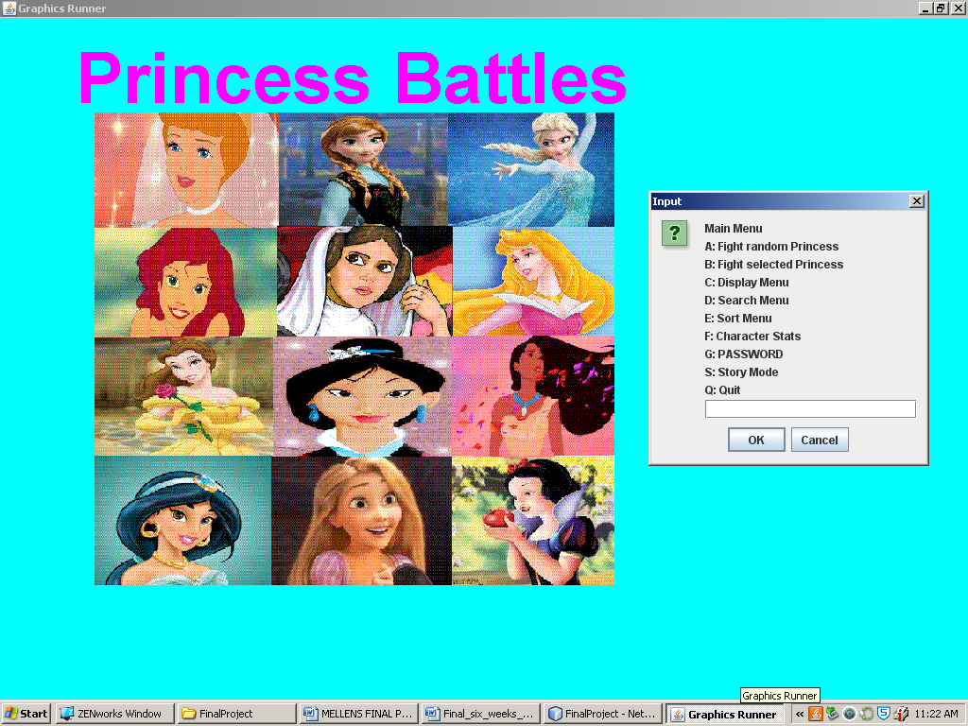

Contents

Description 4

Main Class 5

Main Class Java Docs 18

Princess Class 23

Princess Class Java Docs 30

My Character Class 34

My Character Class Java Docs 38

Fighter Class 43

Fighter Class Java Docs 46

Select Fighter Class 48

Select Fighter Class Java Docs 51

Print Class 53

Print Class Java Docs 56

Search Class 58

Search Class Java Docs 61

Sort Class 63

Sort Class Java Docs 67

Stats Class 69

Stats Class Java Docs 70

Add Method 72

Add Method Java Docs 74

Change Method 76

Change Method Java Docs 83

Delete Method 86

Delete Method Java Docs 87

Story Mode 89

Story Mode Java Docs 103

Story Fight Class 109

Story Fight Class Java Docs 118

Graphics Class 122

Story Graphics Class 125

Screen Shots 129

Fighter Class 129

Select Fighter Class 133

Display Menu 142

Search Menu 147

Sort Menu 176

Character Stats 184

Password 187

Story Mode 206

# Description

Princess Battles is a game where you fight Disney Princesses as a Star Wars princess, Princess Leia. This game allows you to play on a story line or just fight a random/selected princess. You also have the ability to unlock hidden secrets if you win in story mode.

# Main Class

package finalproject;

import java.io.File;

import java.io.FileWriter;

import java.io.PrintWriter;

import java.util.ArrayList;

import java.util.Scanner;

import javax.swing.JOptionPane;

import org.jfugue.Player;

public class Main {

public static ArrayList<Princess> pri = new ArrayList<Princess>();

public static myCharacter hero;

public static Player player = new Player();

public static ArrayList<myCharacter> st = new ArrayList<myCharacter>();

/**

* reads in the princess text file

*

* @throws Exception

*/

public static void readData() throws Exception {

pri = new ArrayList<Princess>();

Scanner file = new Scanner(new File("Princess.txt"));

while (file.hasNextLine()) {

String name = file.nextLine();

String hair = file.nextLine();

String power = file.nextLine();

String prince = file.nextLine();

int hitpoints = file.nextInt();

int attack = file.nextInt();

file.nextLine();

int defense = Integer.parseInt(file.nextLine());

pri.add(new Princess(name, hair, power, prince, hitpoints, attack, defense));

System.out.println(pri.get(pri.size() - 1));

}

}

/**

* reads in the main character

*

* @throws Exception

*/

public static void readInMC() throws Exception {

Scanner file = new Scanner(new File("myCharacter.txt"));

String name = file.nextLine();

String hair = file.nextLine();

String power = file.nextLine();

String prince = file.nextLine();

int hitpoints = file.nextInt();

int attack = file.nextInt();

int defense = file.nextInt();

file.nextLine();

String weapon = file.nextLine();

String shield = file.nextLine();

int AttackWeapon = file.nextInt();

int DefenseShield = file.nextInt();

hero = new myCharacter(name, hair, power, prince, hitpoints, attack, defense, AttackWeapon,

DefenseShield, weapon, shield);

System.out.println(hero);

}

/**

* main menu list all sub menu's and other things in game

*

*/

public static void Menu() throws Exception {

String options = "Main Menu \n"

+ "A: Fight random Princess \n"

+ "B: Fight selected Princess \n"

+ "C: Display Menu \n"

+ "D: Search Menu \n"

+ "E: Sort Menu \n"

+ "F: Character Stats \n"

+ "G: PASSWORD \n"

+ "S: Story Mode \n"

+ "Q: Quit";

String ans = JOptionPane.showInputDialog(null, options).toUpperCase();

if (ans.contains("A")) {

test();

}

if (ans.contains("B")) {

test2();

}

if (ans.contains("C")) {

PrintMenu();

}

if (ans.contains("D")) {

PrintSearch();

}

if (ans.contains("E")) {

PrintSort();

}

if (ans.contains("F")) {

StatsClass.Stats(pri);

}

if (ans.contains("G")) {

password();

}

if (ans.contains("Q")) {

System.exit(0);

}

if (ans.contains("S")) {

storymode();

}

Menu();

}

/**

* goes to story mode

*

* @throws Exception

*/

public static void storymode() throws Exception {

String story = JOptionPane.showInputDialog(null, "STORYMODE:\n"

+ "A: How to Play\n"

+ "B: Start");

if (story.contains("A")) {

StoryMode.HowToPlay();

}

if (story.contains("B")) {

StoryMode.intro(pri, hero);

}

}

/**

* secret code that allows you to add a character, delete a character, and

* change a character

*

*/

public static void password() throws Exception {

String pass = JOptionPane.showInputDialog("TYPE IN PASSWORD");

String code = "StarWars";

if (pass.equalsIgnoreCase(code)) {

String options = "Choose an Item \n"

+ "A: Add New Character \n"

+ "B: Change Character \n"

+ "C: Delete a Princess \n";

String ans = JOptionPane.showInputDialog(null, options).toUpperCase();

if (ans.contains("A")) {

AddMethod.createNew(pri);

}

if (ans.contains("B")) {

String bopt = "Choose an Item \n"

+ "A: Change Hair \n"

+ "B: Change Power \n"

+ "C: Change Prince \n"

+ "D: Change HitPoints \n"

+ "E: Change Attack \n"

+ "F: Change Defense \n";

String re = JOptionPane.showInputDialog(null, bopt).toUpperCase();

if (re.contains("A")) {

Change.ChangeHair(pri);

}

if (re.contains("B")) {

Change.ChangePower(pri);

}

if (re.contains("C")) {

Change.ChangePrince(pri);

}

if (re.contains("D")) {

Change.ChangeHP(pri);

}

if (re.contains("E")) {

Change.ChangeAT(pri);

}

if (re.contains("F")) {

Change.ChangeDE(pri);

}

}

if (ans.contains("C")) {

DeletePrincess.delete(pri);

}

}

Menu();

}

/**

* Prints out certain items that you choose

*

*/

public static void PrintMenu() {

String options = "Choose an Item \n"

+ "A: Name \n"

+ "B: Name Hair \n"

+ "C: Name Power \n"

+ "D: Name Prince \n";

String ans = JOptionPane.showInputDialog(null, options).toUpperCase();

if (ans.contains("A")) {

PrintClass.Normal(pri);

}

if (ans.contains("B")) {

PrintClass.hair(pri);

}

if (ans.contains("C")) {

PrintClass.power(pri);

}

if (ans.contains("D")) {

PrintClass.Prince(pri);

}

}

/**

* print menu list to choose a sort

*

*/

public static void PrintSort() {

String options = "Choose a Sort \n"

+ "A: Attack \n"

+ "B: Defense \n"

+ "C: Hitpoints \n";

String ans = JOptionPane.showInputDialog(null, options).toUpperCase();

if (ans.contains("A")) {

SortClass.SortAttack(pri);

}

if (ans.contains("B")) {

SortClass.SortDE(pri);

}

if (ans.contains("C")) {

SortClass.SortHP(pri);

}

}

/**

* print menu list to search for higher ranks

*

*/

public static void PrintSearch() {

String options = "Choose something to search \n"

+ "A: Attack \n"

+ "B: Defense \n"

+ "C: Hitpoints \n";

String ans = JOptionPane.showInputDialog(null, options).toUpperCase();

if (ans.contains("A")) {

SearchClass.SearchAttack(pri);

}

if (ans.contains("B")) {

SearchClass.SearchDE(pri);

}

if (ans.contains("C")) {

SearchClass.SearchHP(pri);

}

}

/**

* saves the princess monsters(the enemies)

*

*/

public static void SaveP() throws Exception {

PrintWriter fout = new PrintWriter(new FileWriter("Princess.bac"));

for (Princess name : pri) {

fout.println(name.getName());

fout.println(name.getHair());

fout.println(name.getPower());

fout.println(name.getPrince());

fout.println(name.getHP());

fout.println(name.getAT());

fout.println(name.getDE());

//System.out.println(pri.get(pri.size()-1));

}

JOptionPane.showMessageDialog(null, "Saved Finished");

fout.close();

}

/**

* reads the save method

*

*/

public static void Read() throws Exception {

Scanner file = new Scanner(new File("Princess.bac"));

while (file.hasNextLine()) {

String name = file.nextLine();

String hair = file.nextLine();

String power = file.nextLine();

String prince = file.nextLine();

int hitpoints = file.nextInt();

int attack = file.nextInt();

file.nextLine();

int defense = Integer.parseInt(file.nextLine());

pri.add(new Princess(name, hair, power, prince, hitpoints, attack, defense));

System.out.println(pri.get(pri.size() - 1));

}

}

/**

* makes the characters fight

*

*/

public static void test() throws Exception {

Princess e = FighterClass.getRandomCharacter(pri);

FighterClass.FightScene(hero, e);

}

/**

* makes the character you select fight

*/

public static void test2() throws Exception {

String a = JOptionPane.showInputDialog(null, "Type in name");

Princess e = SearchClass.SearchName(pri, a);

SelectFighter.FightSelect(hero, e);

}

/**

* plays music

*

* @throws Exception

*/

public static void MusicPlayer() throws Exception {

player.play("V1 I48 D4i D4i D4i G4h D5h C5i B4i A4i G5h D5q "

+ "C5i B4i A4i G5h D5q C5i B4i C5i A4h D4q D4i G4h D5h C5i"

+ " B4i A4i G5h D5q C5i B4i A4i G5h D5q C5i B4i C5i A4h");

}

/**

* runs the program

*

*/

public static void main(String[] args) throws Exception {

Read();

readInMC();

GraphicsRunner asdf = new GraphicsRunner();

MusicPlayer();

Menu();

}

}

## Main Class Java Docs

**Class Main**

* java.lang.Object
  + finalproject.Main

public class **Main**

extends java.lang.Object

* + **Field Summary**

|  |  |
| --- | --- |
| **Fields** | |
| **Modifier and Type** | **Field and Description** |
| static **myCharacter** | **hero** |
| static org.jfugue.Player | **player** |
| static java.util.ArrayList<**Princess**> | **pri** |
| static java.util.ArrayList<**myCharacter**> | **st** |

* + **Constructor Summary**

|  |
| --- |
| **Constructors** |
| **Constructor and Description** |
| **Main**() |

* + **Method Summary**

|  |  |
| --- | --- |
| **Methods** | |
| **Modifier and Type** | **Method and Description** |
| static void | **main**(java.lang.String[] args)  runs the program |
| static void | **Menu**()  main menu list all sub menu's and other things in game |
| static void | **MusicPlayer**()  plays music |
| static void | **password**()  secret code that allows you to add a character, delete a character, and change a character |
| static void | **PrintMenu**()  Prints out certain items that you choose |
| static void | **PrintSearch**()  print menu list to search for higher ranks |
| static void | **PrintSort**()  print menu list to choose a sort |
| static void | **Read**()  reads the save method |
| static void | **readData**()  reads in the princess text file |
| static void | **readInMC**()  reads in the main character |
| static void | **SaveP**()  saves the princess monsters(the enemies) |
| static void | **storymode**()  goes to story mode |
| static void | **test**()  makes the characters fight |
| static void | **test2**()  makes the character you select fight |

* + - **Methods inherited from class java.lang.Object**

clone, equals, finalize, getClass, hashCode, notify, notifyAll, toString, wait, wait, wait

* + **Field Detail**
    - **pri**

public static java.util.ArrayList<Princess> pri

* + - **hero**

public static myCharacter hero

* + - **player**

public static org.jfugue.Player player

* + - **st**

public static java.util.ArrayList<myCharacter> st

* + **Constructor Detail**
    - **Main**

public Main()

* + **Method Detail**
    - **readData**
    - public static void readData()

throws java.lang.Exception

reads in the princess text file

**Throws:**

java.lang.Exception

* + - **readInMC**
    - public static void readInMC()

throws java.lang.Exception

reads in the main character

**Throws:**

java.lang.Exception

* + - **Menu**
    - public static void Menu()

throws java.lang.Exception

main menu list all sub menu's and other things in game

**Throws:**

java.lang.Exception

* + - **storymode**
    - public static void storymode()

throws java.lang.Exception

goes to story mode

**Throws:**

java.lang.Exception

* + - **password**
    - public static void password()

throws java.lang.Exception

secret code that allows you to add a character, delete a character, and change a character

**Throws:**

java.lang.Exception

* + - **PrintMenu**

public static void PrintMenu()

Prints out certain items that you choose

* + - **PrintSort**

public static void PrintSort()

print menu list to choose a sort

* + - **PrintSearch**

public static void PrintSearch()

print menu list to search for higher ranks

* + - **SaveP**
    - public static void SaveP()

throws java.lang.Exception

saves the princess monsters(the enemies)

**Throws:**

java.lang.Exception

* + - **Read**
    - public static void Read()

throws java.lang.Exception

reads the save method

**Throws:**

java.lang.Exception

* + - **test**
    - public static void test()

throws java.lang.Exception

makes the characters fight

**Throws:**

java.lang.Exception

* + - **test2**
    - public static void test2()

throws java.lang.Exception

makes the character you select fight

**Throws:**

java.lang.Exception

* + - **MusicPlayer**
    - public static void MusicPlayer()

throws java.lang.Exception

plays music

**Throws:**

java.lang.Exception

* + - **main**
    - public static void main(java.lang.String[] args)

throws java.lang.Exception

runs the program

**Throws:**

java.lang.Exception

# Princess Class

package finalproject;

import javax.swing.JOptionPane;

public class Princess {

private String name;

private String hair;

private String power;

private String prince;

private int hitpoints;

private int attack;

private int defense;

/**

* set characteristics to nothing

*

*/

public Princess() {

name = "";

hair = "";

power = "";

prince = "";

hitpoints = 0;

attack = 0;

defense = 0;

}

/**

* name variables

*

*/

public Princess(String na, String ha, String po, String pr, int hi, int at, int de) {

name = na;

hair = ha;

power = po;

prince = pr;

this.hitpoints = hi;

attack = at;

defense = de;

}

/**

* gets name from above

*

*/

public String getName() {

return name;

}

/**

* changes it to name in txt

*

*/

public void changeName(String newName) {

name = newName;

}

/**

* gets Hair from above

*

*/

public String getHair() {

return hair;

}

/**

* changes it to hair in txt

*

*/

public void changeHair(String newHair) {

hair = newHair;

}

/**

* gets power from above

*

*/

public String getPower() {

return power;

}

/**

* changes it to power in txt

*

*/

public void changePower(String newPower) {

power = newPower;

}

/**

* gets prince from above

*

*/

public String getPrince() {

return prince;

}

/**

* changes it to prince in txt

*

*/

public void changePrince(String newPrince) {

prince = newPrince;

}

/**

* gets hitpoints from above

*

*/

public int getHP() {

return hitpoints;

}

/**

* changes it to hitpoints in txt

*

*/

public void changeHP(int newHP) {

hitpoints = newHP;

}

/**

* gets attack from above

*

*/

public int getAT() {

return attack;

}

/**

* changes it to attack in txt

*

*/

public void changeAT(int newAT) {

attack = newAT;

}

/**

* gets defense from above

*

*/

public int getDE() {

return defense;

}

/**

* changes it to defense in txt

*

*/

public void changeDE(int newDE) {

defense = newDE;

}

/**

* puts name: in front of the name field

*

*/

public String toString() {

return "Name: " + this.name;

}

/**

* makes characters fight

*

* @param other

*/

public void Fight(Princess other) {

int chanThis = (int) (Math.random() * 10);

int chanOther = (int) (Math.random() * 10);

if (other.getDE() * chanOther < this.getAT() * chanThis) {

JOptionPane.showMessageDialog(null, this.getName() + "Does damage");

other.changeHP(other.getHP() - this.getAT());

}

if (this.getDE() * chanThis < other.getAT() * chanOther) {

JOptionPane.showMessageDialog(null, other.getName() + "Does damage");

this.changeHP(this.getHP() - other.getAT());

}

}

}

## Princess Class Java Docs

**Class Princess**

* java.lang.Object
  + finalproject.Princess
* **Direct Known Subclasses:**

myCharacter

public class **Princess**

extends java.lang.Object

* + **Constructor Summary**

|  |
| --- |
| **Constructors** |
| **Constructor and Description** |
| **Princess**()  set characteristics to nothing |
| **Princess**(java.lang.String na, java.lang.String ha, java.lang.String po, java.lang.String pr, int hi, int at, int de)  name variables |

* + **Method Summary**

|  |  |
| --- | --- |
| **Methods** | |
| **Modifier and Type** | **Method and Description** |
| void | **changeAT**(int newAT)  changes it to attack in txt |
| void | **changeDE**(int newDE)  changes it to defense in txt |
| void | **changeHair**(java.lang.String newHair)  changes it to hair in txt |
| void | **changeHP**(int newHP)  changes it to hitpoints in txt |
| void | **changeName**(java.lang.String newName)  changes it to name in txt |
| void | **changePower**(java.lang.String newPower)  changes it to power in txt |
| void | **changePrince**(java.lang.String newPrince)  changes it to prince in txt |
| void | **Fight**(**Princess** other)  makes characters fight |
| int | **getAT**()  gets attack from above |
| int | **getDE**()  gets defense from above |
| java.lang.String | **getHair**()  gets Hair from above |
| int | **getHP**()  gets hitpoints from above |
| java.lang.String | **getName**()  gets name from above |
| java.lang.String | **getPower**()  gets power from above |
| java.lang.String | **getPrince**()  gets prince from above |
| java.lang.String | **toString**()  puts name: in front of the name field |

* + - **Methods inherited from class java.lang.Object**

clone, equals, finalize, getClass, hashCode, notify, notifyAll, wait, wait, wait

* + **Constructor Detail**
    - **Princess**

public Princess()

set characteristics to nothing

* + - **Princess**
    - public Princess(java.lang.String na,
    - java.lang.String ha,
    - java.lang.String po,
    - java.lang.String pr,
    - int hi,
    - int at,

int de)

name variables

* + **Method Detail**
    - **getName**

public java.lang.String getName()

gets name from above

* + - **changeName**

public void changeName(java.lang.String newName)

changes it to name in txt

* + - **getHair**

public java.lang.String getHair()

gets Hair from above

* + - **changeHair**

public void changeHair(java.lang.String newHair)

changes it to hair in txt

* + - **getPower**

public java.lang.String getPower()

gets power from above

* + - **changePower**

public void changePower(java.lang.String newPower)

changes it to power in txt

* + - **getPrince**

public java.lang.String getPrince()

gets prince from above

* + - **changePrince**

public void changePrince(java.lang.String newPrince)

changes it to prince in txt

* + - **getHP**

public int getHP()

gets hitpoints from above

* + - **changeHP**

public void changeHP(int newHP)

changes it to hitpoints in txt

* + - **getAT**

public int getAT()

gets attack from above

* + - **changeAT**

public void changeAT(int newAT)

changes it to attack in txt

* + - **getDE**

public int getDE()

gets defense from above

* + - **changeDE**

public void changeDE(int newDE)

changes it to defense in txt

* + - **toString**

public java.lang.String toString()

puts name: in front of the name field

**Overrides:**

toString in class java.lang.Object

* + - **Fight**

public void Fight(Princess other)

makes characters fight

**Parameters:**

other -

# My Character Class

package finalproject;

public class myCharacter extends Princess {

public String weapon;

private String shield;

public int AttackWeapon;

private int DefenseShield;

public myCharacter() {

super();

}

/**

* sets the variables

* @param na

* @param ha

* @param po

* @param pr

* @param hi

* @param at

* @param de

* @param weap

* @param shei

* @param theWeap

* @param theShei

*/

public myCharacter(String na, String ha, String po,

String pr, int hi, int at, int de,

int weap, int shei, String theWeap, String theShei) {

super(na, ha, po, pr, hi, at, de);

weapon = theWeap;

shield = theShei;

AttackWeapon = weap;

DefenseShield = de;

}

/**

* gets the weapon

* @return

*/

public String getWeapon() {

return weapon;

}

/**

* changes the weapon

* @param newWeapon

*/

public void changeWeapon(String newWeapon) {

weapon = newWeapon;

}

/**

* gets the shield

* @return

*/

public String getShield() {

return shield;

}

/**

* changes the shield

* @param newshield

*/

public void changeShield(String newshield) {

this.shield = newshield;

}

/**

* get the attack weapon

* @return

*/

public int getAttackWeapon() {

return AttackWeapon;

}

/**

* changes the attack weapon

* @param newAttackWeapon

*/

public void changeAttackWeapon(int newAttackWeapon) {

AttackWeapon = newAttackWeapon;

}

/**

* gets defense shield

* @return

*/

public int getDefenseShield() {

return DefenseShield;

}

/**

* changes defense shield

* @param newDefenseShield

*/

public void changeDefenseShield(int newDefenseShield) {

this.DefenseShield = newDefenseShield;

}

/**

* gets the attack and changes

* @return

*/

public int getAttack() {

return super.getAT() + AttackWeapon;

}

/**

* get the defense and changes

* @return

*/

public int getDefense() {

return super.getDE() + DefenseShield;

}

}

## My Character Class Java Docs

**Class myCharacter**

* java.lang.Object
  + finalproject.Princess
    - finalproject.myCharacter

public class **myCharacter**

extends Princess

* + **Field Summary**

|  |  |
| --- | --- |
| **Fields** | |
| **Modifier and Type** | **Field and Description** |
| int | **AttackWeapon** |
| java.lang.String | **weapon** |

* + **Constructor Summary**

|  |
| --- |
| **Constructors** |
| **Constructor and Description** |
| **myCharacter**() |
| **myCharacter**(java.lang.String na, java.lang.String ha, java.lang.String po, java.lang.String pr, int hi, int at, int de, int weap, int shei, java.lang.String theWeap, java.lang.String theShei)  sets the variables |

* + **Method Summary**

|  |  |
| --- | --- |
| **Methods** | |
| **Modifier and Type** | **Method and Description** |
| void | **changeAttackWeapon**(int newAttackWeapon)  changes the attack weapon |
| void | **changeDefenseShield**(int newDefenseShield)  changes defense shield |
| void | **changeShield**(java.lang.String newshield)  changes the shield |
| void | **changeWeapon**(java.lang.String newWeapon)  changes the weapon |
| int | **getAttack**()  gets the attack and changes |
| int | **getAttackWeapon**()  get the attack weapon |
| int | **getDefense**()  get the defense and changes |
| int | **getDefenseShield**()  gets defense shield |
| java.lang.String | **getShield**()  gets the shield |
| java.lang.String | **getWeapon**()  gets the weapon |

* + - **Methods inherited from class finalproject.****Princess**

changeAT, changeDE, changeHair, changeHP, changeName, changePower, changePrince, Fight, getAT, getDE, getHair, getHP, getName, getPower, getPrince, toString

* + - **Methods inherited from class java.lang.Object**

clone, equals, finalize, getClass, hashCode, notify, notifyAll, wait, wait, wait

* + **Field Detail**
    - **weapon**

public java.lang.String weapon

* + - **AttackWeapon**

public int AttackWeapon

* + **Constructor Detail**
    - **myCharacter**

public myCharacter()

* + - **myCharacter**
    - public myCharacter(java.lang.String na,
    - java.lang.String ha,
    - java.lang.String po,
    - java.lang.String pr,
    - int hi,
    - int at,
    - int de,
    - int weap,
    - int shei,
    - java.lang.String theWeap,

java.lang.String theShei)

sets the variables

**Parameters:**

na -

ha -

po -

pr -

hi -

at -

de -

weap -

shei -

theWeap -

theShei -

* + **Method Detail**
    - **getWeapon**

public java.lang.String getWeapon()

gets the weapon

**Returns:**

* + - **changeWeapon**

public void changeWeapon(java.lang.String newWeapon)

changes the weapon

**Parameters:**

newWeapon -

* + - **getShield**

public java.lang.String getShield()

gets the shield

**Returns:**

* + - **changeShield**

public void changeShield(java.lang.String newshield)

changes the shield

**Parameters:**

newshield -

* + - **getAttackWeapon**

public int getAttackWeapon()

get the attack weapon

**Returns:**

* + - **changeAttackWeapon**

public void changeAttackWeapon(int newAttackWeapon)

changes the attack weapon

**Parameters:**

newAttackWeapon -

* + - **getDefenseShield**

public int getDefenseShield()

gets defense shield

**Returns:**

* + - **changeDefenseShield**

public void changeDefenseShield(int newDefenseShield)

changes defense shield

**Parameters:**

newDefenseShield -

* + - **getAttack**

public int getAttack()

gets the attack and changes

**Returns:**

* + - **getDefense**

public int getDefense()

get the defense and changes

**Returns:**

# Fighter Class

package finalproject;

import java.util.ArrayList;

import javax.swing.JOptionPane;

public class FighterClass {

/**

* chooses a random character

* @param list

* @return

*/

public static Princess getRandomCharacter(ArrayList<Princess> list) {

int num = list.size();

int randchar = (int) (num * Math.random());

return list.get(randchar);

}

/**

* used to fight between hero and enemy

* @param hero

* @param Enemy

*/

public static void FightScene(myCharacter hero, Princess Enemy) throws Exception {

String asdf = JOptionPane.showInputDialog(null, "Are you ready to DEFEAT THE DISNEY PRINCESSES?!?!");

if(asdf.contains("Y"))

{

boolean fight = true;

while (fight) {

DisplayStats(hero);

DisplayStats(Enemy);

String ans = JOptionPane.showInputDialog("Do you want to fight "+ Enemy+" or do you want to run away?").toUpperCase();

if (ans.contains("R")) {

int chance = (int) (Math.random() * 10);

if (chance > 8) {

fight = false;

}

}

if (fight) {

Enemy.Fight(Enemy);

}

if (hero.getHP() <= 0) {

JOptionPane.showMessageDialog(null, Enemy+" has defeated you.");

}

if (Enemy.getHP() <= 0) {

JOptionPane.showMessageDialog(null, "You have defeated "+Enemy+".");

fight = false;

}

}

}

if(asdf.contains("N")){

Main.Menu();

}

Main.Menu();

}

/**

* used to display stats for a character

* @param toDisplay

*/

public static void DisplayStats(Princess toDisplay) {

String Stats = "";

Stats += "Name: " + toDisplay.getName() + "\n";

Stats += "Hair: " + toDisplay.getHair() + "\n";

Stats += "Power: " + toDisplay.getPower() + "\n";

Stats += "Prince: " + toDisplay.getPrince() + "\n";

Stats += "Hitpoints: " + toDisplay.getHP() + "\n";

Stats += "Attack: " + toDisplay.getAT() + "\n";

Stats += "Defense: " + toDisplay.getDE() + "\n";

JOptionPane.showMessageDialog(null, Stats);

}

}

## Fighter Class Java Docs

**Class FighterClass**

* java.lang.Object
  + finalproject.FighterClass

public class **FighterClass**

extends java.lang.Object

* + **Constructor Summary**

|  |
| --- |
| **Constructors** |
| **Constructor and Description** |
| **FighterClass**() |

* + **Method Summary**

|  |  |
| --- | --- |
| **Methods** | |
| **Modifier and Type** | **Method and Description** |
| static void | **DisplayStats**(**Princess** toDisplay)  used to display stats for a character |
| static void | **FightScene**(**myCharacter** hero, **Princess** Enemy)  used to fight between hero and enemy |
| static **Princess** | **getRandomCharacter**(java.util.ArrayList<**Princess**> list)  chooses a random character |

* + - **Methods inherited from class java.lang.Object**

clone, equals, finalize, getClass, hashCode, notify, notifyAll, toString, wait, wait, wait

* + **Constructor Detail**
    - **FighterClass**

public FighterClass()

* + **Method Detail**
    - **getRandomCharacter**

public static Princess getRandomCharacter(java.util.ArrayList<Princess> list)

chooses a random character

**Parameters:**

list -

**Returns:**

* + - **FightScene**
    - public static void FightScene(myCharacter hero,
    - Princess Enemy)

throws java.lang.Exception

used to fight between hero and enemy

**Parameters:**

hero -

Enemy -

**Throws:**

java.lang.Exception

* + - **DisplayStats**

public static void DisplayStats(Princess toDisplay)

used to display stats for a character

**Parameters:**

toDisplay -

# Select Fighter Class

package finalproject;

import java.util.ArrayList;

import javax.swing.JOptionPane;

public class SelectFighter {

/**

* makes you and the princess of your choice fight

* @param hero

* @param Enemy

*/

public static void FightSelect(myCharacter hero, Princess Enemy) throws Exception {

JOptionPane.showMessageDialog(null, "Once Upon a Time in a Galaxy far far away "

+ "an Evil Queen poisned all the Disney princesses.");

JOptionPane.showMessageDialog(null, "The poison made all the Princesses go mad. "

+ "They have already started to tear apart the land.");

JOptionPane.showMessageDialog(null, "It is now your duty as Princess of the Galaxy to defeat ALL of them!");

String asdf = JOptionPane.showInputDialog(null, "Are you ready to DEFEAT THE DISNEY PRINCESSES?!?!");

if(asdf.contains("Y"))

{

boolean fight = true;

while (fight) {

DisplayStats(hero);

DisplayStats(Enemy);

String ans = JOptionPane.showInputDialog("Do you want to fight "+ Enemy+" or Run").toUpperCase();

if (ans.contains("R")) {

Main.Menu();

//

}

if (fight) {

Enemy.Fight(Enemy);

}

if (hero.getHP() <= 0) {

JOptionPane.showMessageDialog(null, Enemy+" has defeated you.");

}

if (Enemy.getHP() <= 0) {

JOptionPane.showMessageDialog(null, "You have defeated "+Enemy);

fight = false;

}

}

}

if(asdf.contains("N")){

Main.Menu();

}

}

/**

* displays characters stats

* @param toDisplay

*/

public static void DisplayStats(Princess toDisplay) {

String Stats = "";

Stats += "Name: " + toDisplay.getName() + "\n";

Stats += "Hair: " + toDisplay.getHair() + "\n";

Stats += "Power: " + toDisplay.getPower() + "\n";

Stats += "Prince: " + toDisplay.getPrince() + "\n";

Stats += "Hitpoints: " + toDisplay.getHP() + "\n";

Stats += "Attack: " + toDisplay.getAT() + "\n";

Stats += "Defense: " + toDisplay.getDE() + "\n";

JOptionPane.showMessageDialog(null, Stats);

}

}

## Select Fighter Class Java Docs

**Class SelectFighter**

* java.lang.Object
  + finalproject.SelectFighter

public class **SelectFighter**

extends java.lang.Object

* + **Constructor Summary**

|  |
| --- |
| **Constructors** |
| **Constructor and Description** |
| **SelectFighter**() |

* + **Method Summary**

|  |  |
| --- | --- |
| **Methods** | |
| **Modifier and Type** | **Method and Description** |
| static void | **DisplayStats**(**Princess** toDisplay)  displays characters stats |
| static void | **FightSelect**(**myCharacter** hero, **Princess** Enemy)  makes you and the princess of your choice fight |

* + - **Methods inherited from class java.lang.Object**

clone, equals, finalize, getClass, hashCode, notify, notifyAll, toString, wait, wait, wait

* + **Constructor Detail**
    - **SelectFighter**

public SelectFighter()

* + **Method Detail**
    - **FightSelect**
    - public static void FightSelect(myCharacter hero,
    - Princess Enemy)

throws java.lang.Exception

makes you and the princess of your choice fight

**Parameters:**

hero -

Enemy -

**Throws:**

java.lang.Exception

* + - **DisplayStats**

public static void DisplayStats(Princess toDisplay)

displays characters stats

**Parameters:**

toDisplay -

# Print Class

package finalproject;

import java.util.ArrayList;

import javax.swing.JOptionPane;

public class PrintClass {

//3 different prints

//display the name field and special move of all princesses

/**

* prints out just Name

*/

public static void Normal(ArrayList<Princess> pri) {

String tdis = "Name \n";

for (int i = 0; i < pri.size(); i++) {

{

tdis += pri.get(i).getName() + "\n";

}

}

JOptionPane.showMessageDialog(null, tdis);

}

/**

* prints out name and hair

*/

public static void hair(ArrayList<Princess> pri) {

String tdis = "Name \t Hair \n";

for (int i = 0; i < pri.size(); i++) {

{

tdis += pri.get(i).getName() + "\t " + pri.get(i).getHair() + "\n ";

}

}

JOptionPane.showMessageDialog(null, tdis);

}

/**

* prints out name and power

*/

public static void power(ArrayList<Princess> pri) {

String tdis = "Name \t Power \n";

for (int i = 0; i < pri.size(); i++) {

{

tdis += pri.get(i).getName() + "\t " + pri.get(i).getPower() + "\n ";

}

}

JOptionPane.showMessageDialog(null, tdis);

}

/**

* prints out name and prince

*/

public static void Prince(ArrayList<Princess> pri) {

String tdis = "Name \t Prince \n";

for (int i = 0; i < pri.size(); i++) {

{

tdis += pri.get(i).getName() + pri.get(i).getPrince() + "\n ";

}

}

JOptionPane.showMessageDialog(null, tdis);

}

}

## Print Class Java Docs

**Class PrintClass**

* java.lang.Object
  + finalproject.PrintClass

public class **PrintClass**

extends java.lang.Object

* + **Constructor Summary**

|  |
| --- |
| **Constructors** |
| **Constructor and Description** |
| **PrintClass**() |

* + **Method Summary**

|  |  |
| --- | --- |
| **Methods** | |
| **Modifier and Type** | **Method and Description** |
| static void | **hair**(java.util.ArrayList<**Princess**> pri)  prints out name and hair |
| static void | **Normal**(java.util.ArrayList<**Princess**> pri)  prints out just Name |
| static void | **power**(java.util.ArrayList<**Princess**> pri)  prints out name and power |
| static void | **Prince**(java.util.ArrayList<**Princess**> pri)  prints out name and prince |

* + - **Methods inherited from class java.lang.Object**

clone, equals, finalize, getClass, hashCode, notify, notifyAll, toString, wait, wait, wait

* + **Constructor Detail**
    - **PrintClass**

public PrintClass()

* + **Method Detail**
    - **Normal**

public static void Normal(java.util.ArrayList<Princess> pri)

prints out just Name

* + - **hair**

public static void hair(java.util.ArrayList<Princess> pri)

prints out name and hair

* + - **power**

public static void power(java.util.ArrayList<Princess> pri)

prints out name and power

* + - **Prince**

public static void Prince(java.util.ArrayList<Princess> pri)

prints out name and prince

# Search Class

package finalproject;

import java.util.ArrayList;

import javax.swing.JOptionPane;

public class SearchClass {

/**

* searches by attack

* @param pri

*/

public static void SearchAttack(ArrayList<Princess> pri)

{

int attack = Integer.parseInt(JOptionPane.showInputDialog("Enter attack to find, "

+ "I will display all larger attacks."));

for (int i = 0; i < pri.size(); i++) {

if(pri.get(i).getAT()>attack)

{

FighterClass.DisplayStats(pri.get(i));

}

}

JOptionPane.showMessageDialog(null, "Finished Attack Search Class");

}

/**

* searches by defense

* @param pri

*/

public static void SearchDE(ArrayList<Princess> pri)

{

int de = Integer.parseInt(JOptionPane.showInputDialog("Enter defense to find, "

+ "I will display all larger defenses."));

for (int i = 0; i < pri.size(); i++) {

if(pri.get(i).getDE()>de)

{

FighterClass.DisplayStats(pri.get(i));

}

}

JOptionPane.showMessageDialog(null, "Finished Defense Search Class");

}

/**

* searches by HP

* @param pri

*/

public static void SearchHP(ArrayList<Princess> pri)

{

int hp = Integer.parseInt(JOptionPane.showInputDialog("Enter hitpoints to find, "

+ "I will display all larger hitpoints."));

for (int i = 0; i < pri.size(); i++) {

if(pri.get(i).getHP()>hp)

{

FighterClass.DisplayStats(pri.get(i));

}

}

JOptionPane.showMessageDialog(null, "Finished HitPoints Search Class");

}

/**

* searches by name

* @param pri

* @param name

* @return

*/

public static Princess SearchName(ArrayList<Princess> pri ,String name)

{

for (int i = 0; i < pri.size(); i++) {

if(pri.get(i).getName().equalsIgnoreCase(name))

{

return (pri.get(i));

}

}

return pri.get(0);

}

}

## Search Class Java Docs

**Class SearchClass**

* java.lang.Object
  + finalproject.SearchClass

public class **SearchClass**

extends java.lang.Object

* + **Constructor Summary**

|  |
| --- |
| **Constructors** |
| **Constructor and Description** |
| **SearchClass**() |

* + **Method Summary**

|  |  |
| --- | --- |
| **Methods** | |
| **Modifier and Type** | **Method and Description** |
| static void | **SearchAttack**(java.util.ArrayList<**Princess**> pri)  searches by attack |
| static void | **SearchDE**(java.util.ArrayList<**Princess**> pri)  searches by defense |
| static void | **SearchHP**(java.util.ArrayList<**Princess**> pri)  searches by HP |
| static **Princess** | **SearchName**(java.util.ArrayList<**Princess**> pri, java.lang.String name)  searches by name |

* + - **Methods inherited from class java.lang.Object**

clone, equals, finalize, getClass, hashCode, notify, notifyAll, toString, wait, wait, wait

* + **Constructor Detail**
    - **SearchClass**

public SearchClass()

* + **Method Detail**
    - **SearchAttack**

public static void SearchAttack(java.util.ArrayList<Princess> pri)

searches by attack

**Parameters:**

pri -

* + - **SearchDE**

public static void SearchDE(java.util.ArrayList<Princess> pri)

searches by defense

**Parameters:**

pri -

* + - **SearchHP**

public static void SearchHP(java.util.ArrayList<Princess> pri)

searches by HP

**Parameters:**

pri -

* + - **SearchName**
    - public static Princess SearchName(java.util.ArrayList<Princess> pri,

java.lang.String name)

searches by name

**Parameters:**

pri -

name -

**Returns:**

# Sort Class

package finalproject;

import java.util.ArrayList;

import javax.swing.JOptionPane;

public class SortClass {

/**

* sorts alll the pricesses by Attack

* */

public static void SortAttack(ArrayList<Princess> pri)

{

String tdis = "Name \t Hair \t Power \t Prince \t HitPoints \t Attack \t Defense\n";

for (int i = 0; i < pri.size(); i++) {

for (int j = 0; j < pri.size()-1; j++) {

if(pri.get(j).getAT()>pri.get(j+1).getAT()){

Princess asdf = pri.get(j);

pri.set(j, pri.get(j+1));

pri.set(j+1,asdf);

}

}

}

for (int i = 0; i < pri.size(); i++) {{

tdis += pri.get(i).getName() + "\t "

+ pri.get(i).getHair()+ "\t "

+pri.get(i).getPower()+ "\t "

+ pri.get(i).getPrince() + "\t "

+pri.get(i).getHP()+"\t "

+pri.get(i).getAT()+"\t "

+pri.get(i).getDE()+"\n ";

}

JOptionPane.showMessageDialog(null, tdis);

}

}

/**

* sorts display menu by hitpoints

* */

public static void SortHP(ArrayList<Princess> pri)

{

String tdis = "Name \t Hair \t Power \t Prince \t HitPoints \t Attack \t Defense\n";

for (int i = 0; i < pri.size(); i++) {

for (int j = 0; j < pri.size()-1; j++) {

if(pri.get(j).getHP()>pri.get(j+1).getHP()){

Princess asdf = pri.get(j);

pri.set(j, pri.get(j+1));

pri.set(j+1,asdf);

}

}

}

for (int i = 0; i < pri.size(); i++) {{

tdis += pri.get(i).getName() + "\t "

+ pri.get(i).getHair()+ "\t "

+pri.get(i).getPower()+ "\t "

+ pri.get(i).getPrince() + "\t "

+pri.get(i).getHP()+"\t "

+pri.get(i).getAT()+"\t "

+pri.get(i).getDE()+"\n ";

}

JOptionPane.showMessageDialog(null, tdis);

}}

/**

* sorts display menu by defense

* */

public static void SortDE(ArrayList<Princess> pri)

{

String tdis = "Name \t Hair \t Power \t Prince \t HitPoints \t Attack \t Defense\n";

for (int i = 0; i < pri.size(); i++) {

for (int j = 0; j < pri.size()-1; j++) {

if(pri.get(j).getDE()>pri.get(j+1).getDE()){

Princess asdf = pri.get(j);

pri.set(j, pri.get(j+1));

pri.set(j+1,asdf);

}

}

}

for (int i = 0; i < pri.size(); i++) {{

tdis += pri.get(i).getName() + "\t "

+ pri.get(i).getHair()+ "\t "

+pri.get(i).getPower()+ "\t "

+ pri.get(i).getPrince() + "\t "

+pri.get(i).getHP()+"\t "

+pri.get(i).getAT()+"\t "

+pri.get(i).getDE()+"\n ";

}

JOptionPane.showMessageDialog(null, tdis);

}

}}

## Sort Class Java Docs

**Class SortClass**

* java.lang.Object
  + finalproject.SortClass

public class **SortClass**

extends java.lang.Object

* + **Constructor Summary**

|  |
| --- |
| **Constructors** |
| **Constructor and Description** |
| **SortClass**() |

* + **Method Summary**

|  |  |
| --- | --- |
| **Methods** | |
| **Modifier and Type** | **Method and Description** |
| static void | **SortAttack**(java.util.ArrayList<**Princess**> pri)  sorts alll the pricesses by Attack |
| static void | **SortDE**(java.util.ArrayList<**Princess**> pri)  sorts display menu by defense |
| static void | **SortHP**(java.util.ArrayList<**Princess**> pri)  sorts display menu by hitpoints |

* + - **Methods inherited from class java.lang.Object**

clone, equals, finalize, getClass, hashCode, notify, notifyAll, toString, wait, wait, wait

* + **Constructor Detail**
    - **SortClass**

public SortClass()

* + **Method Detail**
    - **SortAttack**

public static void SortAttack(java.util.ArrayList<Princess> pri)

sorts alll the pricesses by Attack

* + - **SortHP**

public static void SortHP(java.util.ArrayList<Princess> pri)

sorts display menu by hitpoints

* + - **SortDE**

public static void SortDE(java.util.ArrayList<Princess> pri)

sorts display menu by defense

# Stats Class

package finalproject;

import java.util.ArrayList;

import javax.swing.JOptionPane;

public class StatsClass {

/**

* prints out the stats of the princesses

*/

public static void Stats(ArrayList<Princess> pri)

{

String tdis = "Name \t Attack \t Defense \t HitPoints \n";

for (int i = 0; i < pri.size(); i++) {{

tdis += pri.get(i).getName() + "\t "+ pri.get(i).getAT()+ "\t " + pri.get(i).getDE() + "\t "+ pri.get(i).getHP()+"\n ";

}

JOptionPane.showMessageDialog(null, tdis);

}

}

}

## Stats Class Java Docs

**Class StatsClass**

* java.lang.Object
  + finalproject.StatsClass

public class **StatsClass**

extends java.lang.Object

* + **Constructor Summary**

|  |
| --- |
| **Constructors** |
| **Constructor and Description** |
| **StatsClass**() |

* + **Method Summary**

|  |  |
| --- | --- |
| **Methods** | |
| **Modifier and Type** | **Method and Description** |
| static void | **Stats**(java.util.ArrayList<**Princess**> pri)  prints out the stats of the princesses |

* + - **Methods inherited from class java.lang.Object**

clone, equals, finalize, getClass, hashCode, notify, notifyAll, toString, wait, wait, wait

* + **Constructor Detail**
    - **StatsClass**

public StatsClass()

* + **Method Detail**
    - **Stats**

public static void Stats(java.util.ArrayList<Princess> pri)

prints out the stats of the princesses

# Add Method

package finalproject;

import java.util.ArrayList;

import javax.swing.JOptionPane;

public class AddMethod {

/**

* creates a new character

* @param pri

*/

public static void createNew(ArrayList<Princess> pri) {

Princess newChar = new Princess();

String Name = JOptionPane.showInputDialog(null, "Enter new Princess Name");

newChar.changeName(Name);

String Hair = JOptionPane.showInputDialog(null, "Enter new Princess Hair");

newChar.changeHair(Hair);

String Power = JOptionPane.showInputDialog(null, "Enter new Princess Power");

newChar.changePower(Power);

String Prince = JOptionPane.showInputDialog(null, "Enter new Princess Prince");

newChar.changePrince(Prince);

int HP = Integer.parseInt(JOptionPane.showInputDialog(null, "Enter new Princess HitPoints"));

newChar.changeHP(HP);

int AT = Integer.parseInt(JOptionPane.showInputDialog(null, "Enter new Princess Attack"));

newChar.changeAT(AT);

int DE = Integer.parseInt(JOptionPane.showInputDialog(null, "Enter new Princess Defense"));

newChar.changeDE(DE);

pri.add(newChar);

}

}

## Add Method Java Docs

**Class AddMethod**

* java.lang.Object
  + finalproject.AddMethod

public class AddMethod

extends java.lang.Object

* + **Constructor Summary**

|  |
| --- |
| **Constructors** |
| **Constructor and Description** |
| **AddMethod**() |

* + **Method Summary**

|  |  |
| --- | --- |
| **Methods** | |
| **Modifier and Type** | **Method and Description** |
| static void | **createNew**(java.util.ArrayList<**Princess**> pri)  creates a new character |

* + - **Methods inherited from class java.lang.Object**

clone, equals, finalize, getClass, hashCode, notify, notifyAll, toString, wait, wait, wait

* + **Constructor Detail**
    - **AddMethod**

public AddMethod()

* + **Method Detail**
    - **createNew**

public static void createNew(java.util.ArrayList<Princess> pri)

creates a new character

Parameters:

pri -

# Change Method

package finalproject;

import java.io.File;

import java.io.FileNotFoundException;

import java.lang.reflect.Array;

import java.util.ArrayList;

import java.util.Scanner;

import javax.swing.JOptionPane;

public class Change {

/**

* changes the hair of a character

*

* @param pri

*/

public static void ChangeHair(ArrayList<Princess> pri) {

String Name = JOptionPane.showInputDialog("Enter Name to Find: \n");

for (int i = 0; i < pri.size(); i++) {

if (pri.get(i).getName().contains(Name)) {

String ans = JOptionPane.showInputDialog(null, pri.get(i).getName()

+ " Found! \n"

+ "Her hair is '" + pri.get(i).getHair() + "' \n"

+ "Do you want to change her Hair? \n");

if (ans.contains("Y")) {

String newhair = JOptionPane.showInputDialog("Enter New Hair: \n");

pri.get(i).changeHair(newhair);

}

}

}

JOptionPane.showMessageDialog(null, "Finished Changing Hair");

}

/**

* changes the power of a character

*

*/

public static void ChangePower(ArrayList<Princess> pri) {

String Name = JOptionPane.showInputDialog("Enter Name to Find: \n");

for (int i = 0; i < pri.size(); i++) {

if (pri.get(i).getName().contains(Name)) {

String ans = JOptionPane.showInputDialog(null, pri.get(i).getName()

+ "Found! \n"

+ "Her power is '" + pri.get(i).getPower() + "' \n"

+ "Do you want to change her Power? \n");

if (ans.contains("Y")) {

String newp = JOptionPane.showInputDialog("Enter New Power: \n");

pri.get(i).changePower(newp);

}

}

}

JOptionPane.showMessageDialog(null, "Finished Changing Power");

}

/**

* changes the prince of a character

*

* @param pri

*/

public static void ChangePrince(ArrayList<Princess> pri) {

String Name = JOptionPane.showInputDialog("Enter Name to Find: \n");

for (int i = 0; i < pri.size(); i++) {

if (pri.get(i).getName().contains(Name)) {

String ans = JOptionPane.showInputDialog(null, pri.get(i).getName()

+ "Found! \n"

+ "Her Prince is '" + pri.get(i).getPrince() + "' \n"

+ "Do you want to change her Prince? \n");

if (ans.contains("Y")) {

String newp = JOptionPane.showInputDialog("Enter New Prince: \n");

pri.get(i).changePrince(newp);

}

}

}

JOptionPane.showMessageDialog(null, "Finished Changing Prince");

}

/**

* changes the hp of a character

*

* @param pri

*/

public static void ChangeHP(ArrayList<Princess> pri) {

String Name = JOptionPane.showInputDialog("Enter Name to Find: \n");

for (int i = 0; i < pri.size(); i++) {

if (pri.get(i).getName().contains(Name)) {

String ans = JOptionPane.showInputDialog(null, pri.get(i).getName()

+ "Found! \n"

+ "Her hitpoints is '" + pri.get(i).getHP() + "' \n"

+ "Do you want to change her HitPoints? \n");

if (ans.contains("Y")) {

int newhp = Integer.parseInt(JOptionPane.showInputDialog("Enter New HitPoints: \n"));

pri.get(i).changeHP(newhp);

}

}

}

JOptionPane.showMessageDialog(null, "Finished Changing HitPoints");

}

/**

* changes the attack of a character

*

* @param pri

*/

public static void ChangeAT(ArrayList<Princess> pri) {

String Name = JOptionPane.showInputDialog("Enter Name to Find: \n");

for (int i = 0; i < pri.size(); i++) {

if (pri.get(i).getName().contains(Name)) {

String ans = JOptionPane.showInputDialog(null, pri.get(i).getName()

+ "Found! \n"

+ "Her attack is '" + pri.get(i).getAT() + "' \n"

+ "Do you want to change her Attack? \n");

if (ans.contains("Y")) {

int newat = Integer.parseInt(JOptionPane.showInputDialog("Enter New Attack: \n"));

pri.get(i).changeAT(newat);

}

}

}

JOptionPane.showMessageDialog(null, "Finished Changing Attack");

}

/**

* changes the defense of a character

*

* @param pri

*/

public static void ChangeDE(ArrayList<Princess> pri) {

String Name = JOptionPane.showInputDialog("Enter Name to Find: \n");

for (int i = 0; i < pri.size(); i++) {

if (pri.get(i).getName().contains(Name)) {

String ans = JOptionPane.showInputDialog(null, pri.get(i).getName()

+ "Found! \n"

+ "Her defense is '" + pri.get(i).getDE() + "' \n"

+ "Do you want to change her Defense? \n");

if (ans.contains("Y")) {

int newde = Integer.parseInt(JOptionPane.showInputDialog("Enter New Defense: \n"));

pri.get(i).changeDE(newde);

}

}

}

JOptionPane.showMessageDialog(null, "Finished Changing Defense");

}

public Change(ArrayList<myCharacter> st) throws FileNotFoundException {

Scanner file = new Scanner(new File("guns.txt"));

String[] guns = new String[6];

while (file.hasNextLine()) {

guns[0] = file.nextLine();

guns[1] = file.nextLine();

guns[2] = file.nextLine();

guns[3] = file.nextLine();

guns[4] = file.nextLine();

guns[5] = file.nextLine();

file.nextLine();

int num = guns.length;

int randchar = (int) (num * Math.random());

for (int i = 0; i < st.size(); i++) {

if (st.get(i).getWeapon().equalsIgnoreCase(null)) {

st.get(i).changeWeapon(guns[randchar]);

}

if (st.get(i).getAttackWeapon() >= 0 || st.get(i).getAttackWeapon() <= 0) {

st.get(i).changeAttackWeapon(100);

}

}

}

}

}

## Change Method Java Docs

**Class Change**

* java.lang.Object
  + finalproject.Change

public class Change

extends java.lang.Object

* + **Constructor Summary**

|  |
| --- |
| **Constructors** |
| **Constructor and Description** |
| **Change**(java.util.ArrayList<**myCharacter**> st) |

* + **Method Summary**

|  |  |
| --- | --- |
| **Methods** | |
| **Modifier and Type** | **Method and Description** |
| static void | **ChangeAT**(java.util.ArrayList<**Princess**> pri)  changes the attack of a character |
| static void | **ChangeDE**(java.util.ArrayList<**Princess**> pri)  changes the defense of a character |
| static void | **ChangeHair**(java.util.ArrayList<**Princess**> pri)  changes the hair of a character |
| static void | **ChangeHP**(java.util.ArrayList<**Princess**> pri)  changes the hp of a character |
| static void | **ChangePower**(java.util.ArrayList<**Princess**> pri)  changes the power of a character |
| static void | **ChangePrince**(java.util.ArrayList<**Princess**> pri)  changes the prince of a character |

* + - **Methods inherited from class java.lang.Object**

clone, equals, finalize, getClass, hashCode, notify, notifyAll, toString, wait, wait, wait

* + **Constructor Detail**
    - **Change**
    - public Change(java.util.ArrayList<myCharacter> st)

throws java.io.FileNotFoundException

Throws:

java.io.FileNotFoundException

* + **Method Detail**
    - **ChangeHair**

public static void ChangeHair(java.util.ArrayList<Princess> pri)

changes the hair of a character

Parameters:

pri -

* + - **ChangePower**

public static void ChangePower(java.util.ArrayList<Princess> pri)

changes the power of a character

* + - **ChangePrince**

public static void ChangePrince(java.util.ArrayList<Princess> pri)

changes the prince of a character

Parameters:

pri -

* + - **ChangeHP**

public static void ChangeHP(java.util.ArrayList<Princess> pri)

changes the hp of a character

Parameters:

pri -

* + - **ChangeAT**

public static void ChangeAT(java.util.ArrayList<Princess> pri)

changes the attack of a character

Parameters:

pri -

* + - **ChangeDE**

public static void ChangeDE(java.util.ArrayList<Princess> pri)

changes the defense of a character

Parameters:

pri -

# Delete Method

package finalproject;

import java.util.ArrayList;

import javax.swing.JOptionPane;

public class DeletePrincess {

/**

* deletes the princess of your choice

* @param pri

*/

public static void delete(ArrayList<Princess> pri){

String name = JOptionPane.showInputDialog("Enter a Name to Delete");

for (int i = 0; i < pri.size(); i++) {

if(pri.get(i).equals(name))

{

String asdf = JOptionPane.showInputDialog("Are You Sure You want to delete " + name);

if(asdf.contains("Y")){

pri.remove(i);

}

}

}

}

}

## Delete Method Java Docs

**Class DeletePrincess**

* java.lang.Object
  + finalproject.DeletePrincess

public class DeletePrincess

extends java.lang.Object

* + **Constructor Summary**

|  |
| --- |
| **Constructors** |
| **Constructor and Description** |
| **DeletePrincess**() |

* + **Method Summary**

|  |  |
| --- | --- |
| **Methods** | |
| **Modifier and Type** | **Method and Description** |
| static void | **delete**(java.util.ArrayList<**Princess**> pri)  deletes the princess of your choice |

* + - **Methods inherited from class java.lang.Object**

clone, equals, finalize, getClass, hashCode, notify, notifyAll, toString, wait, wait, wait

* + **Constructor Detail**
    - **DeletePrincess**

public DeletePrincess()

* + **Method Detail**
    - **delete**

public static void delete(java.util.ArrayList<Princess> pri)

deletes the princess of your choice

Parameters:

pri -

# Story Mode

package finalproject;

import java.io.File;

import java.io.FileNotFoundException;

import java.util.ArrayList;

import java.util.Scanner;

import javax.swing.JOptionPane;

import org.jfugue.Player;

public class StoryMode {

static ArrayList<Princess> pri;

static ArrayList<myCharacter> st;

static myCharacter princess;

public static Player player = new Player();

/**

* tells you how to play

*/

public static void HowToPlay() {

JOptionPane.showMessageDialog(null, "HOW TO PLAY");

JOptionPane.showMessageDialog(null, "Type in the key words in lowercase\n "

+ "to make move when given the option.\n "

+ "Press ok to move onto the next\n "

+ "step or scene.\n");

}

/**

* Intro to the story

*

* @param pr

* @param as

*/

public static void intro(ArrayList<Princess> pr, myCharacter as) throws Exception {

pri = pr;

princess = as;

JOptionPane.showInputDialog(null, "Once Upon a Time in a Galaxy far far away \n "

+ "an Evil Queen poisned all the Disney princesses.");

JOptionPane.showMessageDialog(null, "The poison made all the Princesses go mad.\n "

+ "They have already started to tear apart the world of NeverLand.");

JOptionPane.showMessageDialog(null, "It is now your duty as Princess of the Galaxy to defeat ALL of them!");

String ans = JOptionPane.showInputDialog(null, "Are you ready to DEFEAT THE DISNEY PRINCESSES?!?!\n", "yes or no");

if (ans.contains("yes")) {

String a = JOptionPane.showInputDialog(null, "You have been equipped with a ray gun.\n "

+ "Do you want to proceed to leave the starship?", "yes or no");

if (a.contains("yes")) {

JOptionPane.showMessageDialog(null, "Leaving the starship.");

fight1();

}

if (a.contains("no")) {

NO();

}

}

if (ans.contains("no")) {

NO();

}

}

/**

* return player to main menu

*/

public static void NO() throws Exception {

JOptionPane.showMessageDialog(null, "Going back to Main Menu.");

Main.Menu();

}

/**

* first fight

*/

public static void fight1() throws Exception {

Princess b = StoryFight.getRandomCharacter(pri);

JOptionPane.showMessageDialog(null, "You have come up to your First princess " + b + ".");

StoryFight.Fight1(princess, b);

}

/**

* if you pass fight 1`you go to part 1

*/

public static void part1() throws Exception {

String run = JOptionPane.showInputDialog(null, "You have defeated your first "

+ "princess.\n Do you want to go through the woods to get to the "

+ "Evil Queen's Castle\n or run to the mountains to see if there are any Princesses there?", "woods or mountains");

if (run.contains("woods")) {

String stand = JOptionPane.showInputDialog(null, "You are running through the woods and"

+ " hear a sound.\n Do you keep running or stand still?", "run or stand");

if (stand.contains("run")) {

String attack = JOptionPane.showInputDialog(null, "You hear someone running after you.\n "

+ "Do you turn around and "

+ "attack\n or keep running till you can't run any more?", "attack or run");

if (attack.contains("attack")) {

fight2();

}

if (attack.contains("run")) {

JOptionPane.showMessageDialog(null, "A princess catches up to you and attacks you till you die.");

NO();

}

}

if (stand.contains("stand")) {

String ata = JOptionPane.showInputDialog(null, "You hear movement behind a tree.\n "

+ "Suddenly a princess comes out.\n "

+ "Do you attack or scream?", "attack or scream");

if (ata.contains("attack")) {

fight2();

}

if (ata.contains("scream")) {

JOptionPane.showMessageDialog(null, "The princess attacks you and you die.");

NO();

}

}

}

if (run.contains("mountains")) {

JOptionPane.showMessageDialog(null, "You fell into a well and drowned.");

NO();

}

}

/**

* second fight

*/

public static void fight2() throws Exception {

Princess b = StoryFight.getRandomCharacter(pri);

JOptionPane.showMessageDialog(null, "You have come up to your Second princess " + b + ".");

StoryFight.Fight2(princess, b);

}

/**

* if you pass fight 2 you go to part 2, 3, or 4 depending on your path

*/

public static void part234() throws Exception {

String run = JOptionPane.showInputDialog(null, "You have defeated your Second Princess.\n "

+ "Do you want to keep running to the Evil Queen's Castle\n or run to go get a better weapon?", "run or change");

if (run.contains("run")) {

String de = JOptionPane.showInputDialog(null, "You finally arrive to the Evil Queen's Castle.\n "

+ "Her servant tells you she has killed herself\n "

+ "in an attempt to not have to face her murderous princesses.\n "

+ "Do you continue to search her castle or leave?", "search or leave");

//part 2

//goes to fight 3

if (de.contains("search")) {

JOptionPane.showMessageDialog(null, "You walk into the Evil Queen's Bedroom.");

String as = JOptionPane.showInputDialog(null, "A princess comes out from her closest.\n Do you attack or hide?", "attack or hide");

if (as.contains("attack")) {

fight3();

}

if (as.contains("hide")) {

JOptionPane.showMessageDialog(null, "The princess found you and killed you.");

NO();

}

}

//part 3

//goes to fight 4

if (de.contains("leave")) {

JOptionPane.showMessageDialog(null, "You leave the Castle and run through a path nearby.\n You come across a weaping lonely girl.");

String s = JOptionPane.showInputDialog(null, "Do you go up to her or keep running?", "go or run");

if (s.contains("g")) {

JOptionPane.showMessageDialog(null, "It is a Princess her potion has worn off and\n she asks if you can help her go back to her castle.");

String asde = JOptionPane.showInputDialog(null, "Do you help her or just run off?", "help or run");

if (asde.contains("help")) {

JOptionPane.showMessageDialog(null, "Y'all start to walk through the path\n when a gust of wind pushes y'all down.");

JOptionPane.showMessageDialog(null, "A princess comes out and threatens to attack.");

String attt = JOptionPane.showInputDialog(null, "Do you attack or run?", "attack or run");

if (attt.contains("attack")) {

fight4();

}

if (attt.contains("run")) {

JOptionPane.showMessageDialog(null, "You run to a nearby bush and drag the princess along with you.\n You hide untill the evil princess goes away. \n You start to walk again when the evil princess comes back this time you have to fight or die.");

String die = JOptionPane.showInputDialog(null, "Do you fight or die?", "fight or die");

if (die.contains("fight")) {

fight4();

}

if (die.contains("die")) {

JOptionPane.showMessageDialog(null, "You have chosen to die.\n The galaxy falls in ruins and every planet is destroyed.");

NO();

}

}

}

if (asde.contains("run")) {

JOptionPane.showMessageDialog(null, "Her potion wasn't really worn off\n she just tricked you and killed you.");

NO();

}

}

if (s.contains("run")) {

JOptionPane.showMessageDialog(null, "She runs after you and kills you");

NO();

}

}

}

//part 4

//goes to fight 5

if (run.contains("change")) {

changeweap(st);

String w = JOptionPane.showInputDialog(null, "Your gun has been changed.\n "

+ "Do you run back through a desert to reach a hard to see\n "

+ "castle or run to the forest?", "castle or forest");

if (w.contains("castle")) {

JOptionPane.showMessageDialog(null, "You run through the desert for an hour\n "

+ "and finally come up to a castle.\n"

+ "You walk inside and see a woman.\n "

+ "It's a princess!");

String q = JOptionPane.showInputDialog(null, "Do you ATTACK or RUN?!", "attack or run");

if (q.contains("attack")) {

fight5();

}

if (q.contains("run")) {

JOptionPane.showMessageDialog(null, "She chases you and kills you.");

NO();

}

if (w.contains("forest")) {

JOptionPane.showMessageDialog(null, "You run through the forest and come across another princess.");

String o = JOptionPane.showInputDialog(null, "Do you ATTACK or RUN?!", "attack or run");

if (o.contains("attack")) {

fight5();

}

if (o.contains("run")) {

JOptionPane.showMessageDialog(null, "You run away trying to avoid the princess.\n"

+ "As you run another princess comes up to you\n "

+ "and you try to fight back but she has the uper hand and you die.");

NO();

}

}

}

}

}

/**

* changes the weapon

*/

public static void changeweap(ArrayList<myCharacter> st) throws FileNotFoundException {

Scanner file = new Scanner(new File("guns.txt"));

String[] guns = new String[6];

while (file.hasNextLine()) {

guns[0] = file.nextLine();

guns[1] = file.nextLine();

guns[2] = file.nextLine();

guns[3] = file.nextLine();

guns[4] = file.nextLine();

guns[5] = file.nextLine();

file.nextLine();

int num = guns.length;

int randchar = (int) (num * Math.random());

for (int i = 0; i < st.size(); i++) {

if (st.get(i).getWeapon().equalsIgnoreCase(null)) {

st.get(i).changeWeapon(guns[randchar]);

}

if (st.get(i).getAttackWeapon() >= 0 || st.get(i).getAttackWeapon() <= 0) {

st.get(i).changeAttackWeapon(100);

}

}

}

}

/**

* part 2 3rd fight

*

* @throws Exception

*/

public static void fight3() throws Exception {

Princess b = StoryFight.getRandomCharacter(pri);

JOptionPane.showMessageDialog(null, "You have come up to your Third princess." + b + ".");

StoryFight.Fight3(princess, b);

}

/**

* part 3 3rd fight

*

* @throws Exception +

*/

public static void fight4() throws Exception {

Princess b = StoryFight.getRandomCharacter(pri);

JOptionPane.showMessageDialog(null, "You have come up to your Third princess." + b + ".");

StoryFight.Fight4(princess, b);

}

/**

* part 4 3rd fight

*

* @throws Exception +

*/

public static void fight5() throws Exception {

Princess b = StoryFight.getRandomCharacter(pri);

JOptionPane.showMessageDialog(null, "You have come up to your Third princess." + b + ".");

StoryFight.Fight5(princess, b);

}

/**

* Ends the story

*

* @throws Exception

*/

public static void TheEnd() throws Exception {

JOptionPane.showMessageDialog(null, "You are in a white room.");

JOptionPane.showMessageDialog(null, "A lady stands in a corner weaping.");

JOptionPane.showMessageDialog(null, "You walk up to her slowly and she starts to turn around.");

String e = JOptionPane.showInputDialog(null, "She looks at you with watery eyes.\n "

+ "You notice she is the Evil Queen.\n "

+ "Do you try and RUN from fear or try and \n"

+ "SEE why she is crying and why she's still alive?");

if (e.contains("run")) {

JOptionPane.showMessageDialog(null, "She stares into your soul and turns you to ash.");

NO();

}

if (e.contains("see")) {

JOptionPane.showMessageDialog(null, "She tells you how she has made a big mistake\n"

+ "and says how she only wanted to kill off\n "

+ "the evil jedi who wanted to take over NeverLand.");

JOptionPane.showMessageDialog(null, "You feel her sorrow and ask to help.\n "

+ "She tells you to take the crystal from your safety lightsaber\n "

+ "and stab her then to take it to the mystic well and drop it in.\n");

String o = JOptionPane.showInputDialog(null, "Do you HELP her or LEAVE her?");

if (o.contains("help")) {

JOptionPane.showMessageDialog(null, "You take the crystal out of your lightsaber "

+ "and stab her with it.\n "

+ "You fall from no where and start to run you then see the mystic well and run faster.");

JOptionPane.showMessageDialog(null, "A jedi stops you along the way and asks where you are going.");

String p = JOptionPane.showInputDialog(null, "Which is the best excuse?\n"

+ "A: I have to go see my sick mother.\n"

+ "B: I am the princess of the galaxy and I demand you let me through!\n"

+ "C: I am trying to help the Evil Queen with an arrand.\n"

+ "D: I am just looking at the land.", "type in CAPITALIZED letter");

if (p.contains("A")) {

JOptionPane.showMessageDialog(null, "You get to the well and drop the crystal in.\n"

+ "It turns the water purple then it sparks and all war goes silent.");

JOptionPane.showMessageDialog(null, "You see Princesses running to you and the jedi as well.");

JOptionPane.showMessageDialog(null, "They shatter into ashes right before you.");

JOptionPane.showMessageDialog(null, "Only a few Jedi come up to you and hand you a paper.");

JOptionPane.showMessageDialog(null, "The paper reads:");

StoryGraphicsRunner asdf = new StoryGraphicsRunner();

player.play("V1 I48 D4i D4i D4i G4h D5h C5i B4i A4i G5h D5q C5i B4i A4i G5h "

+ "D5q C5i B4i C5i A4h D4q D4i G4h D5h C5i B4i A4i G5h D5q C5i B4i A4i "

+ "G5h D5q C5i B4i C5i A4h");

}

if (p.contains("B")) {

JOptionPane.showMessageDialog(null, "They take you and kill you because they \n"

+ "did not believe you and thought you were mad.");

NO();

}

if (p.contains("C")) {

JOptionPane.showMessageDialog(null, "They kill you due to your relation to the Evil Queen.");

NO();

}

if (p.contains("D")) {

JOptionPane.showMessageDialog(null, "You get to the well and drop the crystal in.\n"

+ "It turns the water purple then it sparks and all war goes silent.");

JOptionPane.showMessageDialog(null, "You see Princesses running to you and jedis as well.");

JOptionPane.showMessageDialog(null, "They shatter into ashes right before you.");

JOptionPane.showMessageDialog(null, "Only a few Jedi come up to you and hand you a paper.");

JOptionPane.showMessageDialog(null, "The paper reads:");

StoryGraphicsRunner asdf = new StoryGraphicsRunner();

player.play("V1 I48 D4i D4i D4i G4h D5h C5i B4i A4i G5h D5q C5i B4i A4i G5h "

+ "D5q C5i B4i C5i A4h D4q D4i G4h D5h C5i B4i A4i G5h D5q C5i B4i A4i "

+ "G5h D5q C5i B4i C5i A4h");

}

}

if (o.contains("leave")) {

JOptionPane.showMessageDialog(null, "She steals your lightsaber and kills you with it.");

NO();

}

}

}

}

## Story Mode Java Docs

**Class StoryMode**

* java.lang.Object
  + finalproject.StoryMode

public class StoryMode

extends java.lang.Object

* + **Field Summary**

|  |  |
| --- | --- |
| **Fields** | |
| **Modifier and Type** | **Field and Description** |
| static org.jfugue.Player | **player** |

* + **Constructor Summary**

|  |
| --- |
| **Constructors** |
| **Constructor and Description** |
| **StoryMode**() |

* + **Method Summary**

|  |  |
| --- | --- |
| **Methods** | |
| **Modifier and Type** | **Method and Description** |
| static void | **changeweap**(java.util.ArrayList<**myCharacter**> st)  changes the weapon |
| static void | **fight1**()  first fight |
| static void | **fight2**()  second fight |
| static void | **fight3**()  part 2 3rd fight |
| static void | **fight4**()  part 3 3rd fight |
| static void | **fight5**()  part 4 3rd fight |
| static void | **HowToPlay**()  tells you how to play |
| static void | **intro**(java.util.ArrayList<**Princess**> pr, **myCharacter** as)  Intro to the story |
| static void | **NO**()  return player to main menu |
| static void | **part1**()  if you pass fight 1`you go to part 1 |
| static void | **part234**()  if you pass fight 2 you go to part 2, 3, or 4 depending on your path |
| static void | **TheEnd**()  Ends the story |

* + - **Methods inherited from class java.lang.Object**

clone, equals, finalize, getClass, hashCode, notify, notifyAll, toString, wait, wait, wait

* + **Field Detail**
    - **player**

public static org.jfugue.Player player

* + **Constructor Detail**
    - **StoryMode**

public StoryMode()

* + **Method Detail**
    - **HowToPlay**

public static void HowToPlay()

tells you how to play

* + - **intro**
    - public static void intro(java.util.ArrayList<Princess> pr,
    - myCharacter as)

throws java.lang.Exception

Intro to the story

Parameters:

pr -

as -

Throws:

java.lang.Exception

* + - **NO**
    - public static void NO()

throws java.lang.Exception

return player to main menu

Throws:

java.lang.Exception

* + - **fight1**
    - public static void fight1()

throws java.lang.Exception

first fight

Throws:

java.lang.Exception

* + - **part1**
    - public static void part1()

throws java.lang.Exception

if you pass fight 1`you go to part 1

Throws:

java.lang.Exception

* + - **fight2**
    - public static void fight2()

throws java.lang.Exception

second fight

Throws:

java.lang.Exception

* + - **part234**
    - public static void part234()

throws java.lang.Exception

if you pass fight 2 you go to part 2, 3, or 4 depending on your path

Throws:

java.lang.Exception

* + - **changeweap**
    - public static void changeweap(java.util.ArrayList<myCharacter> st)

throws java.io.FileNotFoundException

changes the weapon

Throws:

java.io.FileNotFoundException

* + - **fight3**
    - public static void fight3()

throws java.lang.Exception

part 2 3rd fight

Throws:

java.lang.Exception

* + - **fight4**
    - public static void fight4()

throws java.lang.Exception

part 3 3rd fight

Throws:

java.lang.Exception - +

* + - **fight5**
    - public static void fight5()

throws java.lang.Exception

part 4 3rd fight

Throws:

java.lang.Exception - +

* + - **TheEnd**
    - public static void TheEnd()

throws java.lang.Exception

Ends the story

Throws:

java.lang.Exception

# Story Fight Class

package finalproject;

import java.util.ArrayList;

import javax.swing.JOptionPane;

public class StoryFight {

/**

* chooses a random character

* @param list

* @return

*/

public static Princess getRandomCharacter(ArrayList<Princess> list) {

int num = list.size();

int randchar = (int) (num * Math.random());

return list.get(randchar);

}

/**

* used to fight between hero and enemy fight 1

* @param hero

* @param Enemy

*/

public static void Fight1(myCharacter hero, Princess Enemy) throws Exception {

String asdf = JOptionPane.showInputDialog(null, "Are you ready to DEFEAT A DISNEY PRINCESS?!?!");

if(asdf.contains("Y"))

{

boolean fight = true;

while (fight) {

DisplayStats(hero);

DisplayStats(Enemy);

String ans = JOptionPane.showInputDialog("Do you want to fight "+ Enemy+" or do you want to run away?").toUpperCase();

if (ans.contains("R")) {

int chance = (int) (Math.random() * 10);

if (chance > 8) {

fight = false;

}

}

if (fight) {

Enemy.Fight(Enemy);

}

if (hero.getHP() <= 0) {

JOptionPane.showMessageDialog(null, Enemy+" has defeated you.");

JOptionPane.showMessageDialog(null, "You Lost.");

StoryMode.NO();

}

if (Enemy.getHP() <= 0) {

JOptionPane.showMessageDialog(null, "You have defeated "+Enemy+".");

fight = false;

StoryMode.part1();

}

}

}

if(asdf.contains("N")){

Main.Menu();

}

Main.Menu();

}

/**

* used to fight between hero and enemy fight 2

* @param hero

* @param Enemy

*/

public static void Fight2(myCharacter hero, Princess Enemy) throws Exception {

String asdf = JOptionPane.showInputDialog(null, "Are you ready to DEFEAT A DISNEY PRINCESS?!?!");

if(asdf.contains("Y"))

{

boolean fight = true;

while (fight) {

DisplayStats(hero);

DisplayStats(Enemy);

String ans = JOptionPane.showInputDialog("Do you want to fight "+ Enemy+" or do you want to run away?").toUpperCase();

if (ans.contains("R")) {

int chance = (int) (Math.random() * 10);

if (chance > 8) {

fight = false;

}

}

if (fight) {

Enemy.Fight(Enemy);

}

if (hero.getHP() <= 0) {

JOptionPane.showMessageDialog(null, Enemy+" has defeated you.");

JOptionPane.showMessageDialog(null, "You Lost.");

StoryMode.NO();

}

if (Enemy.getHP() <= 0) {

JOptionPane.showMessageDialog(null, "You have defeated "+Enemy+".");

fight = false;

StoryMode.part234();

}

}

}

if(asdf.contains("N")){

Main.Menu();

}

Main.Menu();

}

/**

* used to fight between hero and enemy fight 3

* @param hero

* @param Enemy

*/

public static void Fight3(myCharacter hero, Princess Enemy) throws Exception {

String asdf = JOptionPane.showInputDialog(null, "Are you ready to DEFEAT A DISNEY PRINCESS?!?!");

if(asdf.contains("Y"))

{

boolean fight = true;

while (fight) {

DisplayStats(hero);

DisplayStats(Enemy);

String ans = JOptionPane.showInputDialog("Do you want to fight "+ Enemy+" or do you want to run away?").toUpperCase();

if (ans.contains("R")) {

int chance = (int) (Math.random() * 10);

if (chance > 8) {

fight = false;

}

}

if (fight) {

Enemy.Fight(Enemy);

}

if (hero.getHP() <= 0) {

JOptionPane.showMessageDialog(null, Enemy+" has defeated you.");

JOptionPane.showMessageDialog(null, "You Lost.");

StoryMode.NO();

}

if (Enemy.getHP() <= 0) {

JOptionPane.showMessageDialog(null, "You have defeated "+Enemy+".");

fight = false;

StoryMode.TheEnd();

}

}

}

if(asdf.contains("N")){

Main.Menu();

}

Main.Menu();

}

/**

* used to fight between hero and enemy fight 4

* @param hero

* @param Enemy

*/

public static void Fight4(myCharacter hero, Princess Enemy) throws Exception {

String asdf = JOptionPane.showInputDialog(null, "Are you ready to DEFEAT A DISNEY PRINCESS?!?!");

if(asdf.contains("Y"))

{

boolean fight = true;

while (fight) {

DisplayStats(hero);

DisplayStats(Enemy);

String ans = JOptionPane.showInputDialog("Do you want to fight "+ Enemy+" or do you want to run away?").toUpperCase();

if (ans.contains("R")) {

int chance = (int) (Math.random() * 10);

if (chance > 8) {

fight = false;

}

}

if (fight) {

Enemy.Fight(Enemy);

}

if (hero.getHP() <= 0) {

JOptionPane.showMessageDialog(null, Enemy+" has defeated you.");

JOptionPane.showMessageDialog(null, "You Lost.");

StoryMode.NO();

}

if (Enemy.getHP() <= 0) {

JOptionPane.showMessageDialog(null, "You have defeated "+Enemy+".");

fight = false;

StoryMode.TheEnd();

}

}

}

if(asdf.contains("N")){

Main.Menu();

}

Main.Menu();

}

public static void Fight5(myCharacter hero, Princess Enemy) throws Exception {

String asdf = JOptionPane.showInputDialog(null, "Are you ready to DEFEAT A DISNEY PRINCESS?!?!");

if(asdf.contains("Y"))

{

boolean fight = true;

while (fight) {

DisplayStats(hero);

DisplayStats(Enemy);

String ans = JOptionPane.showInputDialog("Do you want to fight "+ Enemy+" or do you want to run away?").toUpperCase();

if (ans.contains("R")) {

int chance = (int) (Math.random() * 10);

if (chance > 8) {

fight = false;

}

}

if (fight) {

Enemy.Fight(Enemy);

}

if (hero.getHP() <= 0) {

JOptionPane.showMessageDialog(null, Enemy+" has defeated you.");

JOptionPane.showMessageDialog(null, "You Lost.");

StoryMode.NO();

}

if (Enemy.getHP() <= 0) {

JOptionPane.showMessageDialog(null, "You have defeated "+Enemy+".");

fight = false;

StoryMode.TheEnd();

}

}

}

if(asdf.contains("N")){

Main.Menu();

}

Main.Menu();

}

/**

* used to display statistics for a character

* @param toDisplay

*/

public static void DisplayStats(Princess toDisplay) {

String Stats = "";

Stats += "Name: " + toDisplay.getName() + "\n";

Stats += "Hair: " + toDisplay.getHair() + "\n";

Stats += "Power: " + toDisplay.getPower() + "\n";

Stats += "Prince: " + toDisplay.getPrince() + "\n";

Stats += "Hitpoints: " + toDisplay.getHP() + "\n";

Stats += "Attack: " + toDisplay.getAT() + "\n";

Stats += "Defense: " + toDisplay.getDE() + "\n";

JOptionPane.showMessageDialog(null, Stats);

}

}

## Story Fight Class Java Docs

**Class StoryFight**

* java.lang.Object
  + finalproject.StoryFight

public class StoryFight

extends java.lang.Object

* + **Constructor Summary**

|  |
| --- |
| **Constructors** |
| **Constructor and Description** |
| **StoryFight**() |

* + **Method Summary**

|  |  |
| --- | --- |
| **Methods** | |
| **Modifier and Type** | **Method and Description** |
| static void | **DisplayStats**(**Princess** toDisplay)  used to display statistics for a character |
| static void | **Fight1**(**myCharacter** hero, **Princess** Enemy)  used to fight between hero and enemy fight 1 |
| static void | **Fight2**(**myCharacter** hero, **Princess** Enemy)  used to fight between hero and enemy fight 2 |
| static void | **Fight3**(**myCharacter** hero, **Princess** Enemy)  used to fight between hero and enemy fight 3 |
| static void | **Fight4**(**myCharacter** hero, **Princess** Enemy)  used to fight between hero and enemy fight 4 |
| static void | **Fight5**(**myCharacter** hero, **Princess** Enemy) |
| static **Princess** | **getRandomCharacter**(java.util.ArrayList<**Princess**> list)  chooses a random character |

* + - **Methods inherited from class java.lang.Object**

clone, equals, finalize, getClass, hashCode, notify, notifyAll, toString, wait, wait, wait

* + **Constructor Detail**
    - **StoryFight**

public StoryFight()

* + **Method Detail**
    - **getRandomCharacter**

public static Princess getRandomCharacter(java.util.ArrayList<Princess> list)

chooses a random character

Parameters:

list -

Returns:

* + - **Fight1**
    - public static void Fight1(myCharacter hero,
    - Princess Enemy)

throws java.lang.Exception

used to fight between hero and enemy fight 1

Parameters:

hero -

Enemy -

Throws:

java.lang.Exception

* + - **Fight2**
    - public static void Fight2(myCharacter hero,
    - Princess Enemy)

throws java.lang.Exception

used to fight between hero and enemy fight 2

Parameters:

hero -

Enemy -

Throws:

java.lang.Exception

* + - **Fight3**
    - public static void Fight3(myCharacter hero,
    - Princess Enemy)

throws java.lang.Exception

used to fight between hero and enemy fight 3

Parameters:

hero -

Enemy -

Throws:

java.lang.Exception

* + - **Fight4**
    - public static void Fight4(myCharacter hero,
    - Princess Enemy)

throws java.lang.Exception

used to fight between hero and enemy fight 4

Parameters:

hero -

Enemy -

Throws:

java.lang.Exception

* + - **Fight5**
    - public static void Fight5(myCharacter hero,
    - Princess Enemy)

throws java.lang.Exception

Throws:

java.lang.Exception

* + - **DisplayStats**

public static void DisplayStats(Princess toDisplay)

used to display statistics for a character

Parameters:

toDisplay -

# Graphics Class

package finalproject;

import javax.swing.JFrame;

import java.awt.Graphics;

import java.awt.Color;

import java.awt.Canvas;

import java.awt.Font;

import java.awt.Image;

import java.io.File;

import javax.imageio.ImageIO;

class GraphicsClass extends java.applet.Applet {

/**

* sets background color

*/

public GraphicsClass() {

setSize(800, 800);

setBackground(Color.CYAN);

setVisible(true);

}

/**

* puts image on background and puts a title on it

*

* @param window

*/

public void paint(Graphics window) {

window.setColor(Color.BLUE);

try {

Image image = ImageIO.read(new File("priBackGround.gif"));

window.drawImage(image, 100, 100, 550, 500, null);

} catch (Exception e) {

}

window.setColor(Color.magenta);

window.setFont(new Font("TimesRoman", Font.BOLD, 75));

window.drawString("Princess Battles", 80, 90);

}

}

/**

* GraphicsRunner Class

*

*/

class GraphicsRunner extends JFrame {

private static final int WIDTH = 800;

private static final int HEIGHT = 800;

/**

* Used to setup canvas

*/

public GraphicsRunner() {

super("Graphics Runner");

setSize(WIDTH, HEIGHT);

getContentPane().add(new GraphicsClass());

setVisible(true);

setDefaultCloseOperation(JFrame.EXIT_ON_CLOSE);

}

}

# Story Graphics Class

package finalproject;

import javax.swing.JFrame;

import java.awt.Graphics;

import java.awt.Color;

import java.awt.Canvas;

import java.awt.Font;

import java.awt.Image;

import static java.awt.image.ImageObserver.WIDTH;

import java.io.File;

import javax.imageio.ImageIO;

class StoryGraphics extends java.applet.Applet {

/**

* sets background color

*/

public StoryGraphics() {

setSize(800, 800);

setBackground(Color.GREEN);

setVisible(true);

}

/**

* puts image on background and puts a title on it and ending credits

*

* @param window

*/

public void paint(Graphics window) {

window.setColor(Color.CYAN);

try {

Image image = ImageIO.read(new File("scroll2.GIF"));

window.drawImage(image, 100, 100, 550, 600, null);

} catch (Exception e) {

}

window.setColor(Color.pink);

window.setFont(new Font("TimesRoman", Font.BOLD, 60));

window.drawString("Princess Battles", 145, 80);

window.setColor(Color.white);

window.setFont(new Font("TimesRoman", Font.PLAIN, 20));

window.drawString(" My dear Princess Leia, you have ", 185, 180);

window.drawString(" accomplished so many things.", 185, 210);

window.drawString(" Many being saving this world, ", 185, 240);

window.drawString(" NeverLand, from complete destruction.", 185, 270);

window.drawString(" I am very proud of you and ", 185, 300);

window.drawString(" all you have done. The princesses and", 185, 330);

window.drawString(" jedis that have been destroyed ", 185, 360);

window.drawString(" were the evil ones, the ones that", 185, 390);

window.drawString(" knew no better than to betray ", 185, 420);

window.drawString(" their home lands and galaxies.", 185, 450);

window.drawString(" You my dear, and a few others ", 185, 480);

window.drawString(" are the heros and true beings.", 185, 510);

window.drawString(" I wish you luck on your ", 185, 540);

window.drawString(" future journeys and that you stay a", 185, 570);

window.drawString(" true Princess.", 185, 600);

window.drawString("Love Your Real Mother,", 185, 640);

window.drawString(" Queen Grimhilde", 185, 660);

window.drawString(" Code:StarWars", 185, 670);

}

}

/**

* GraphicsRunner Class

*

*/

class StoryGraphicsRunner extends JFrame {

private static final int WIDTH = 800;

private static final int HEIGHT = 800;

/**

* Used to setup canvas

*/

public StoryGraphicsRunner() {

super("Graphics");

setSize(WIDTH, HEIGHT);

getContentPane().add(new StoryGraphics());

setVisible(true);

setDefaultCloseOperation(JFrame.EXIT_ON_CLOSE);

}

}

# Screen Shots

## Fighter Class

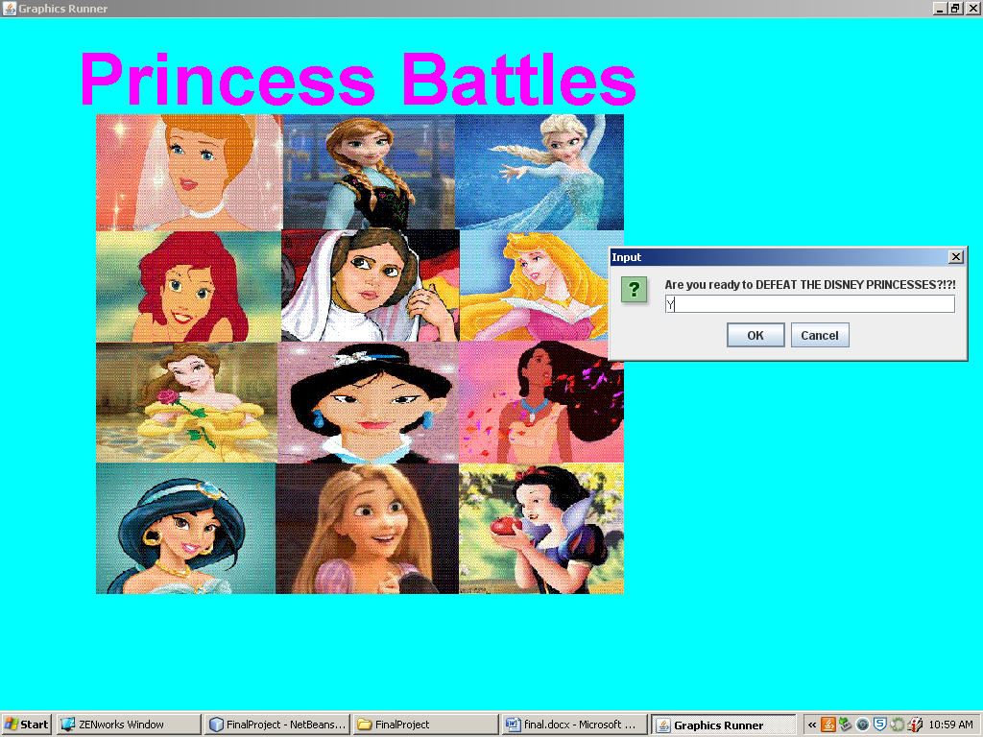

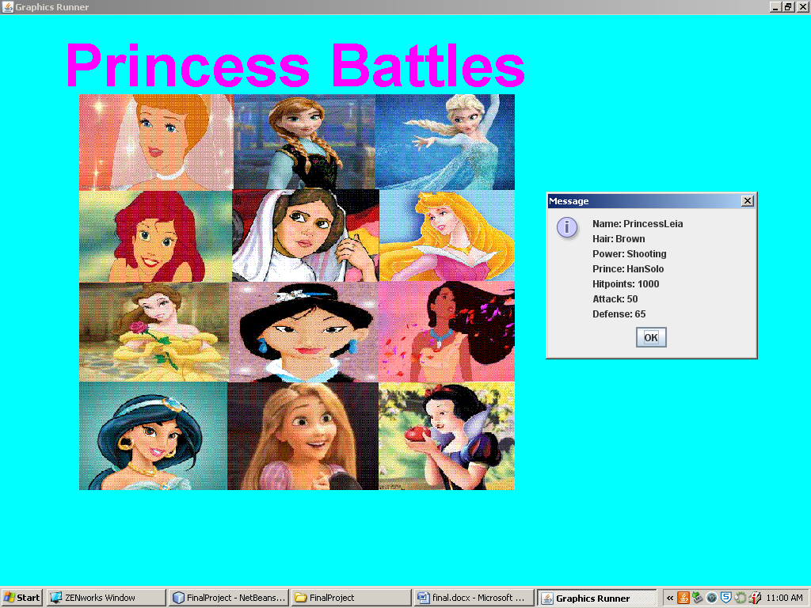

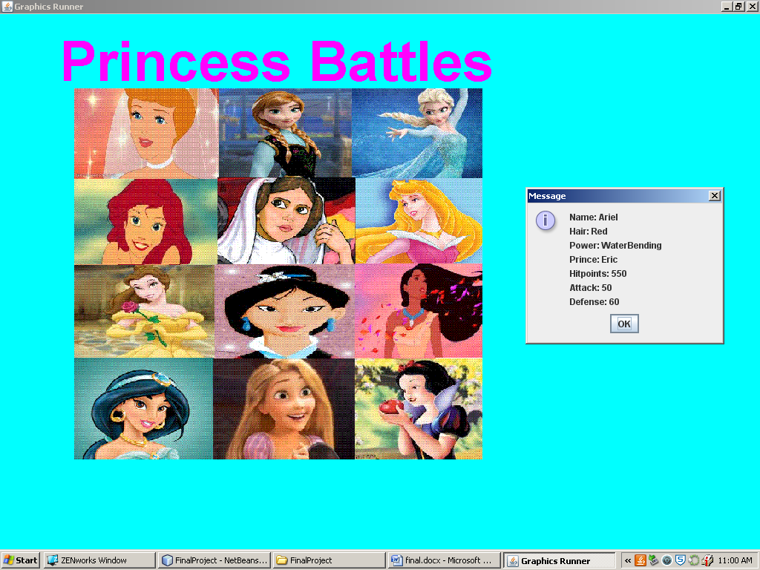

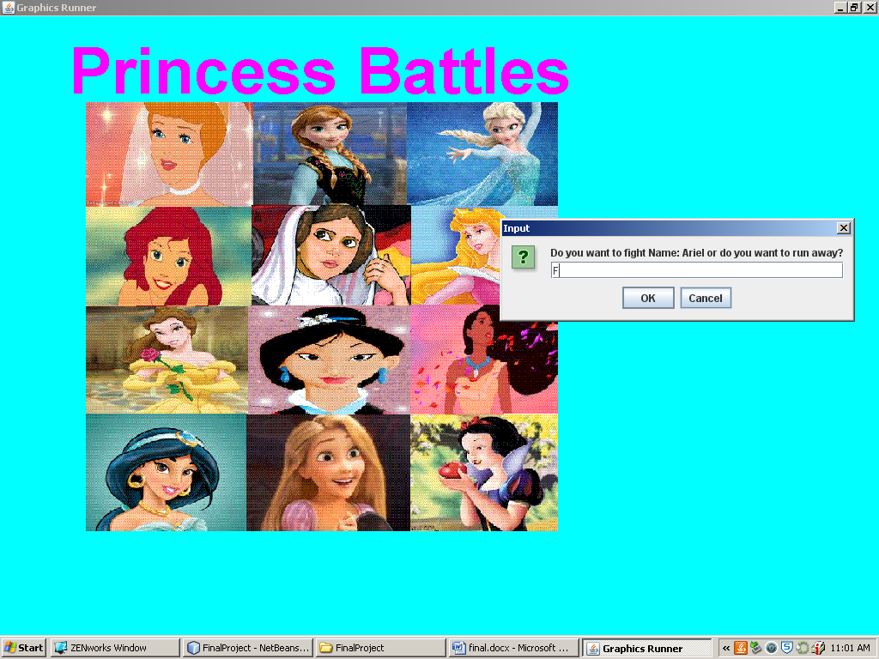

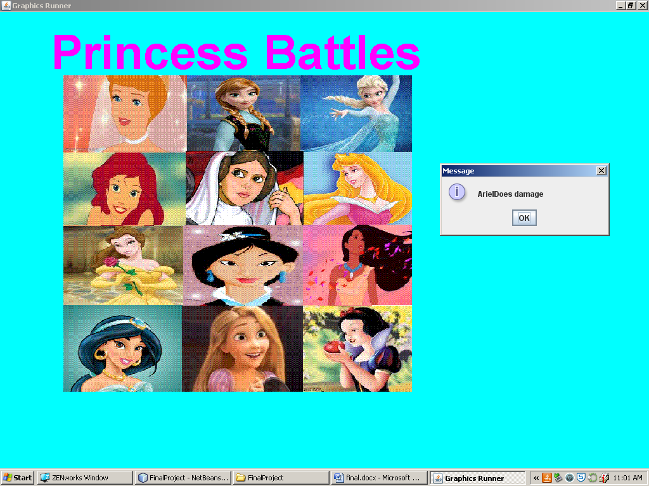

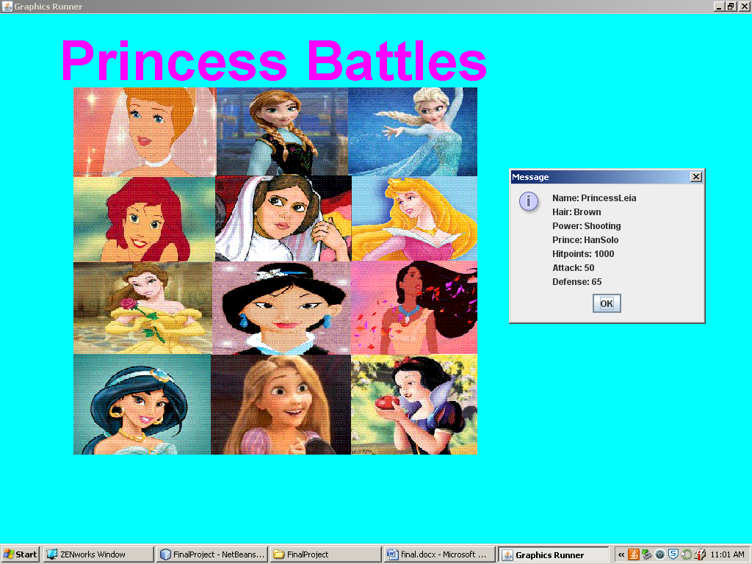

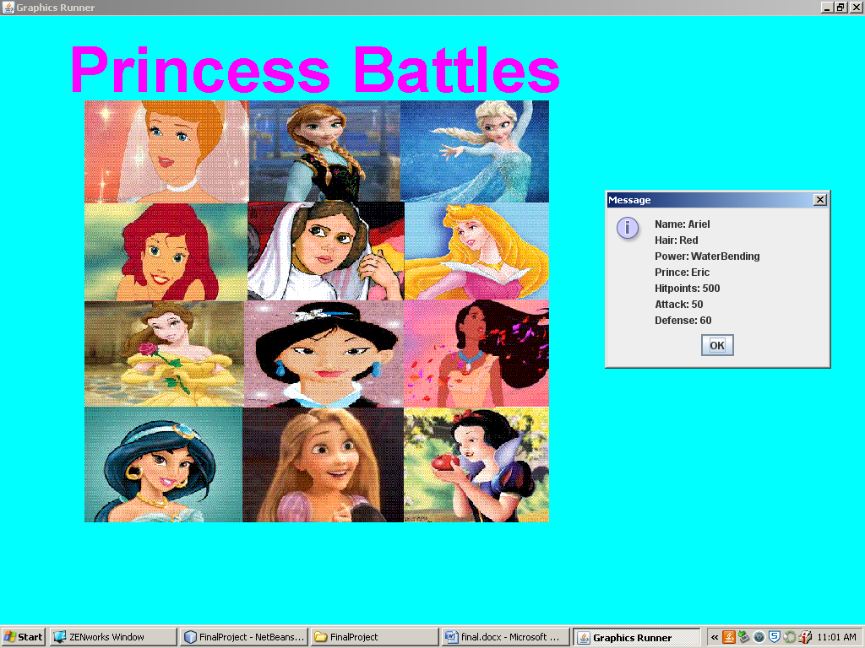

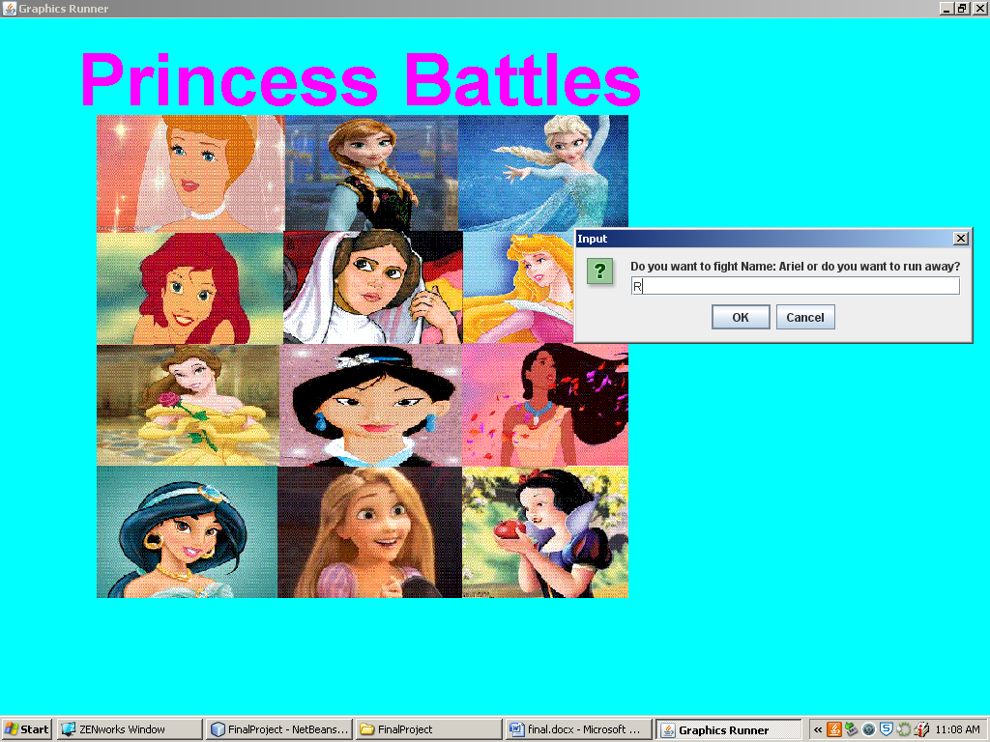

## Select Fighter Class

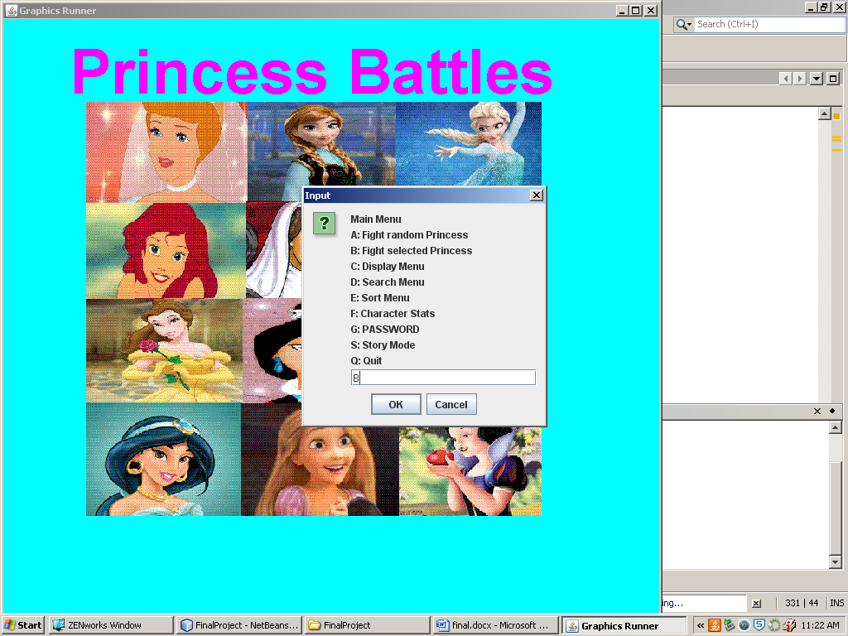

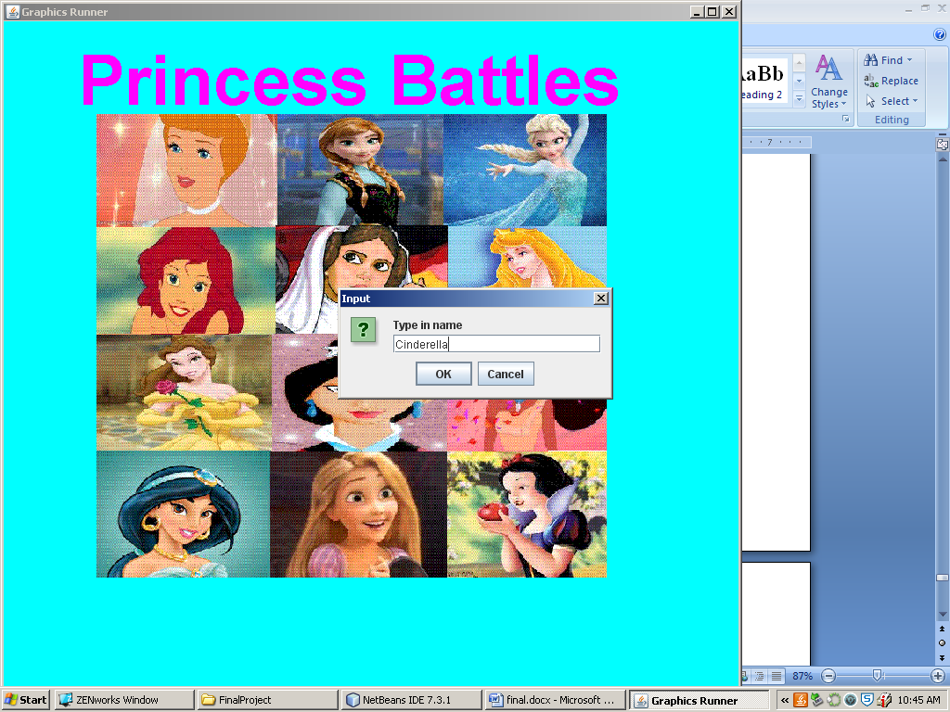

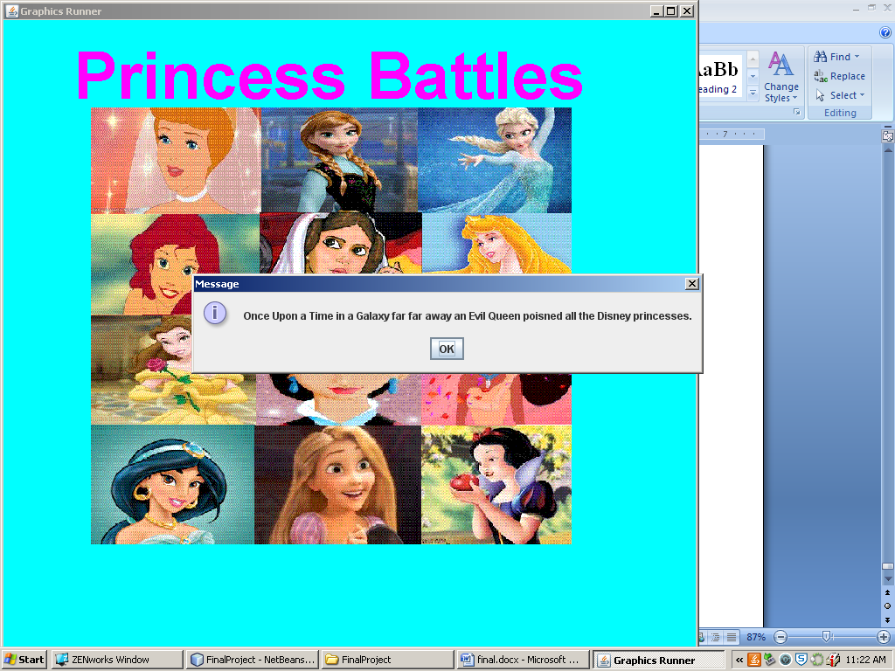

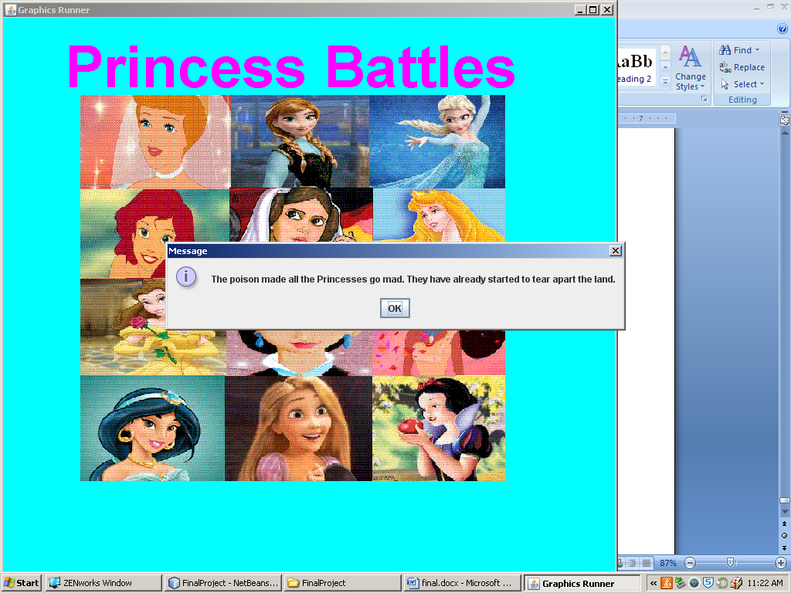

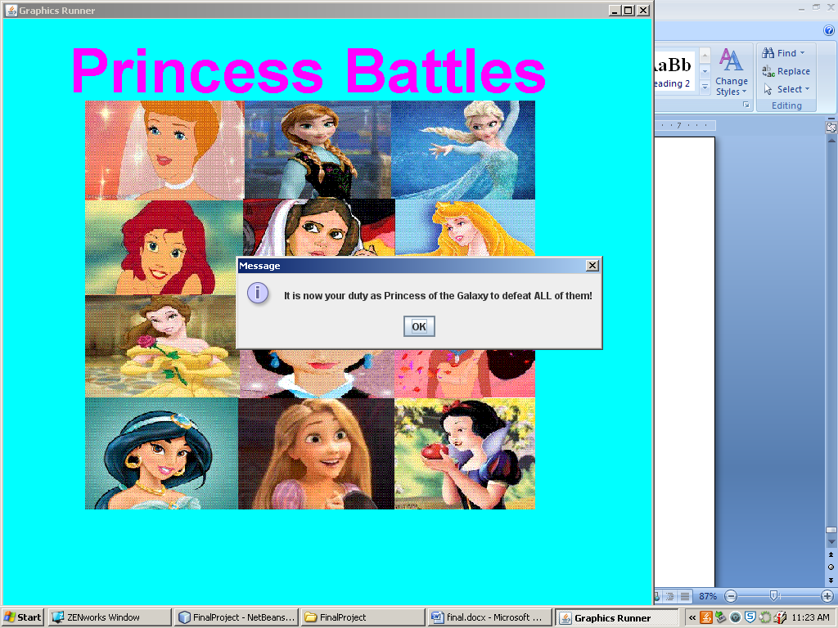

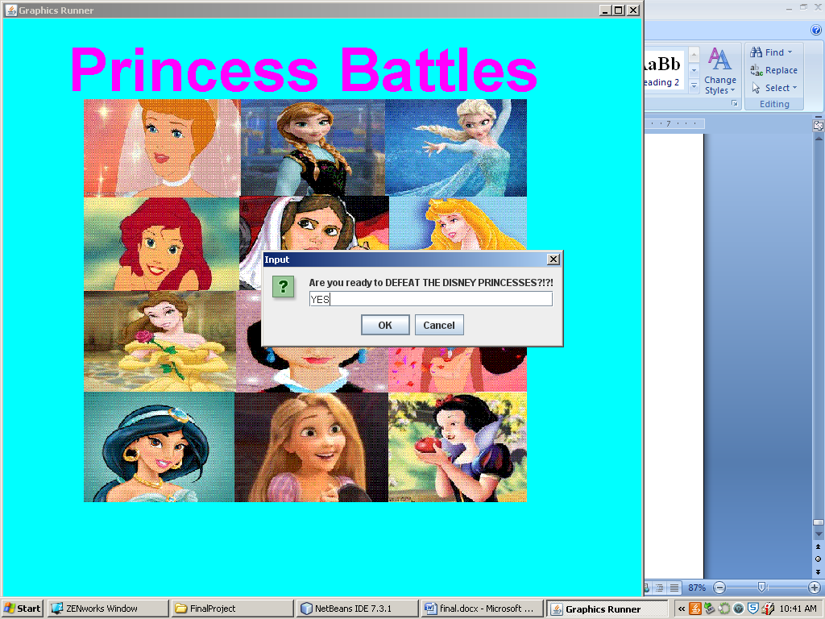

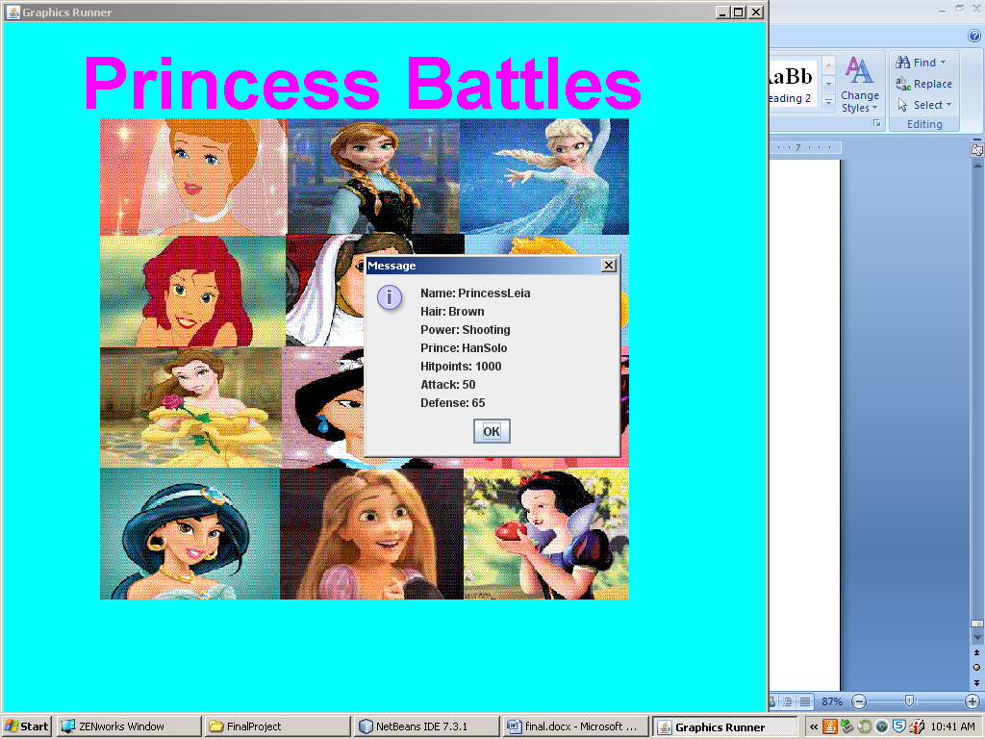

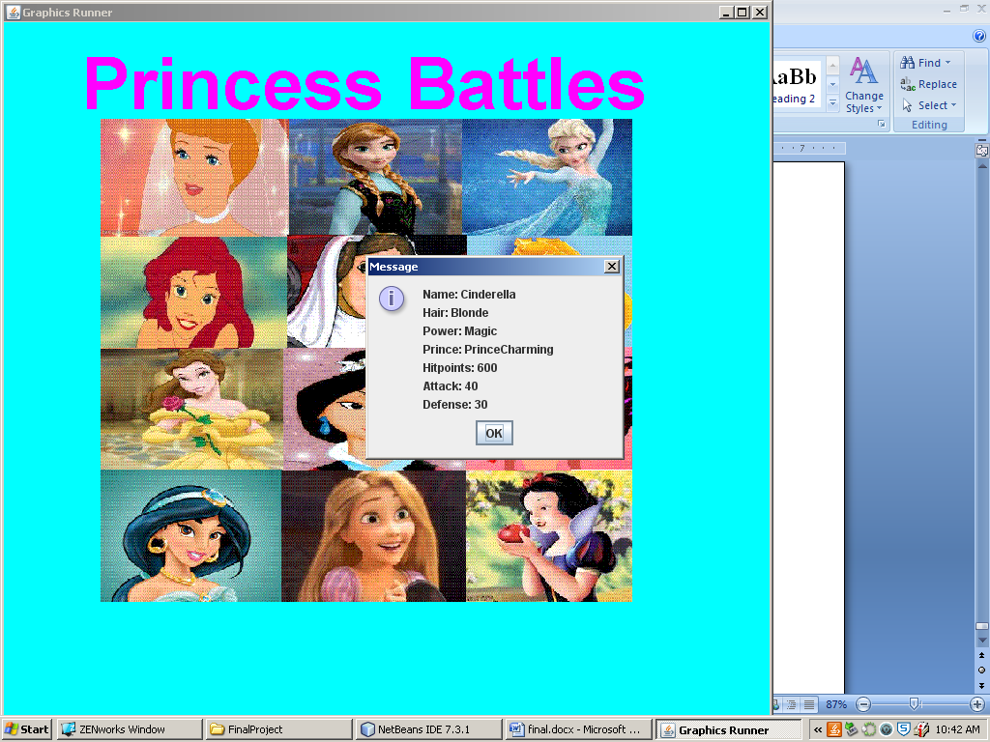

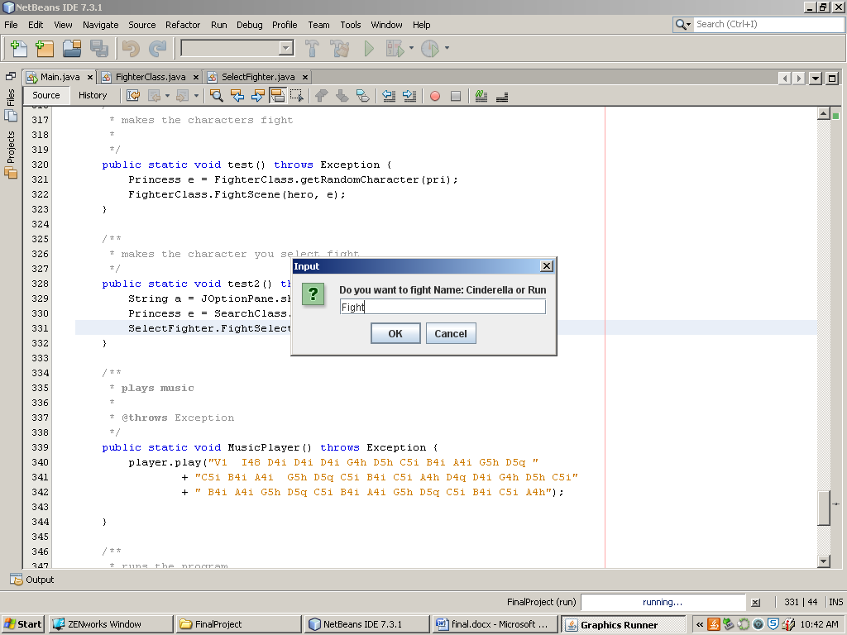

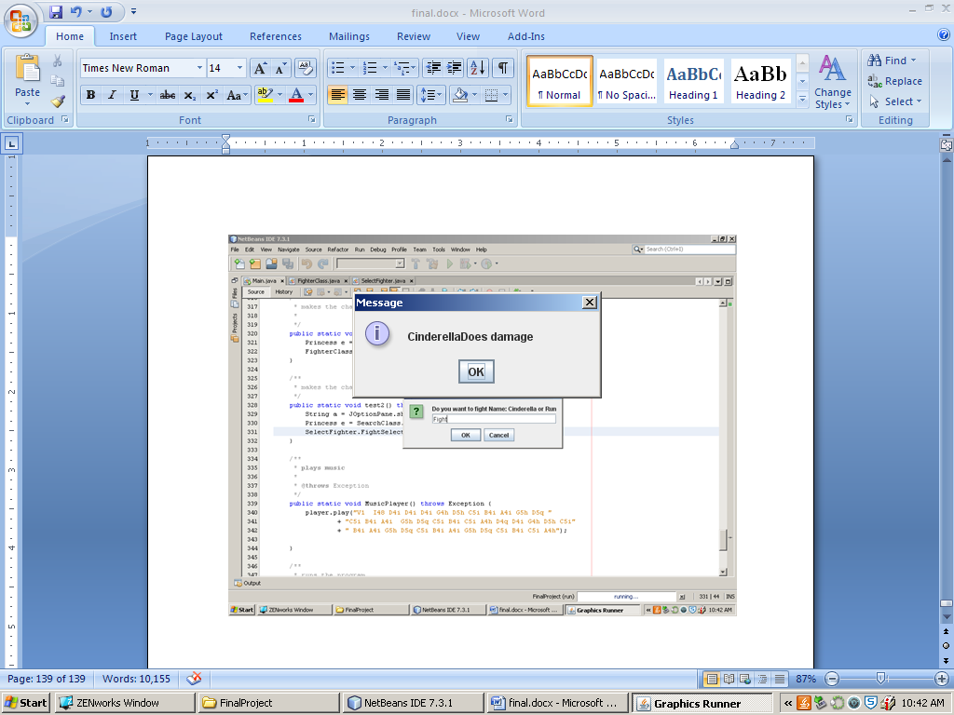

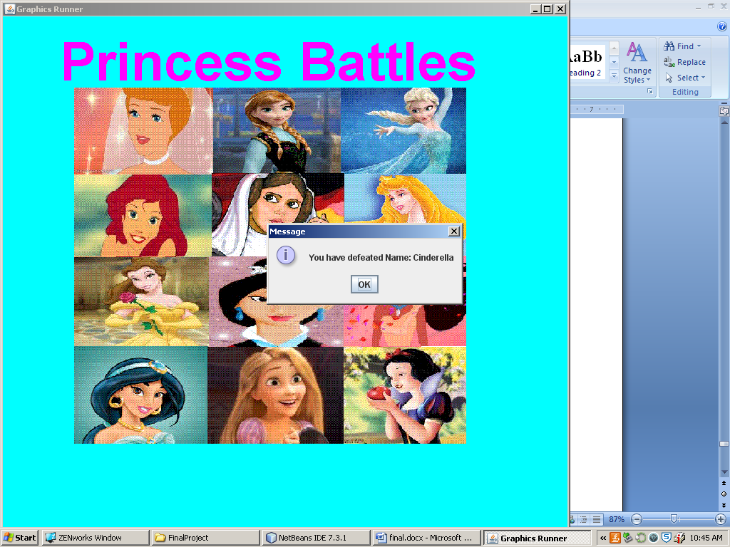

## Display Menu

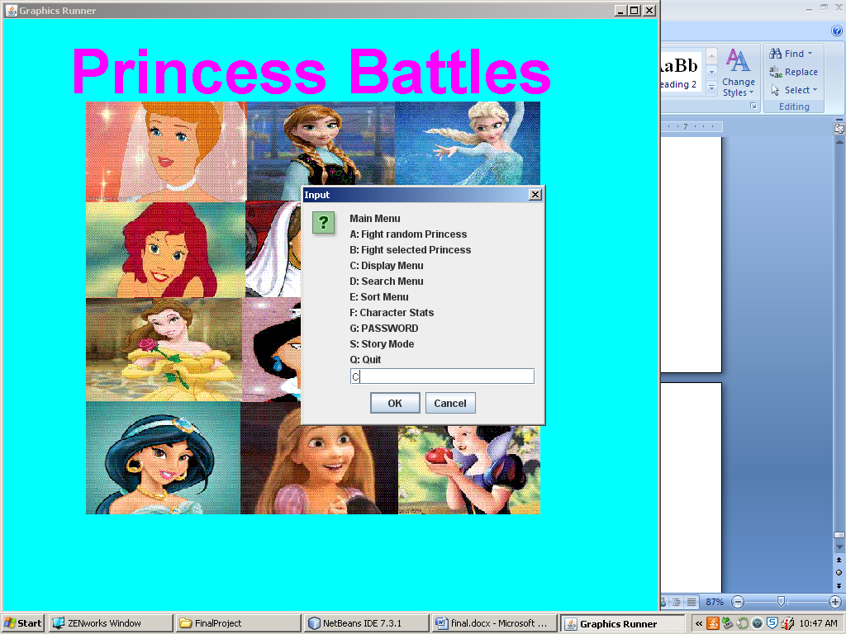

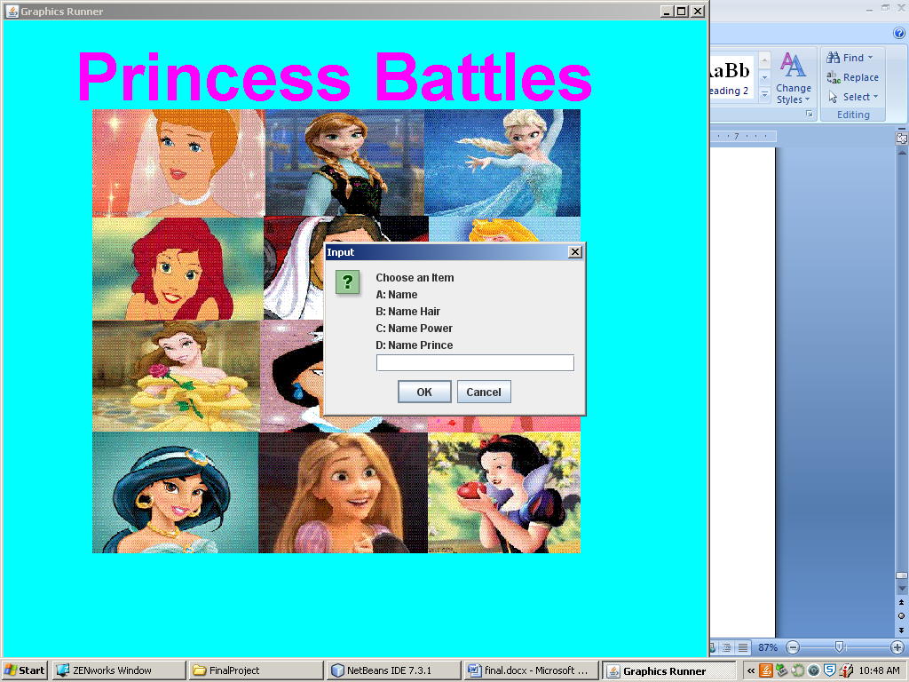

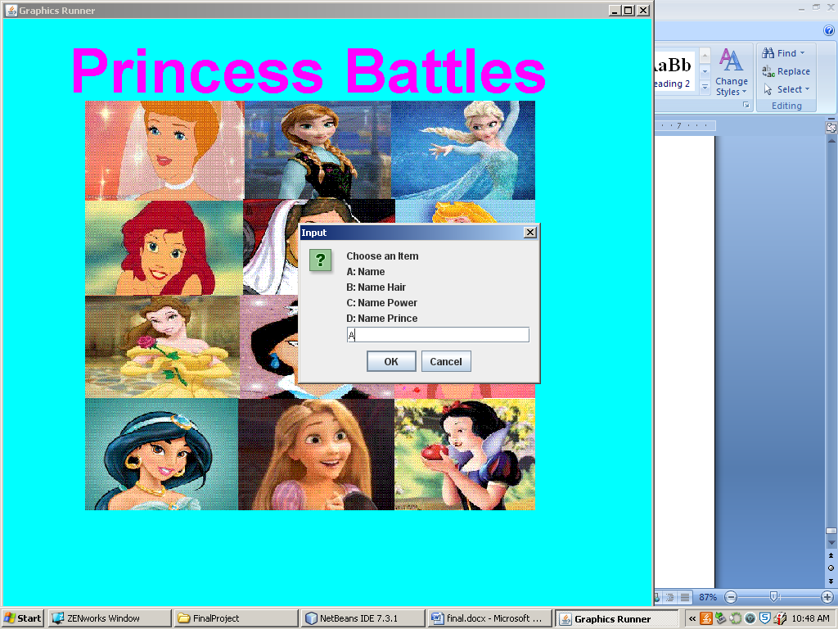

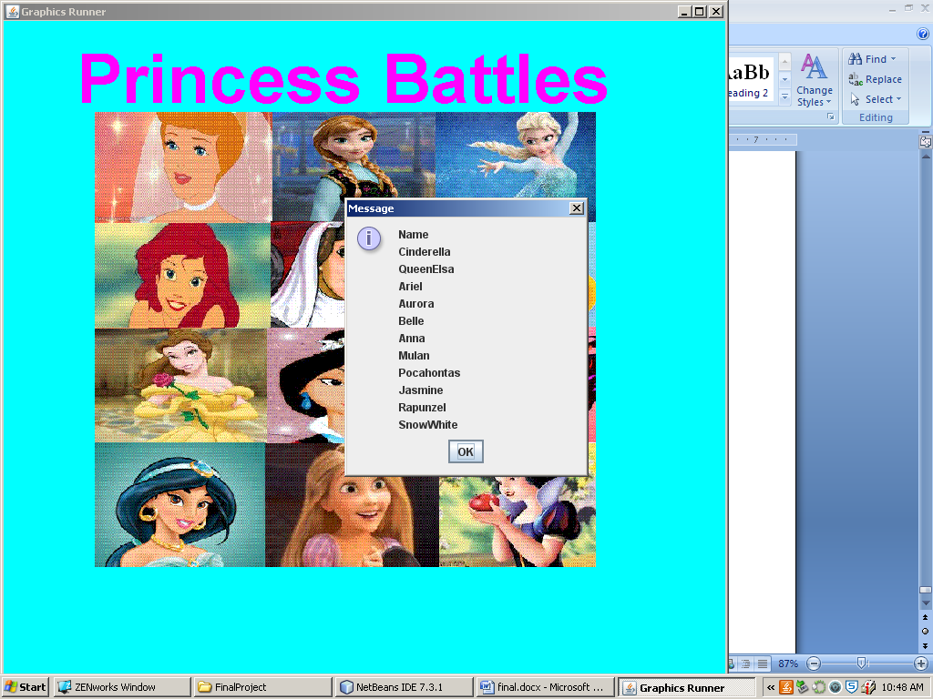

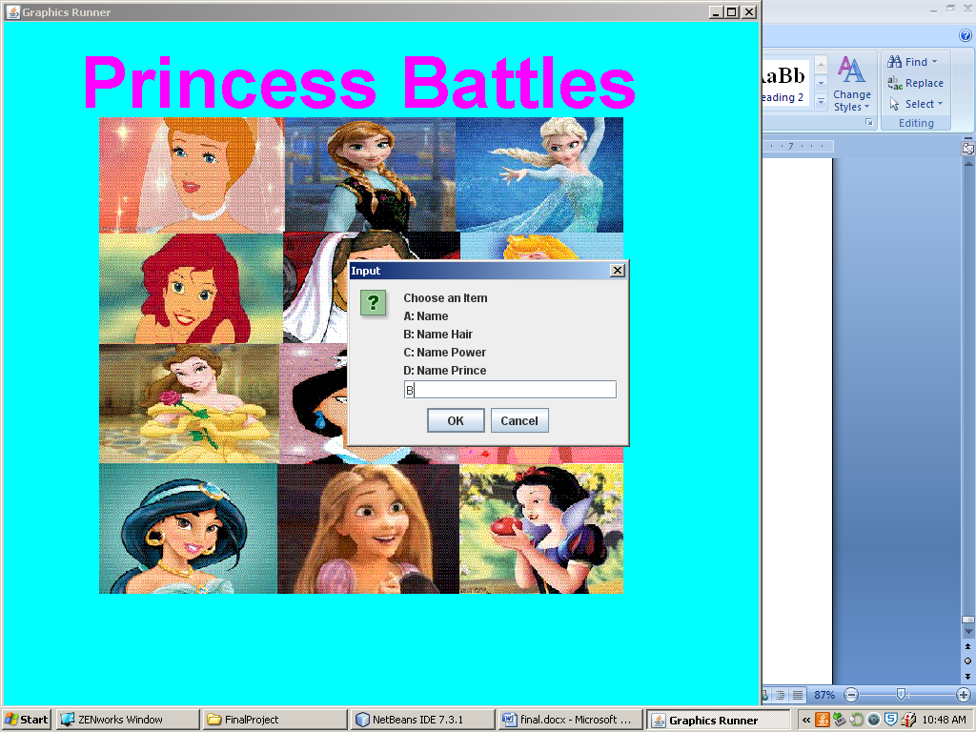

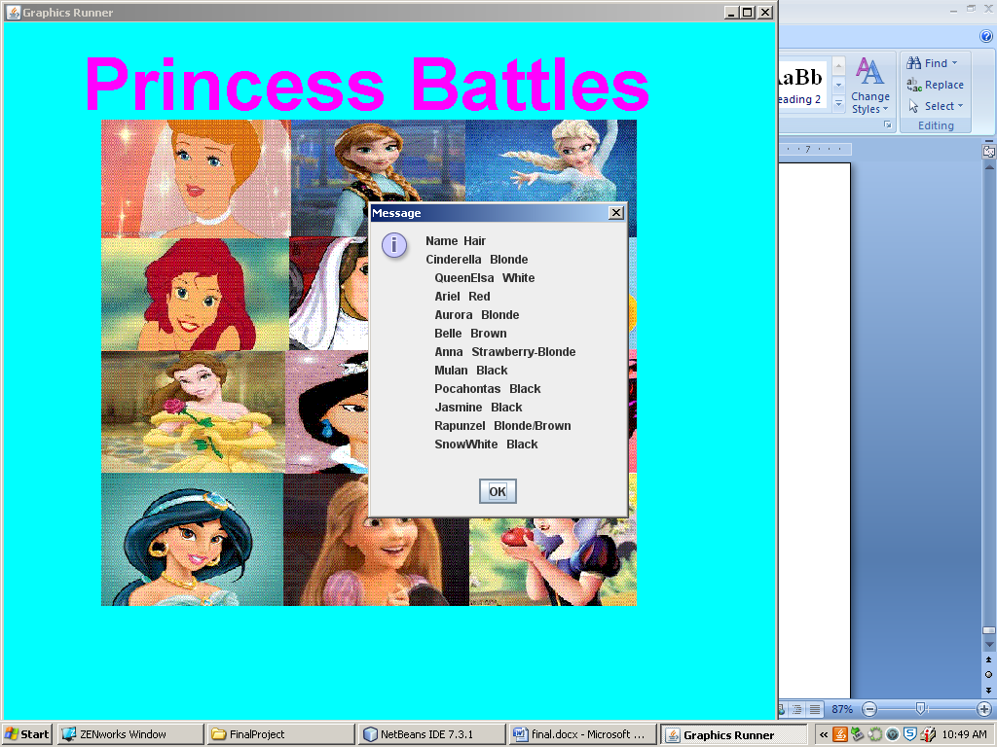

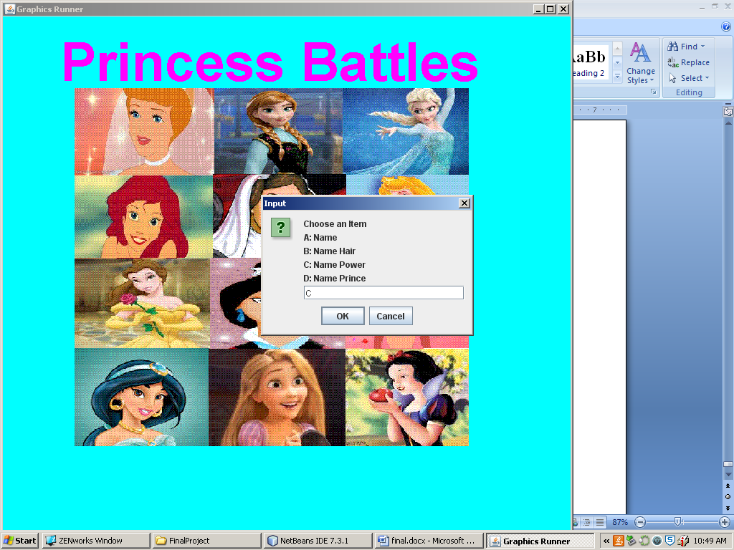

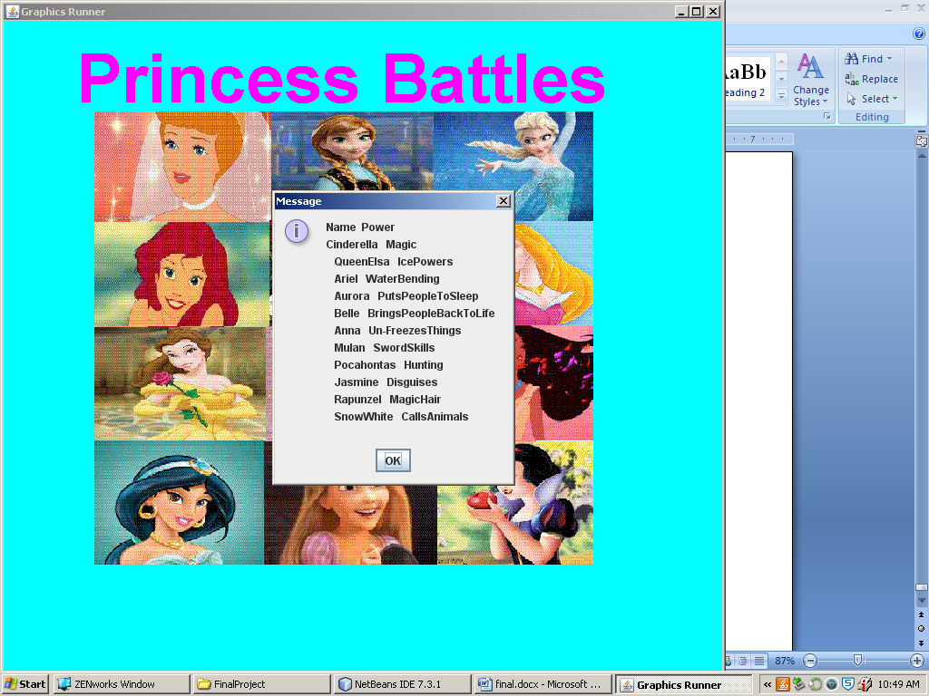

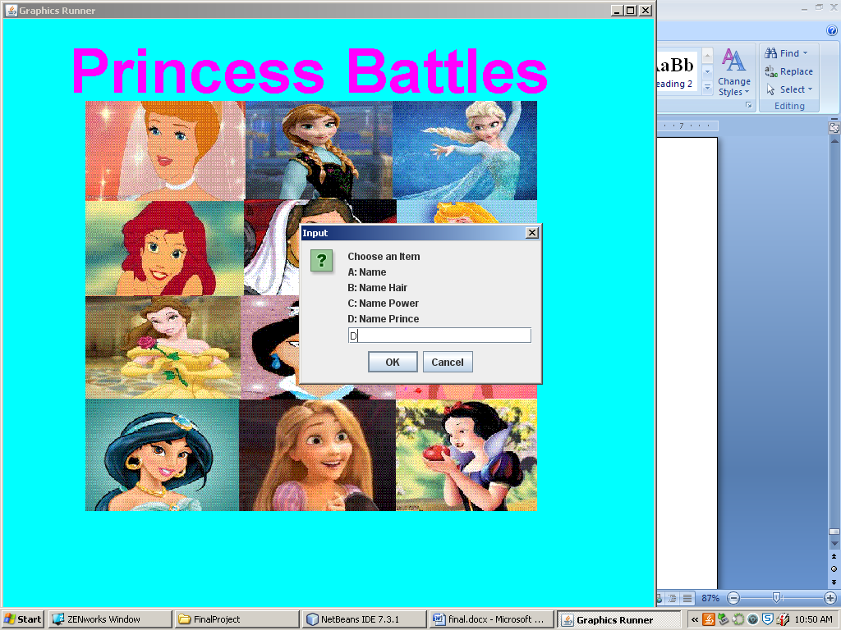

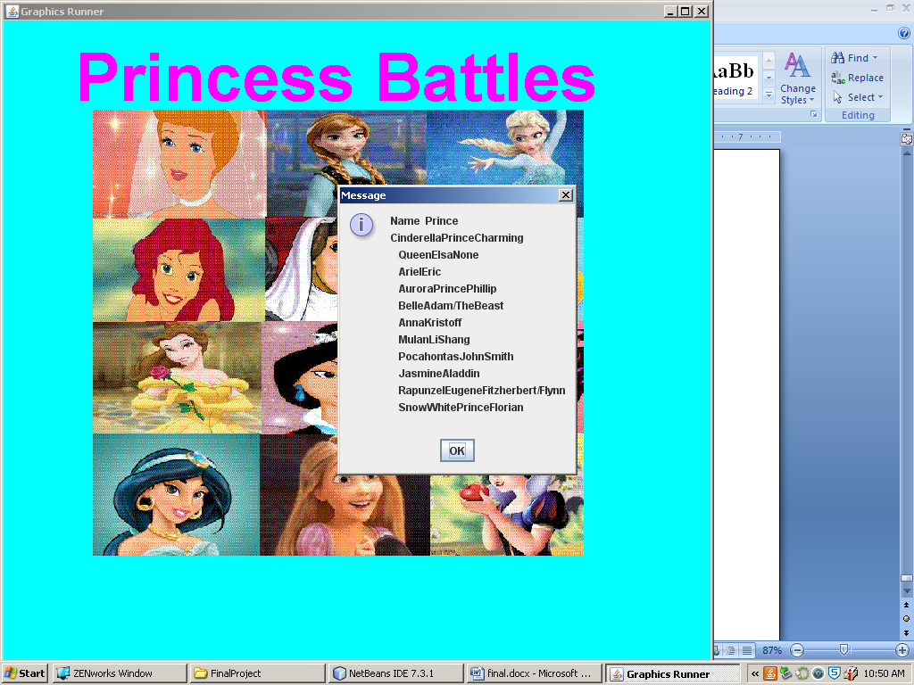

## Search Menu

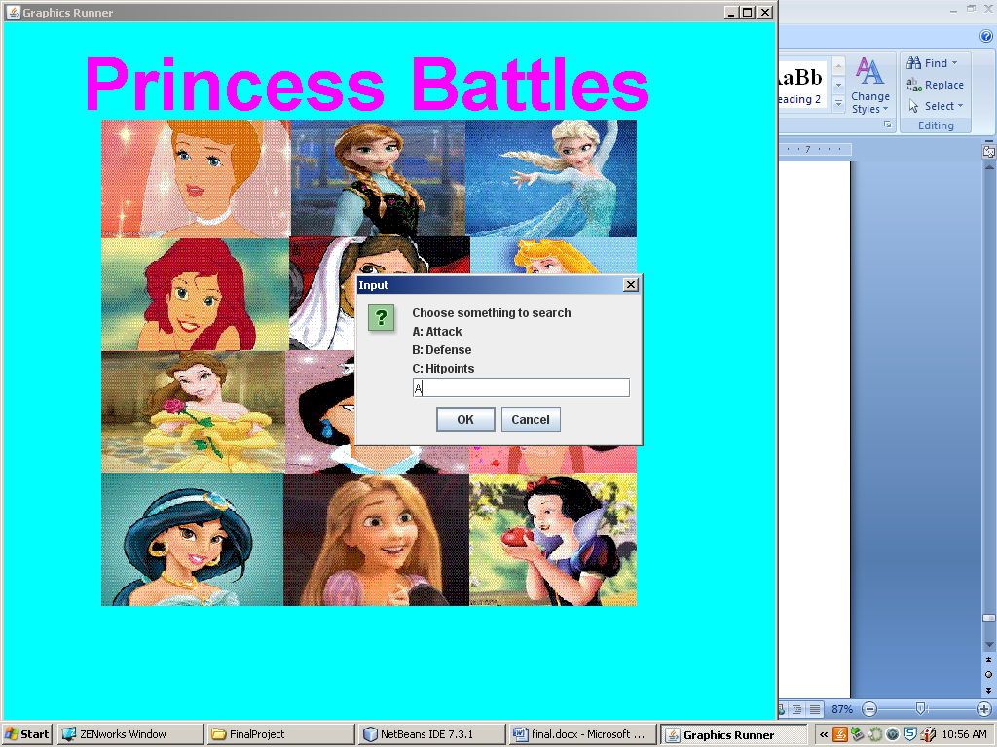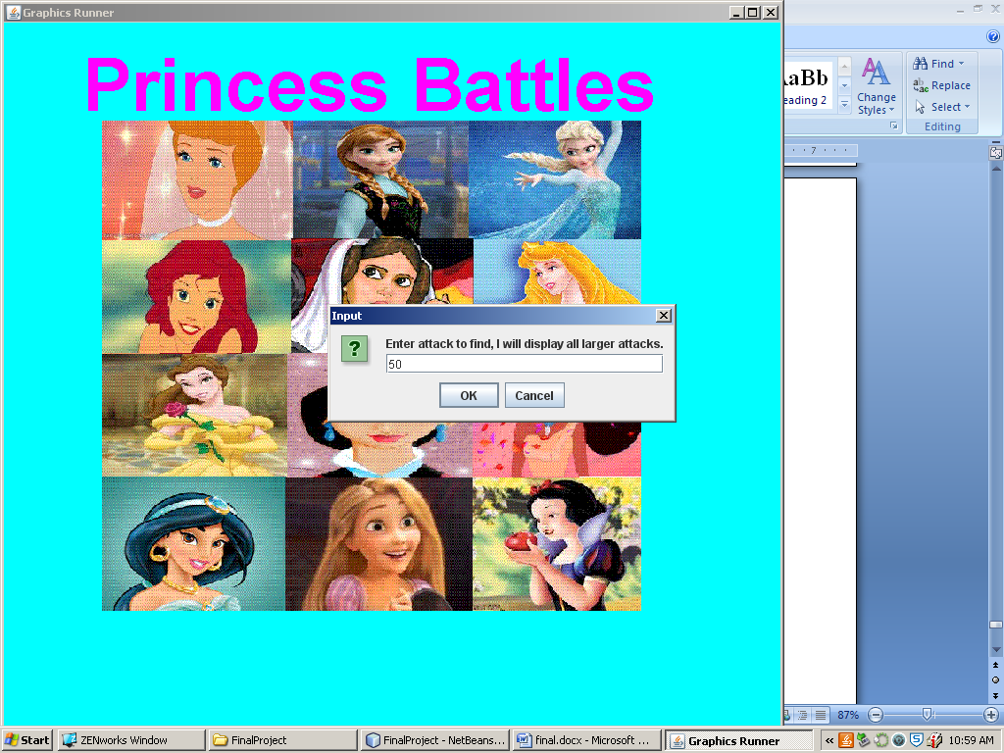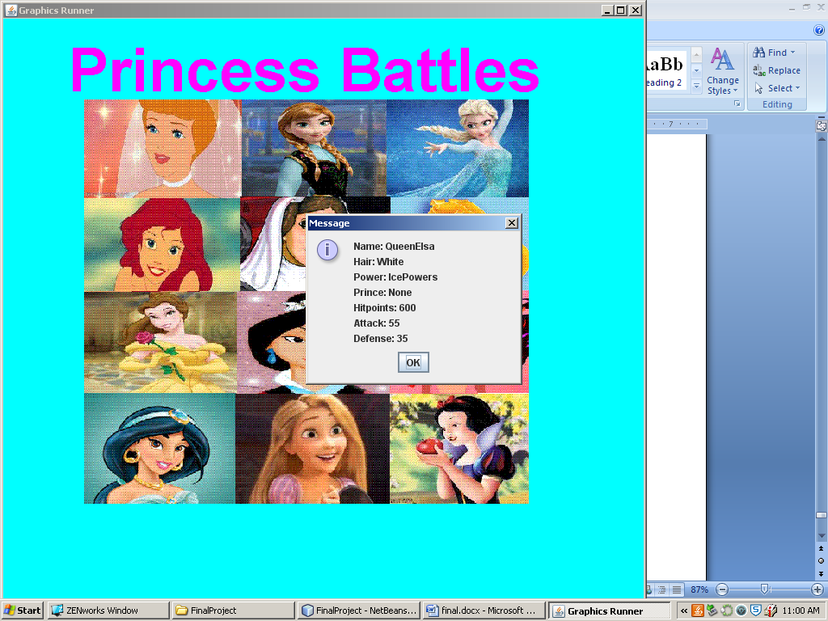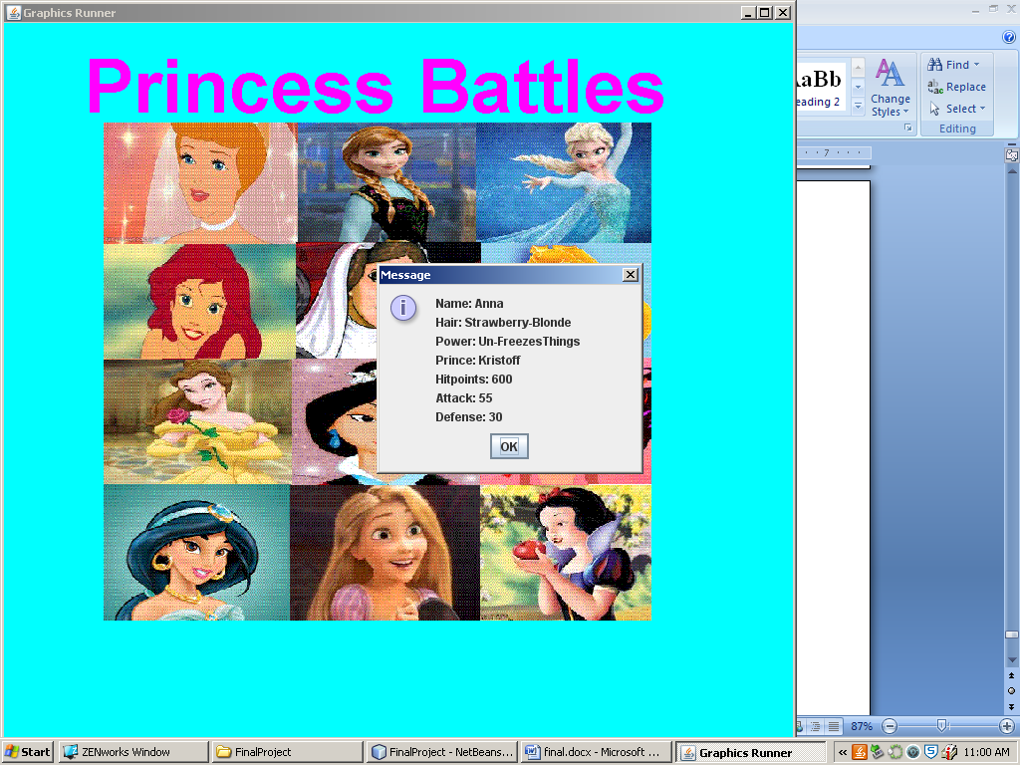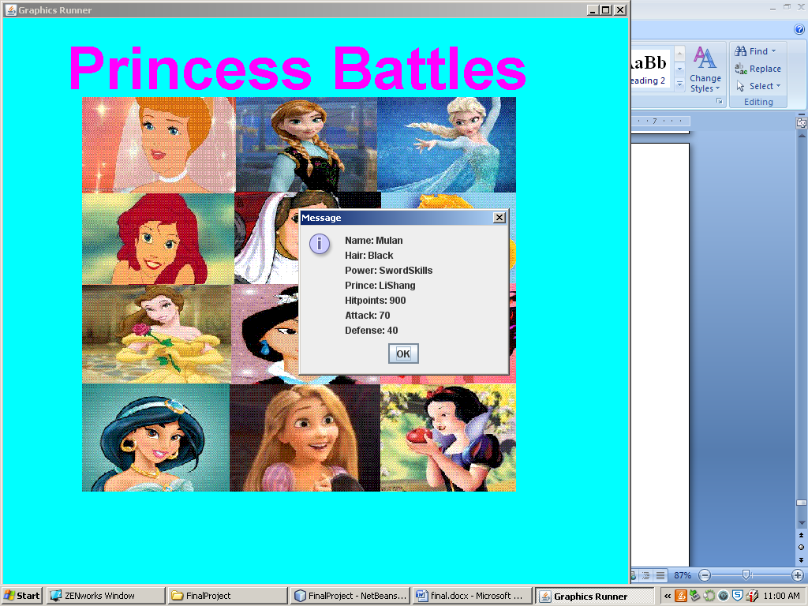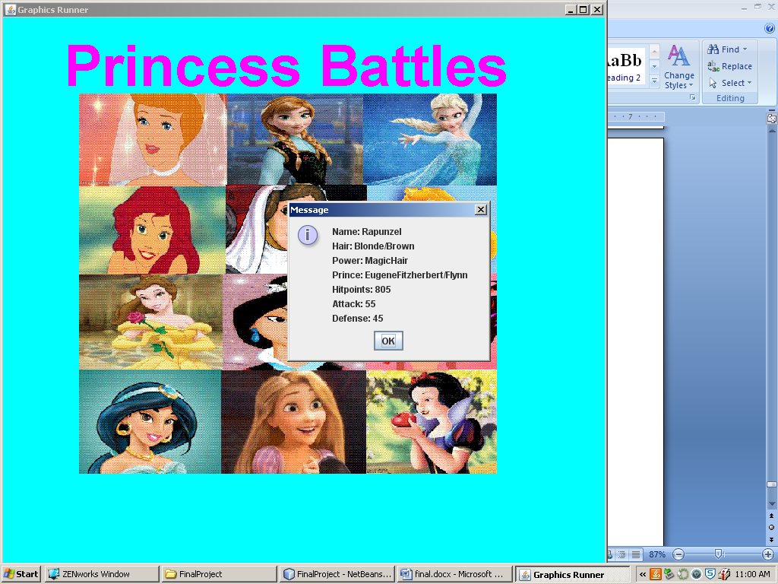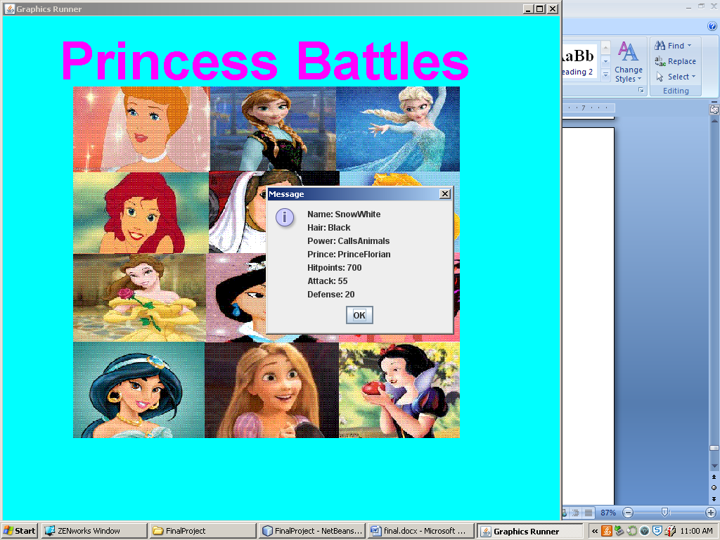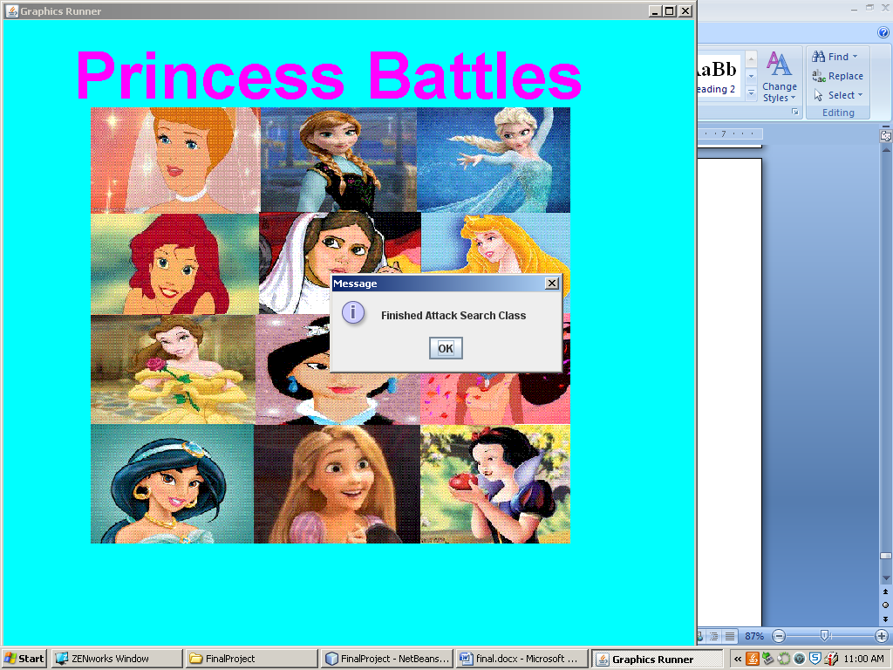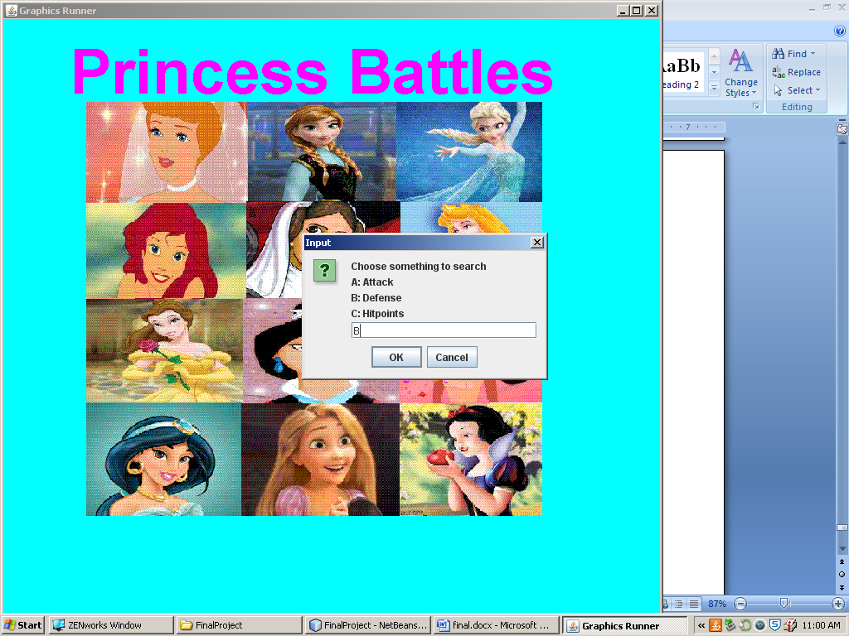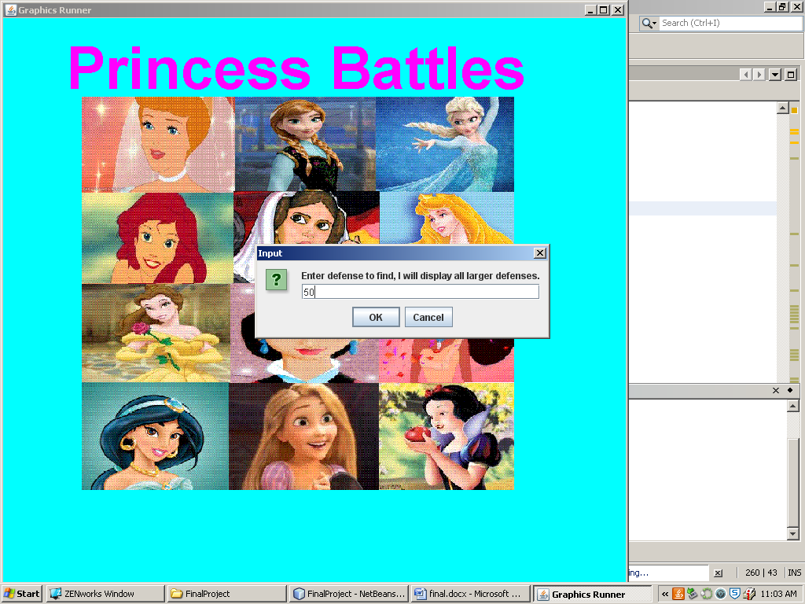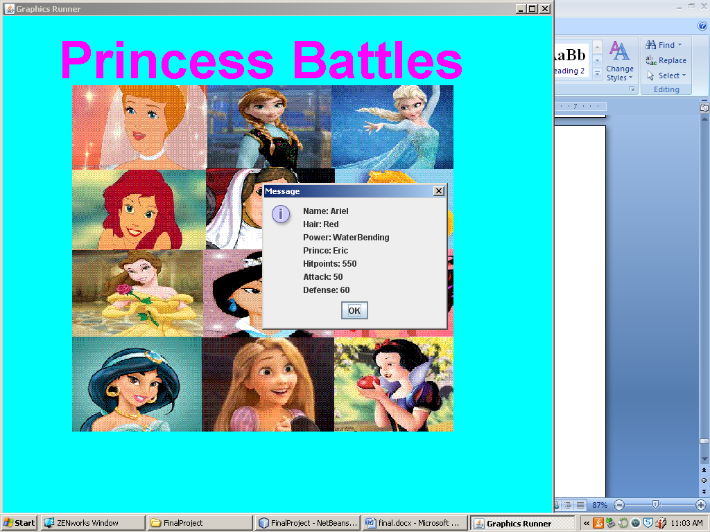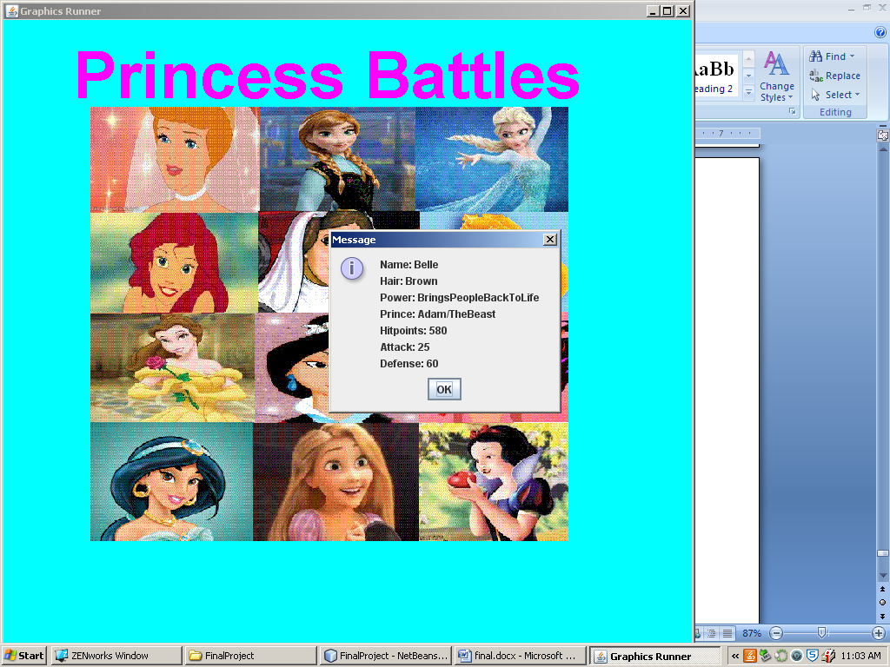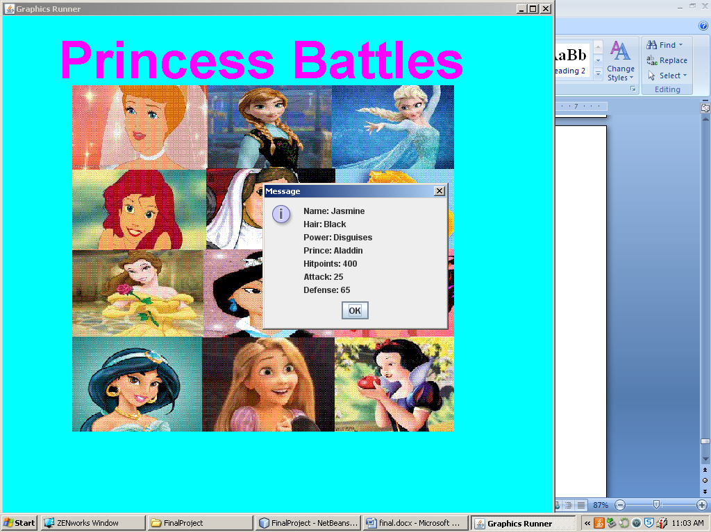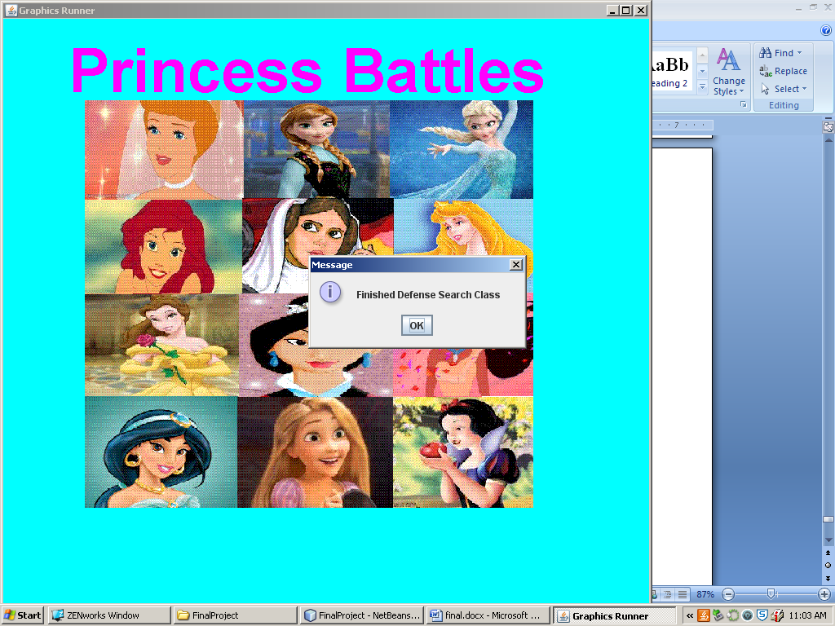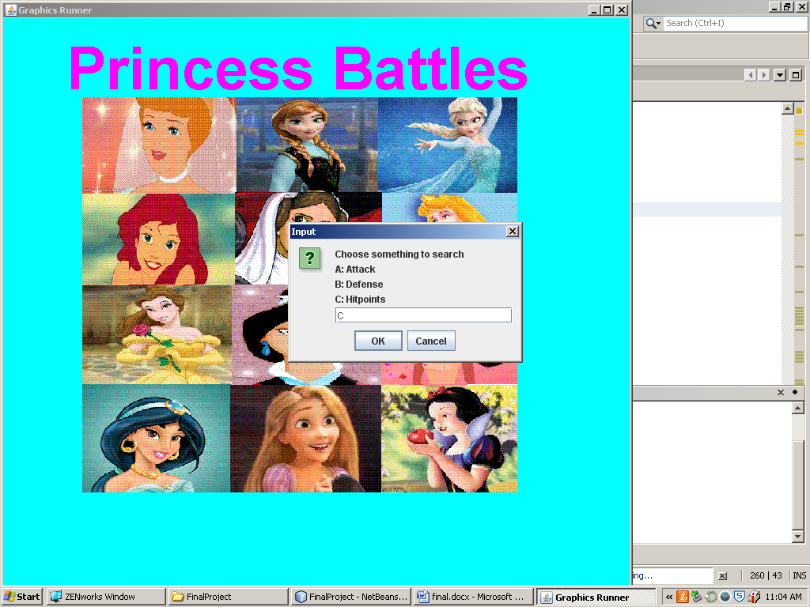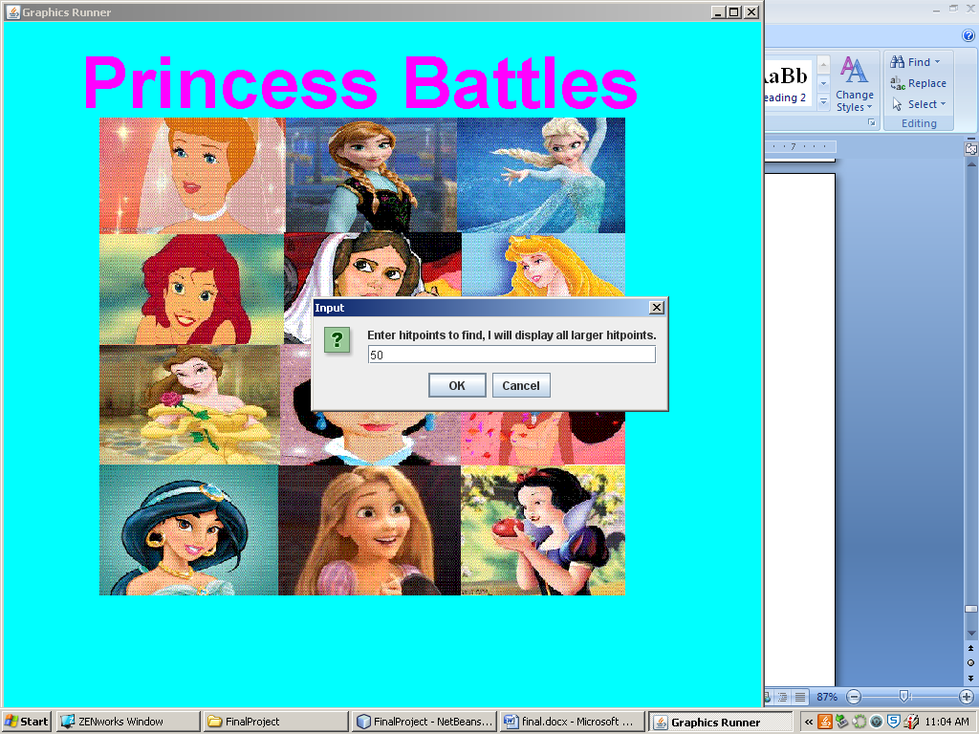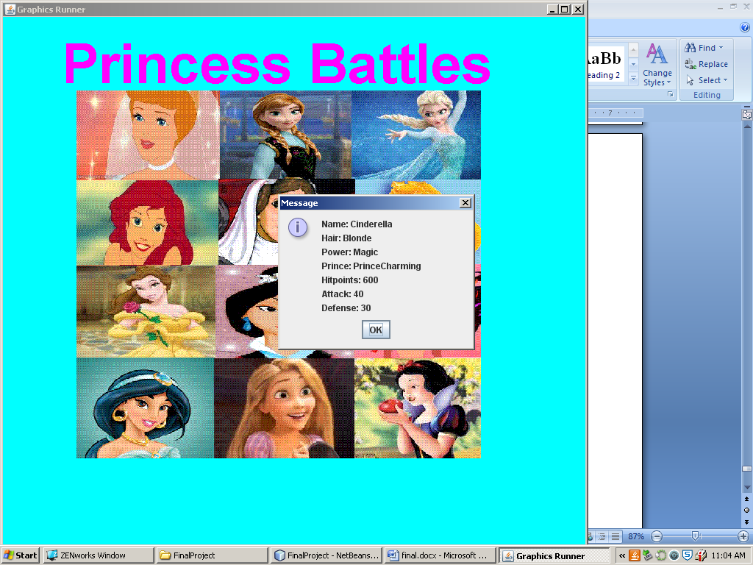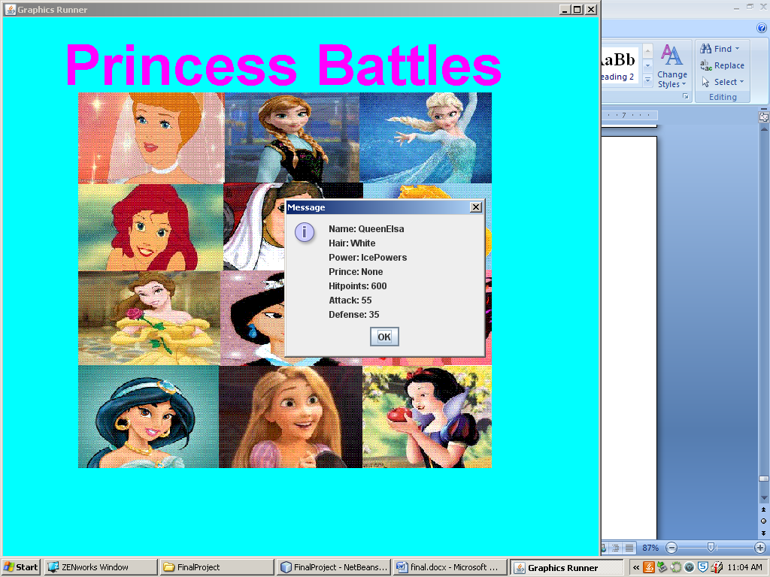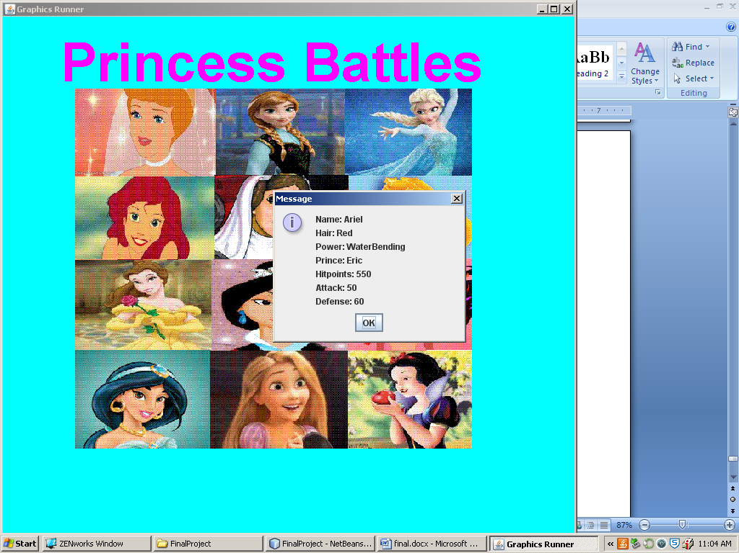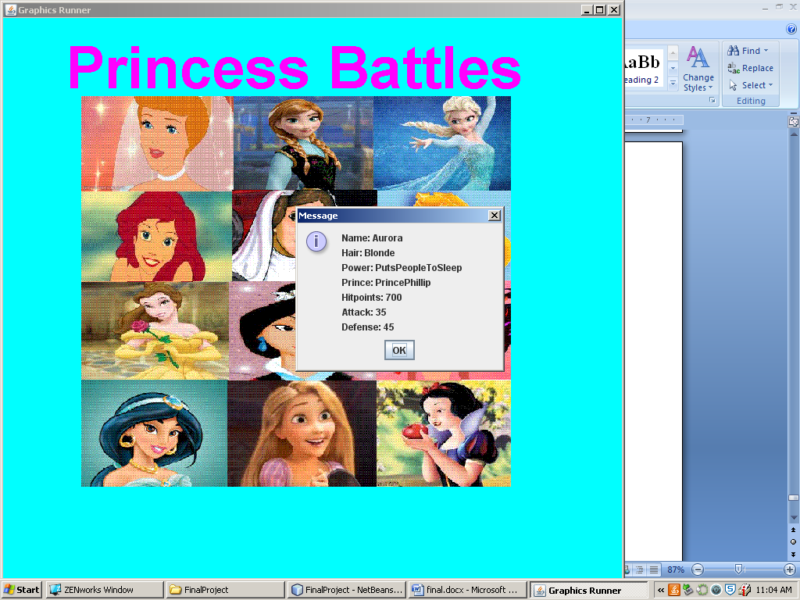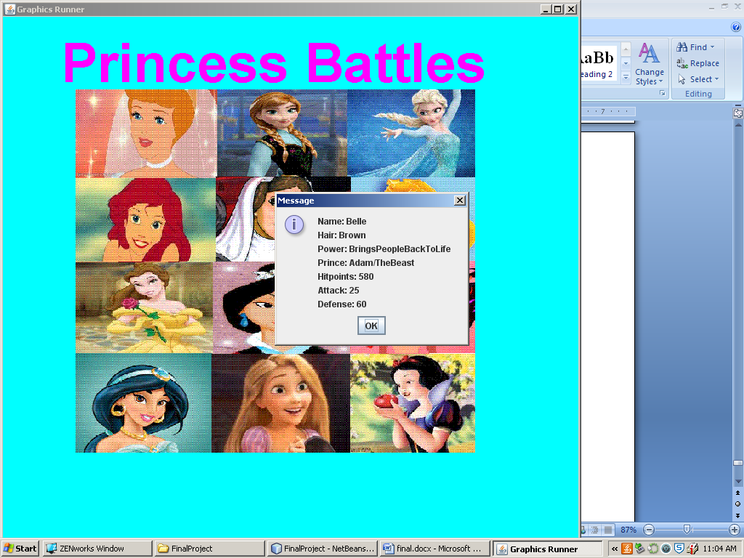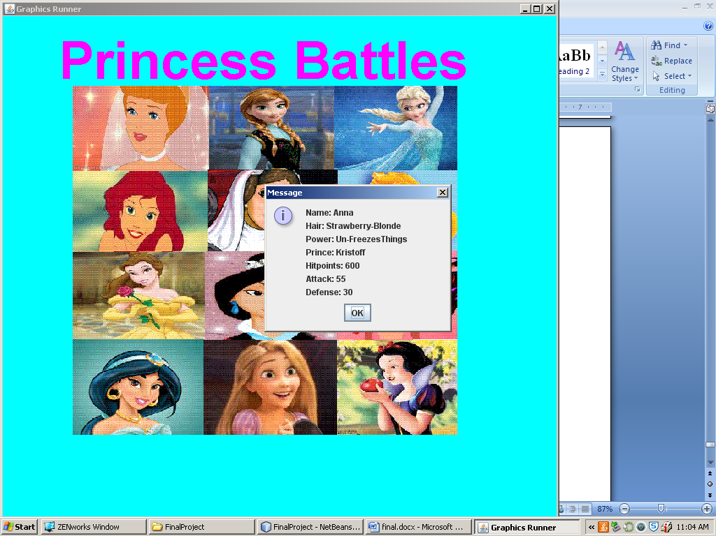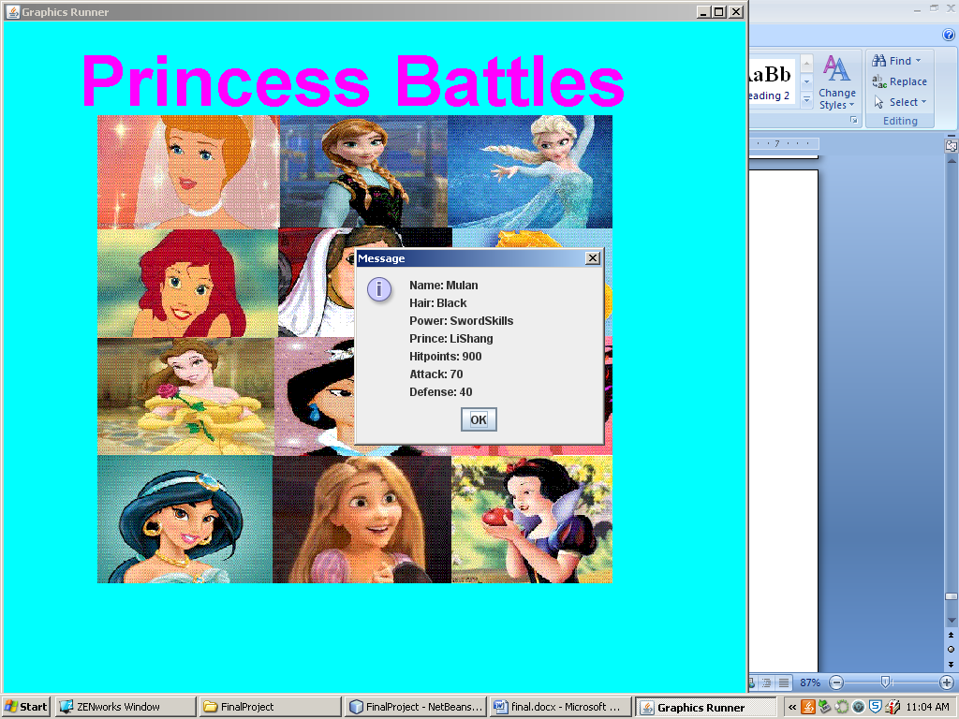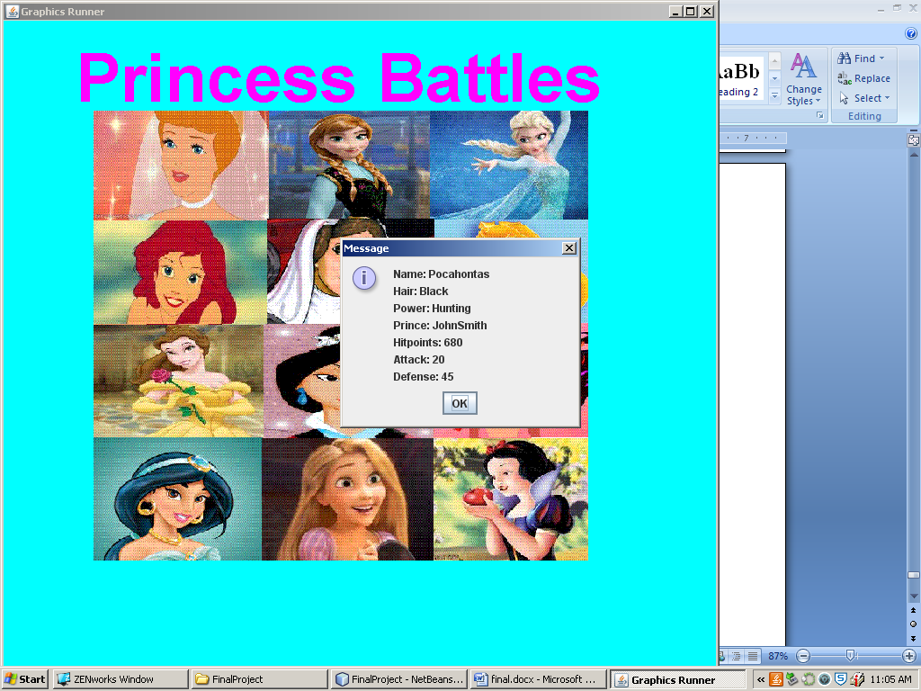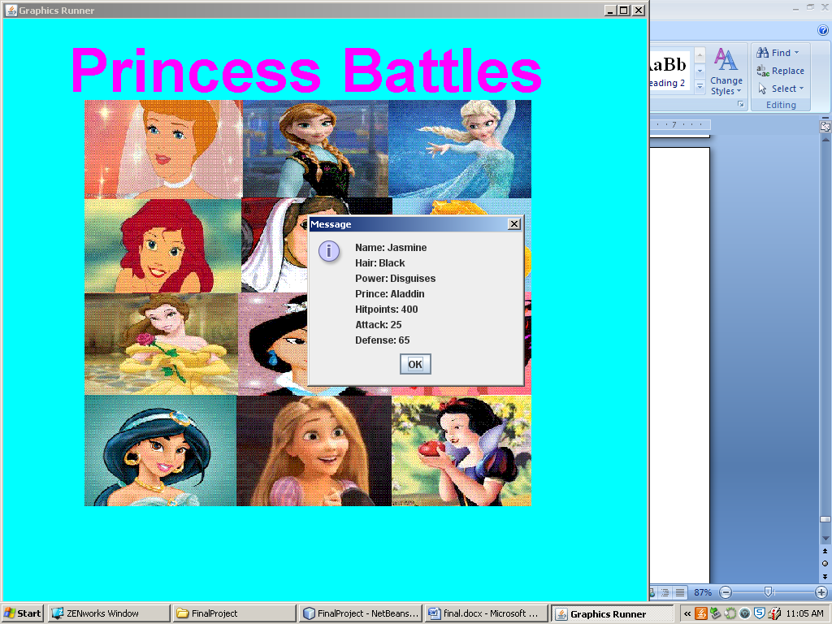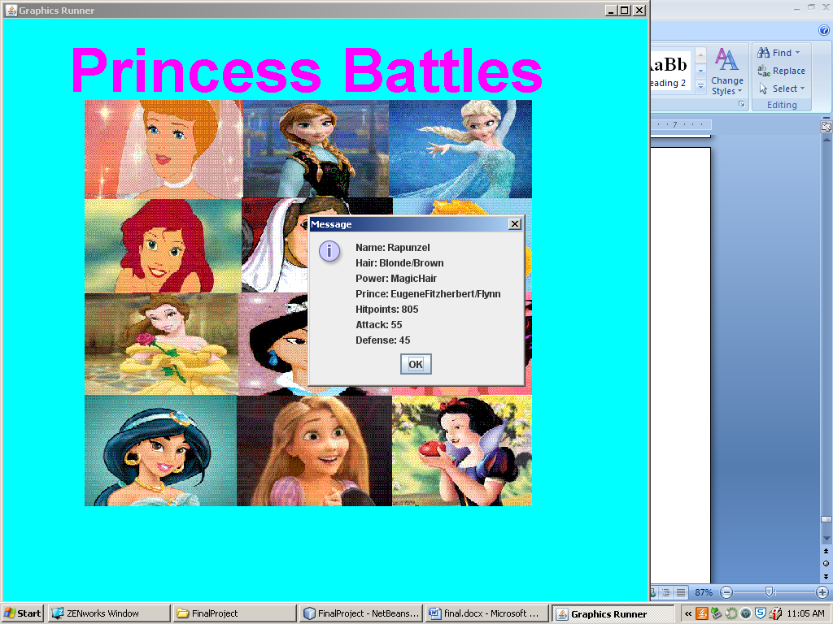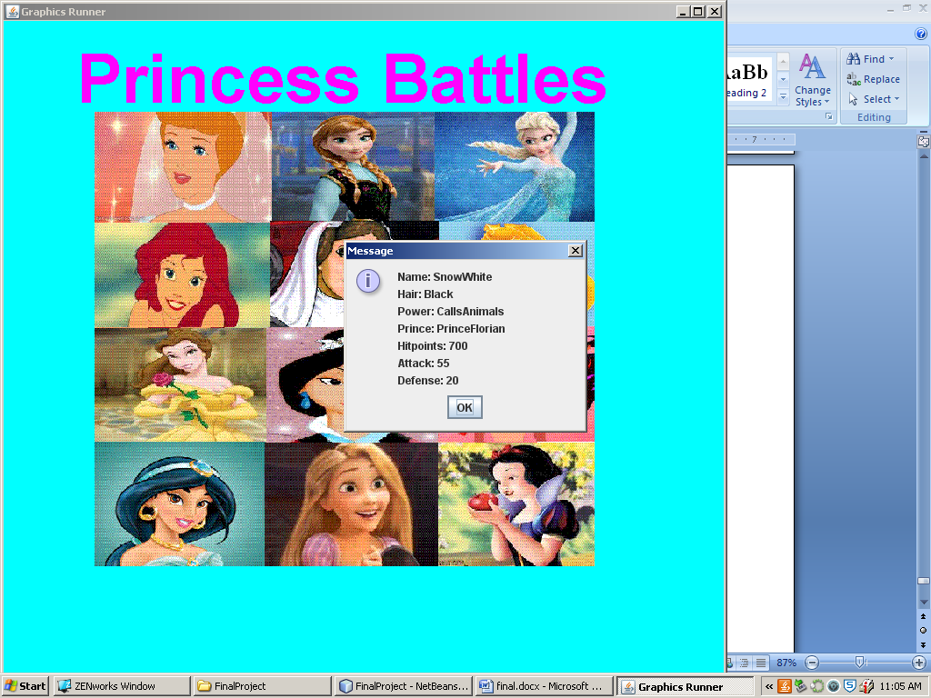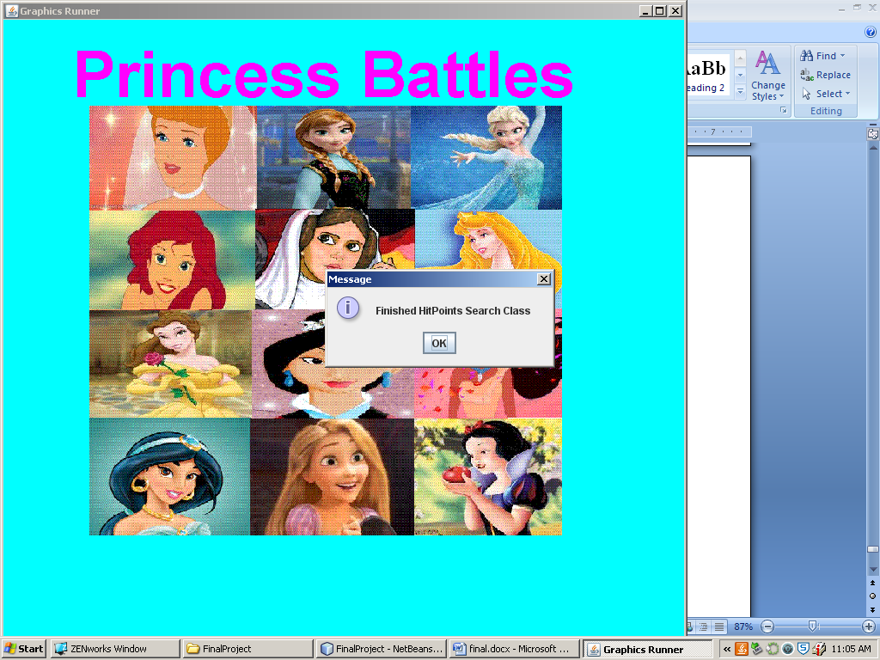

## Sort Menu

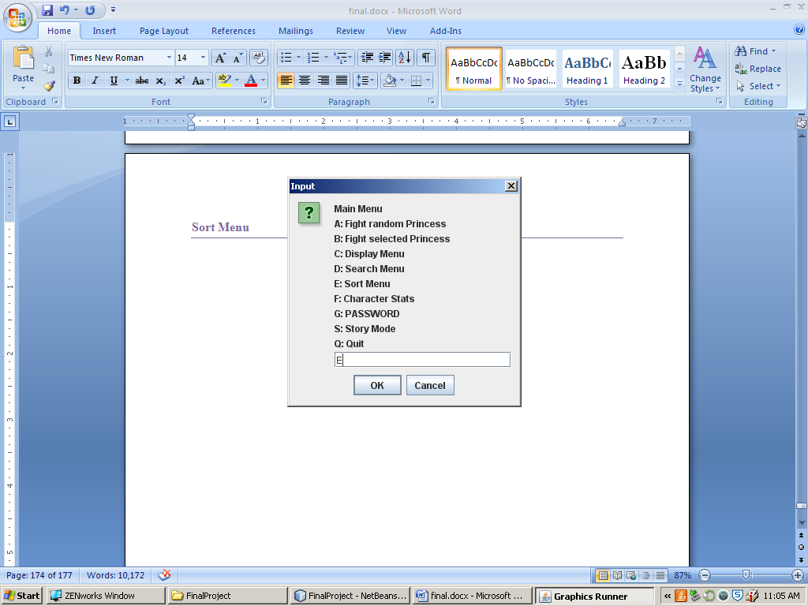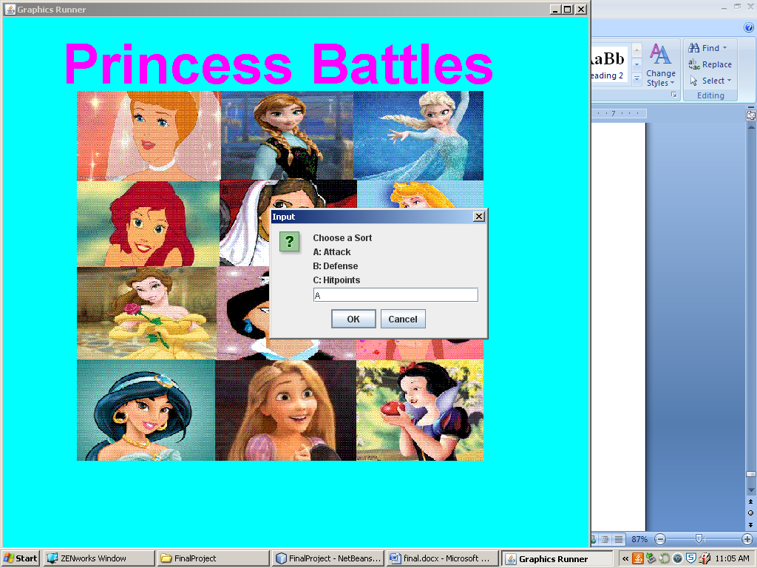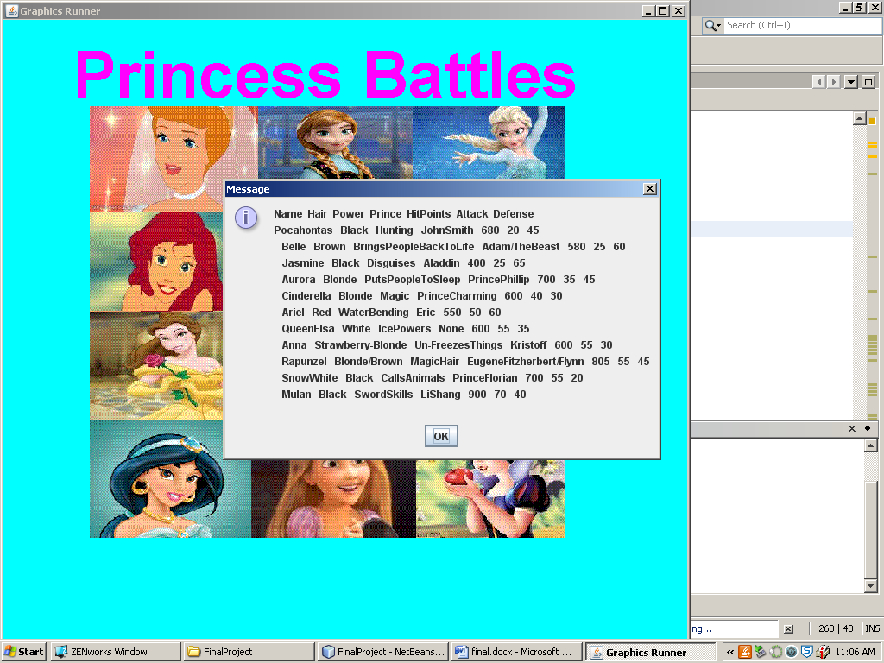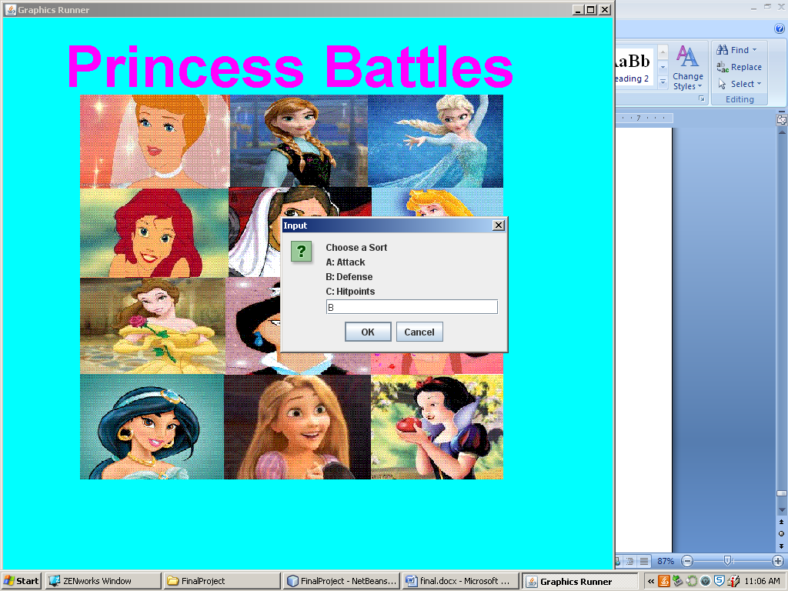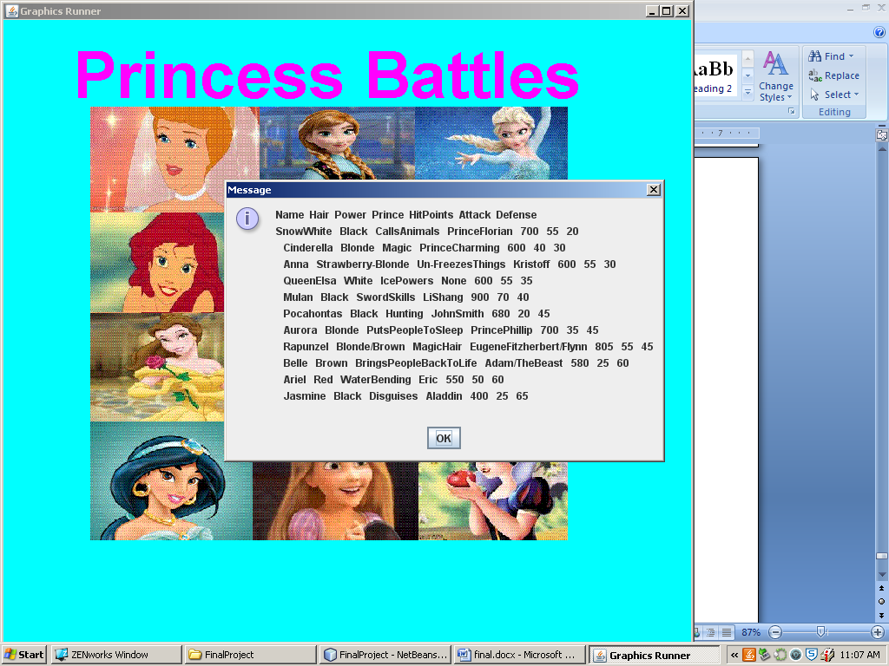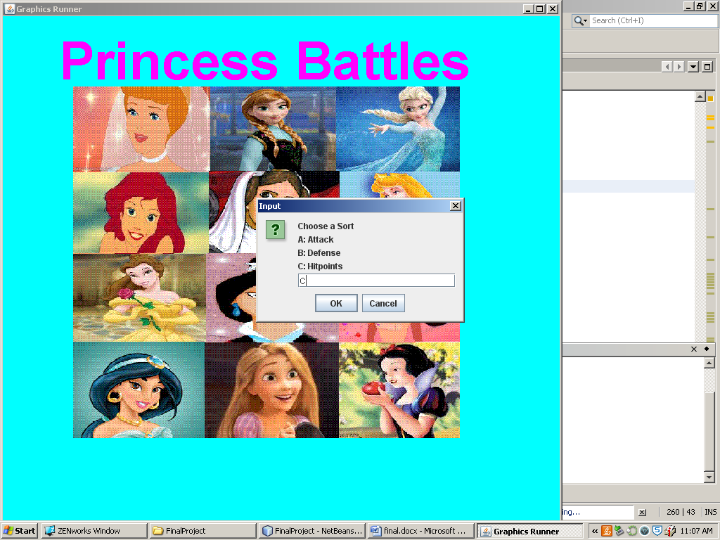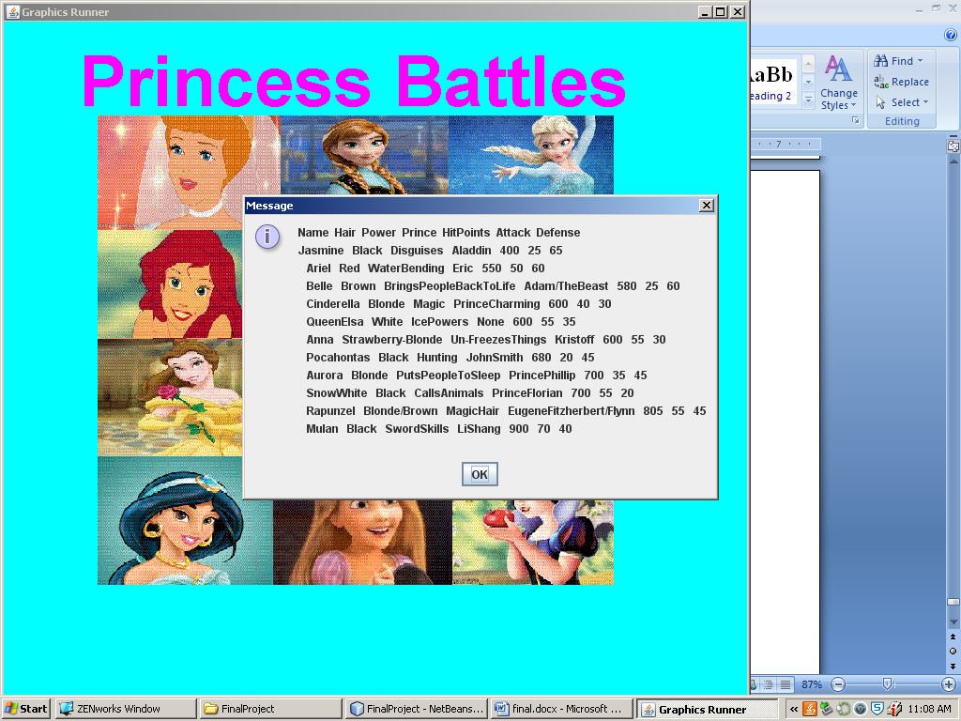

## Character Stats

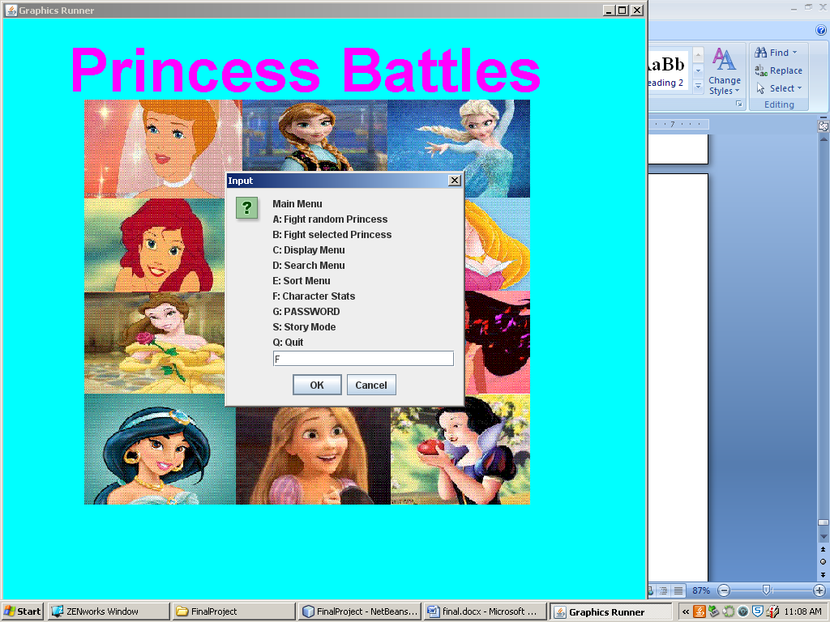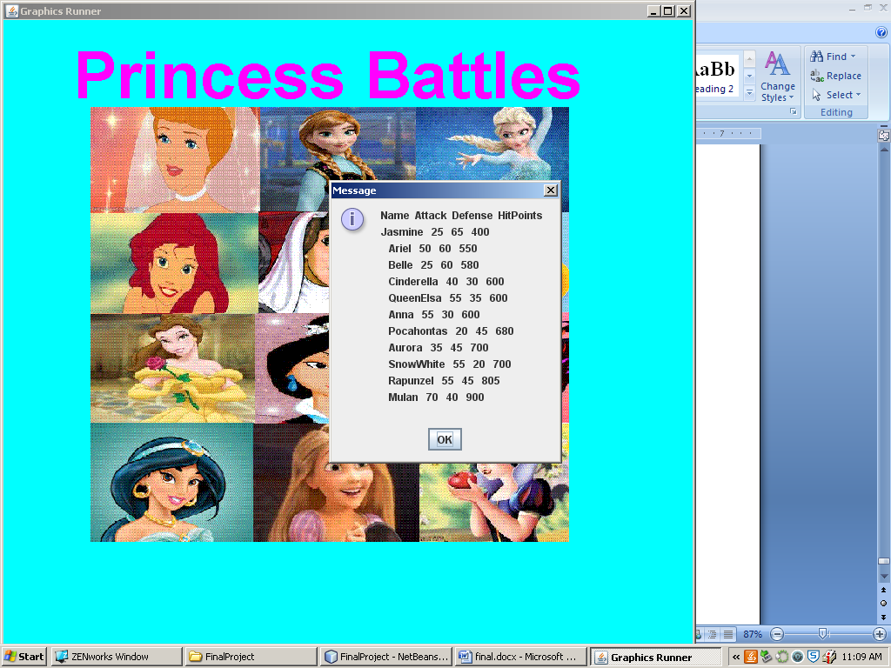

## Password

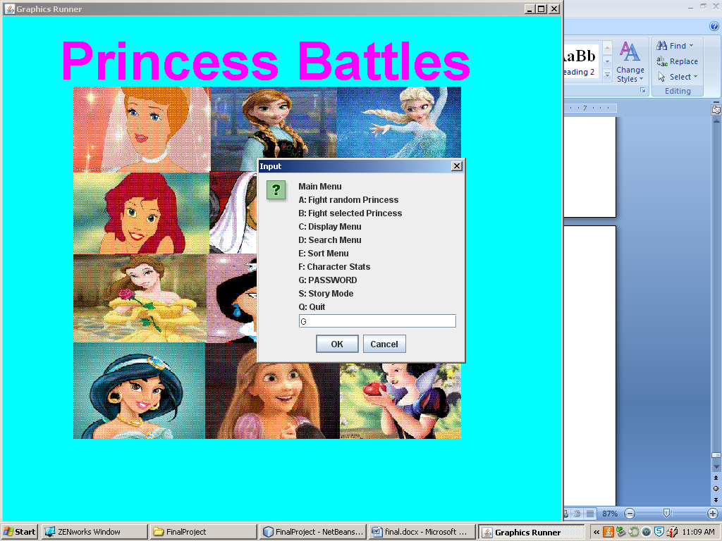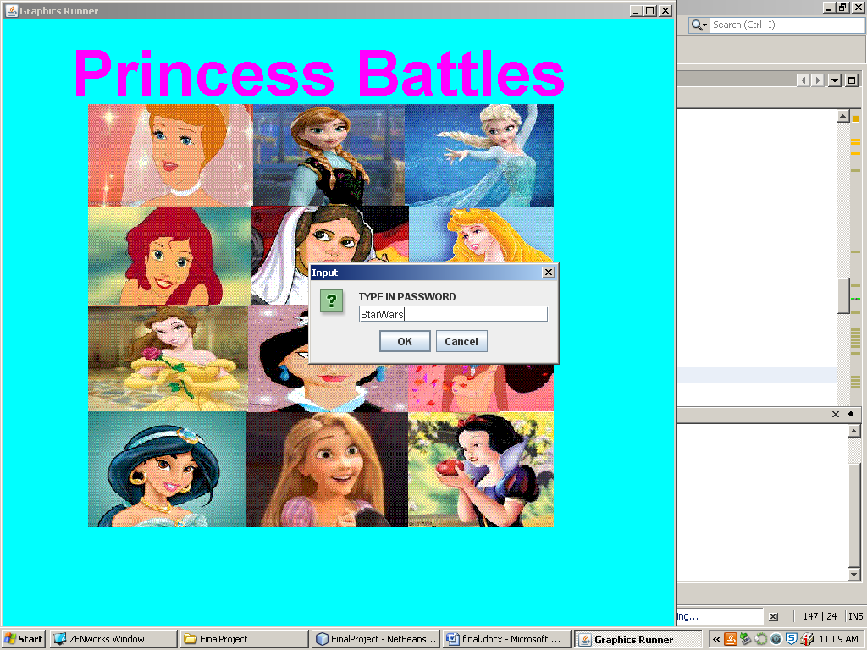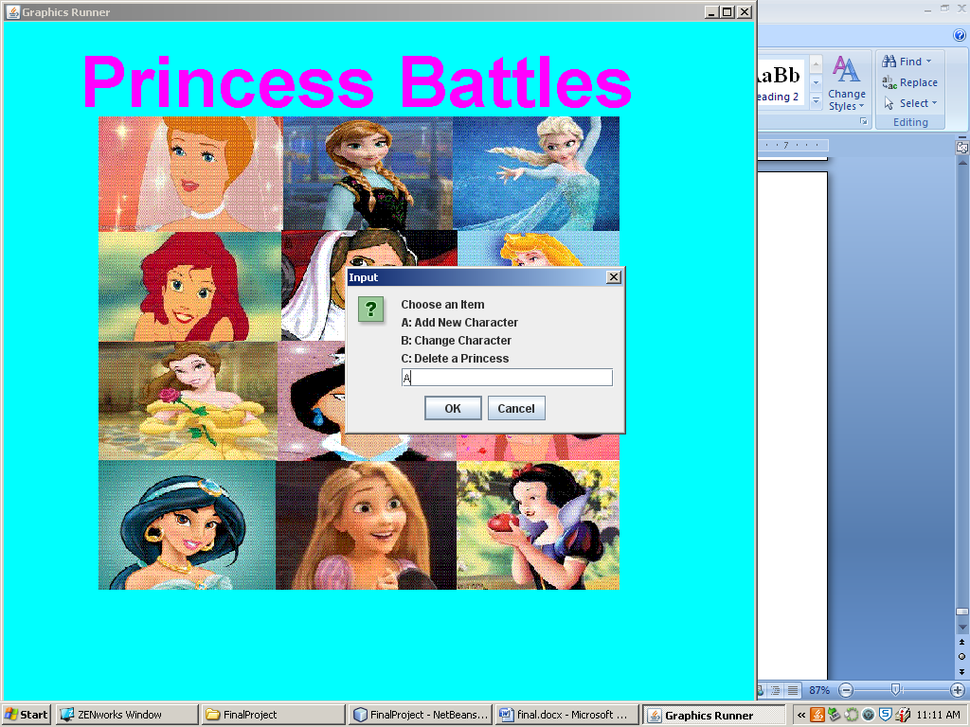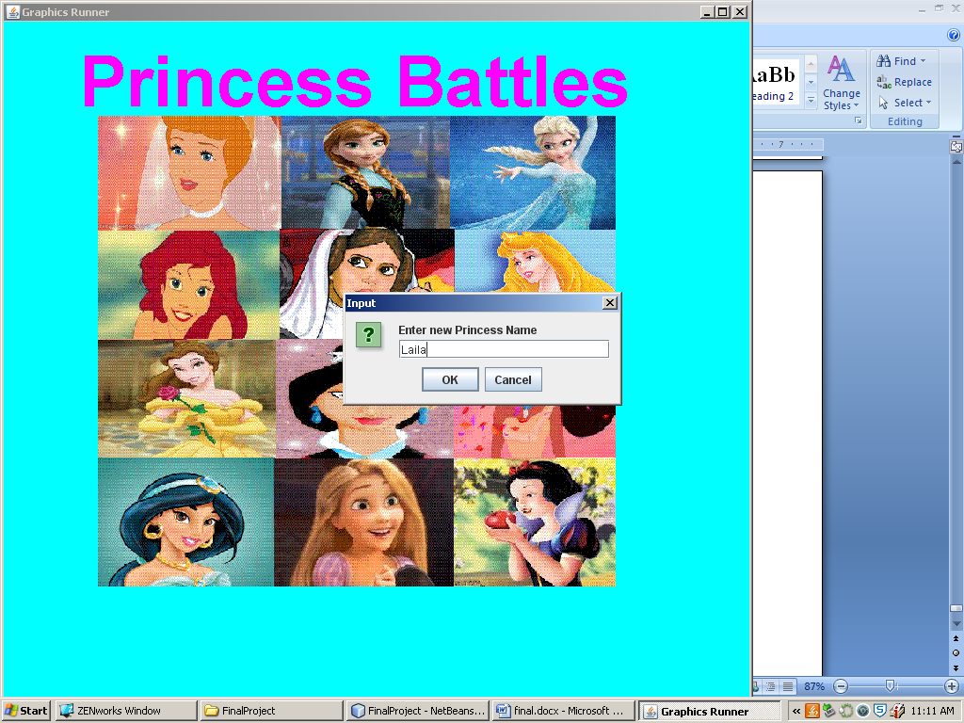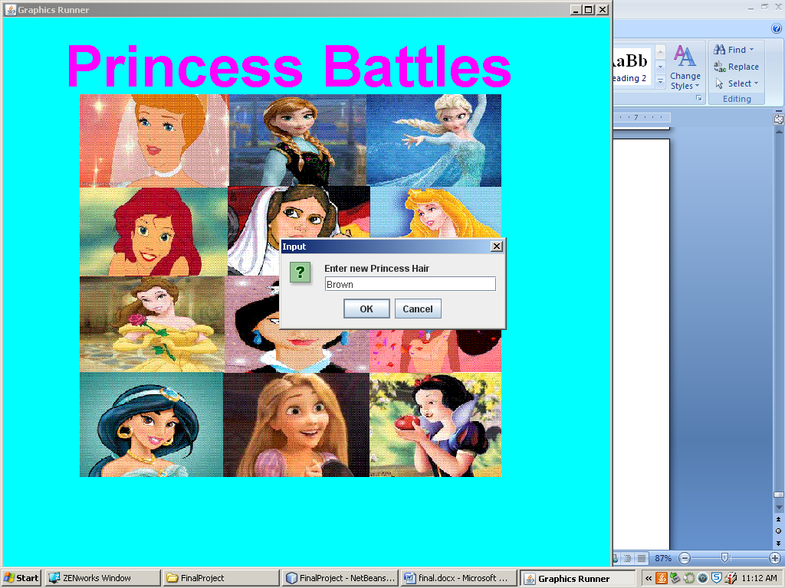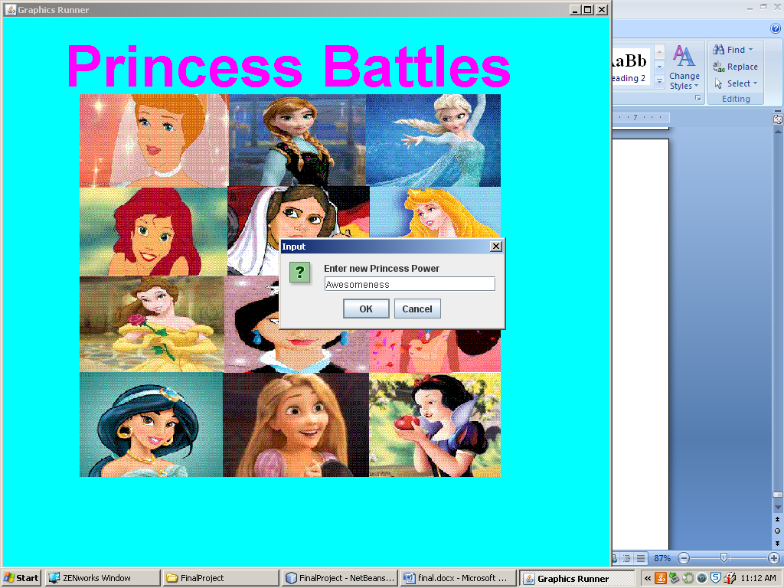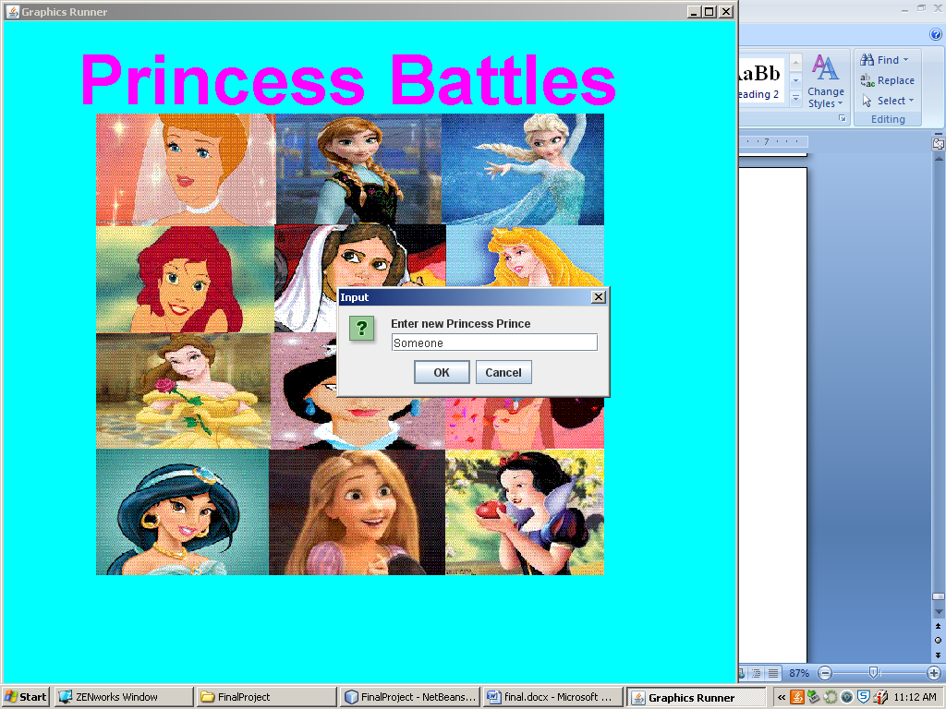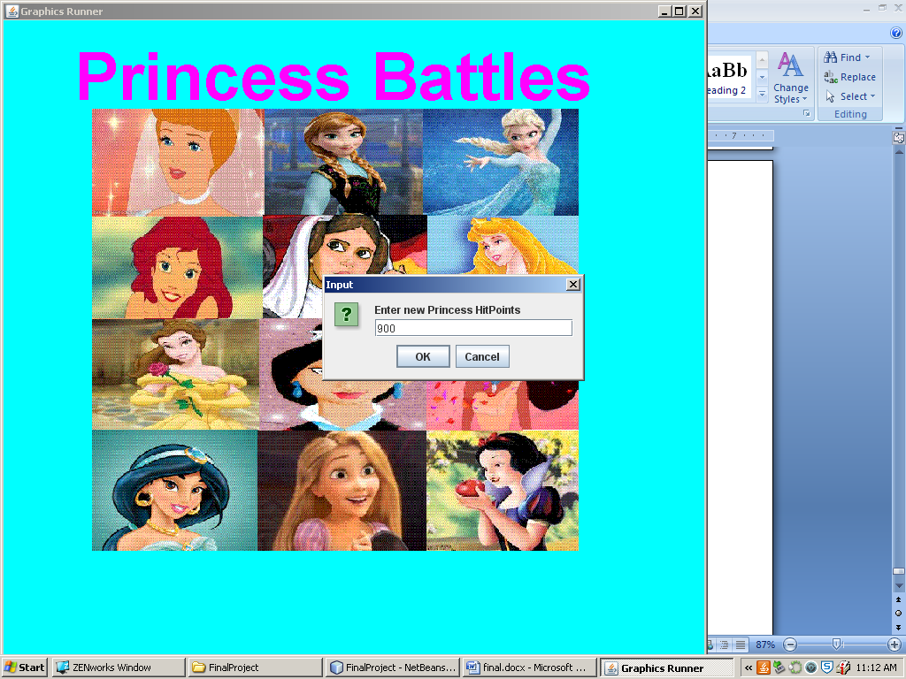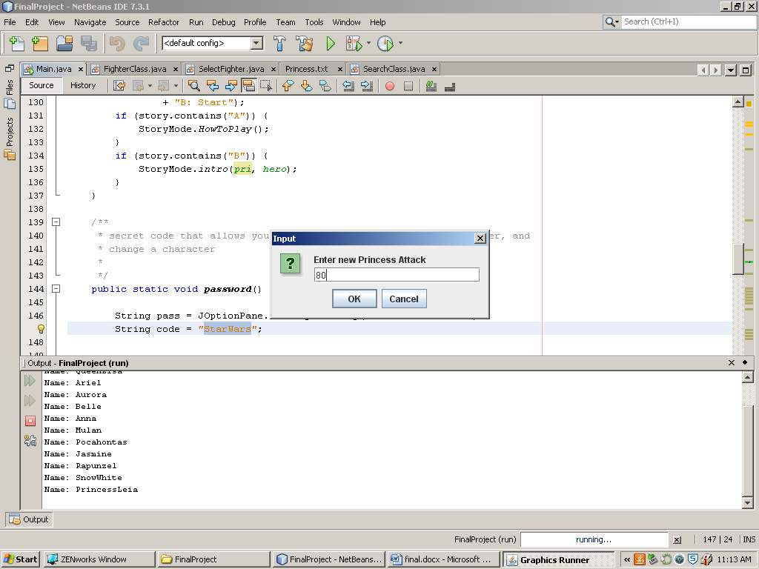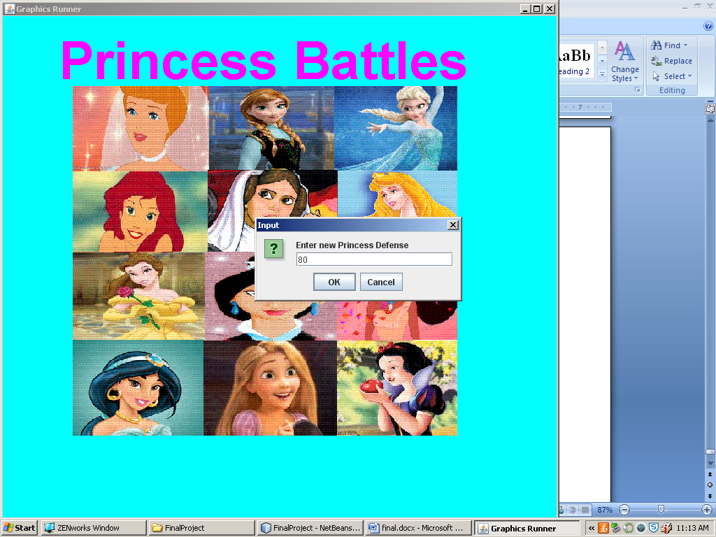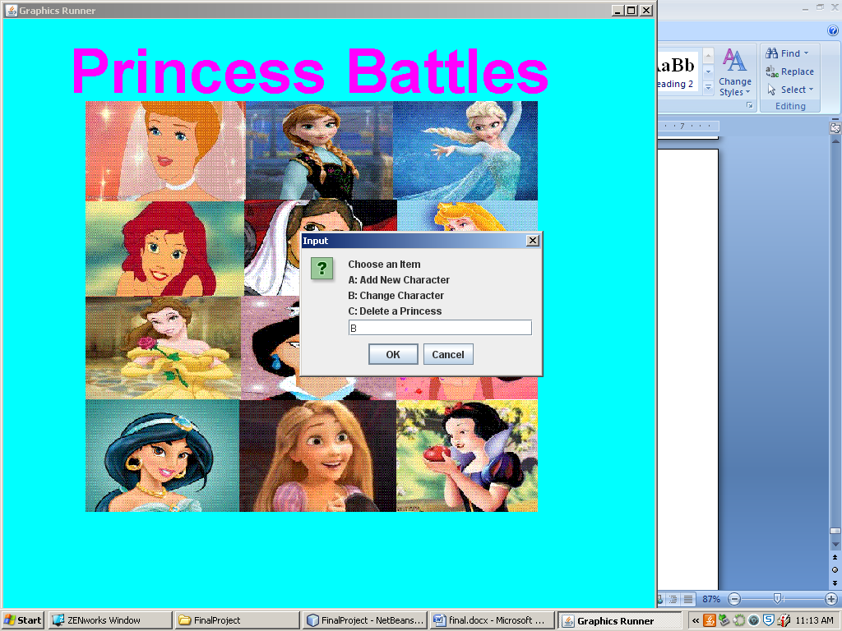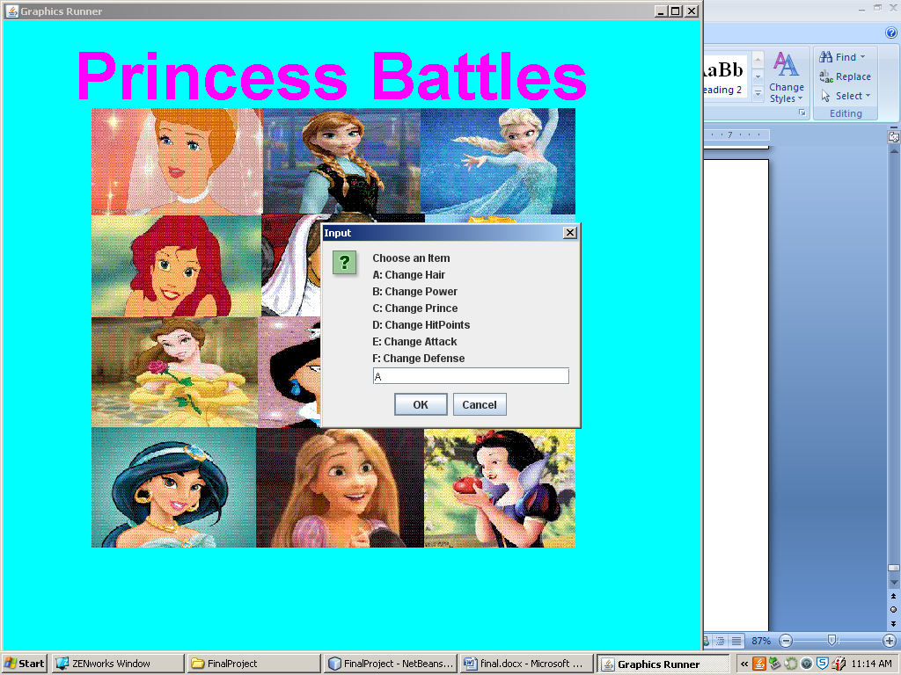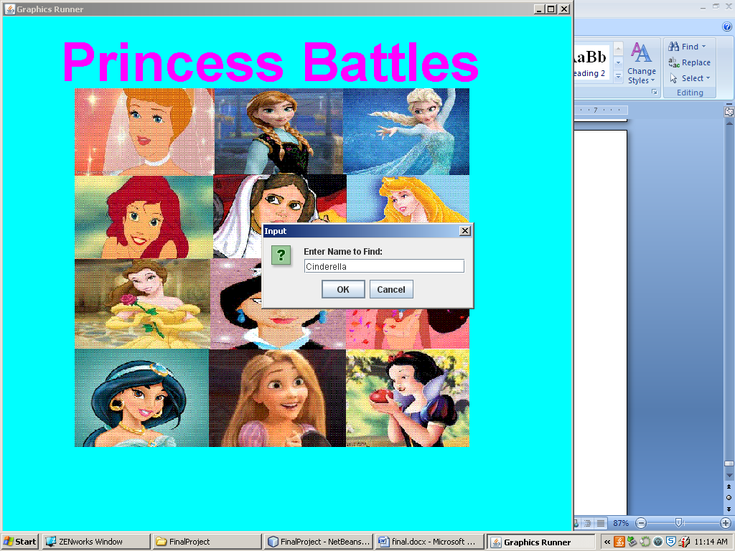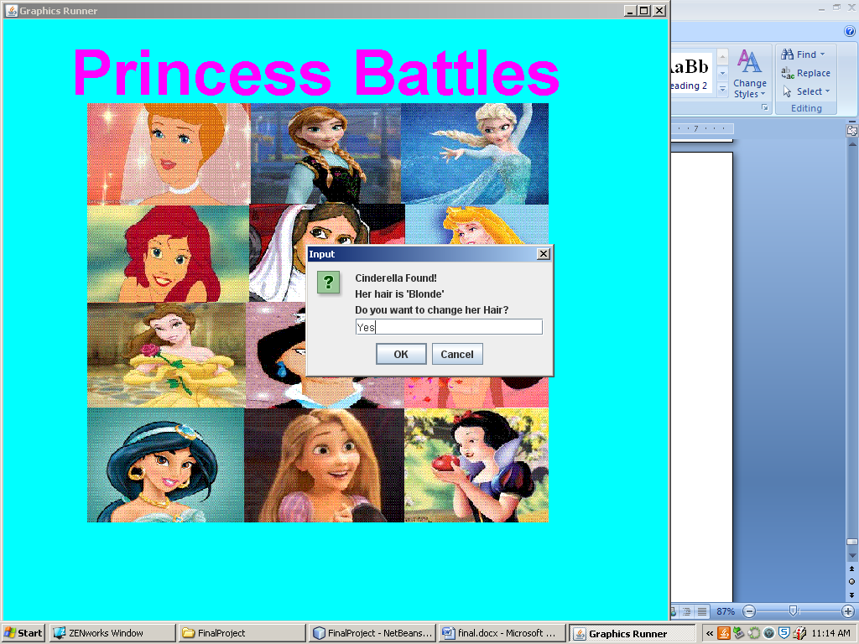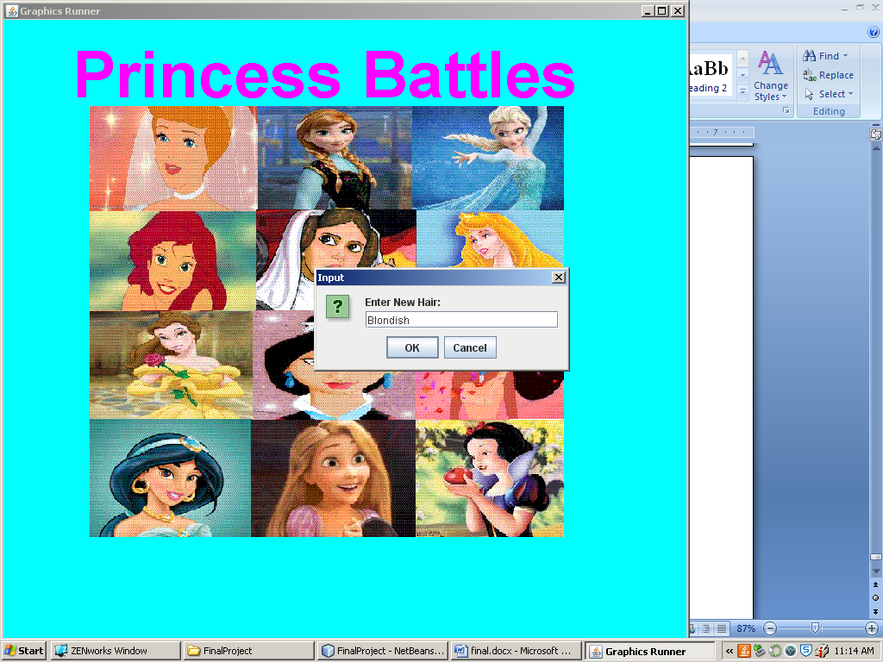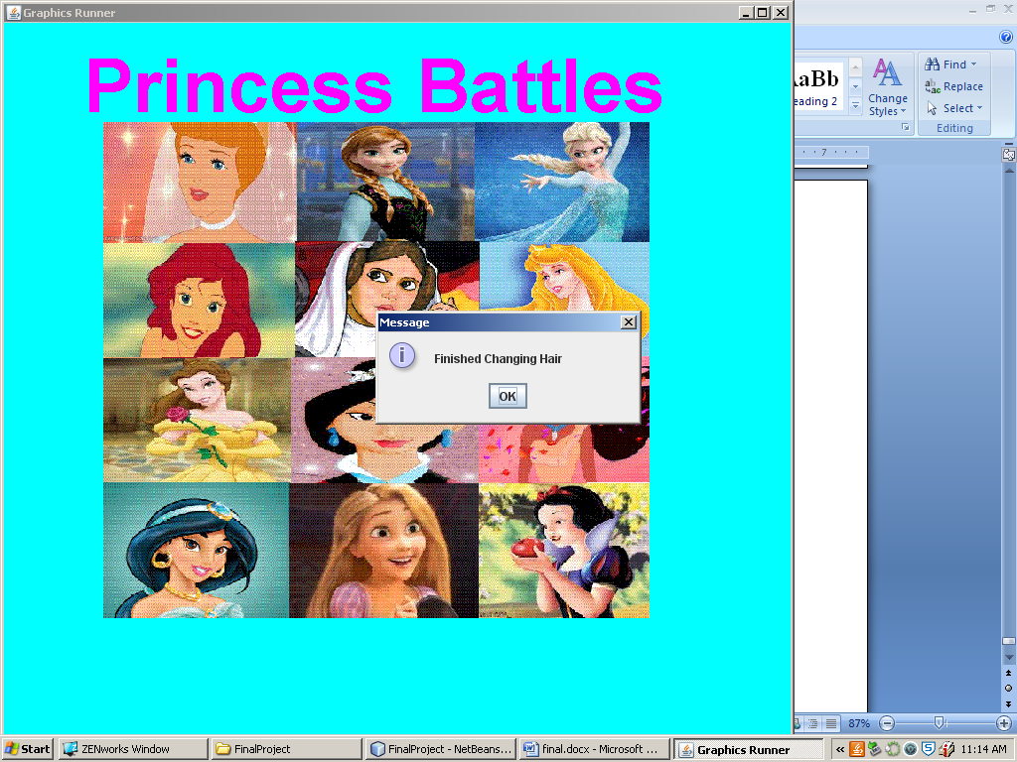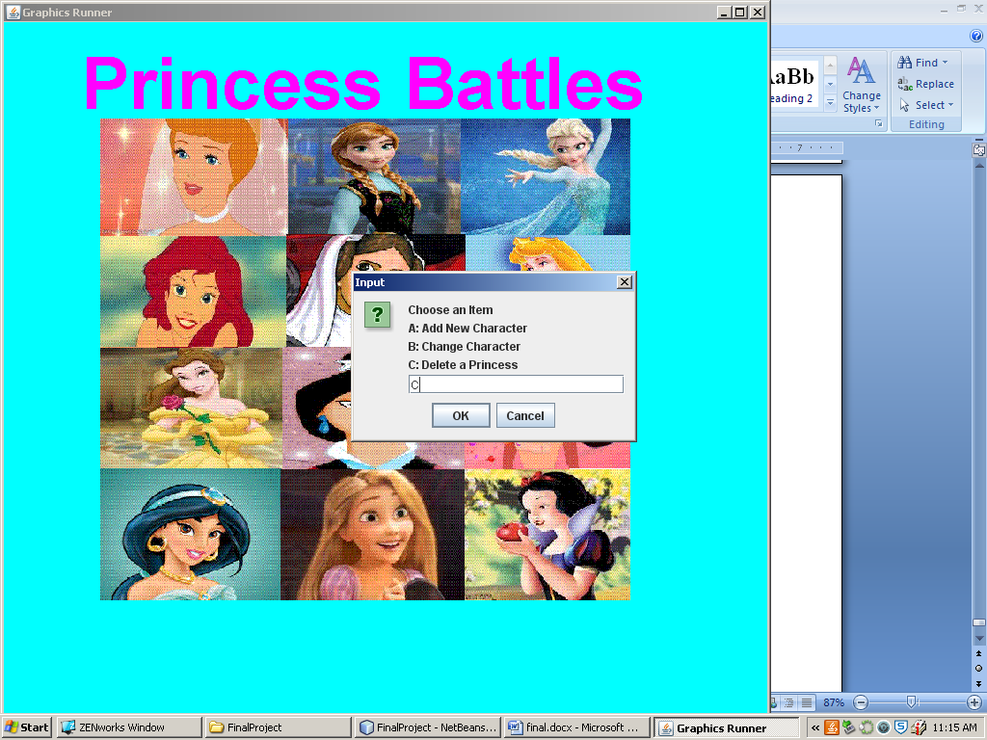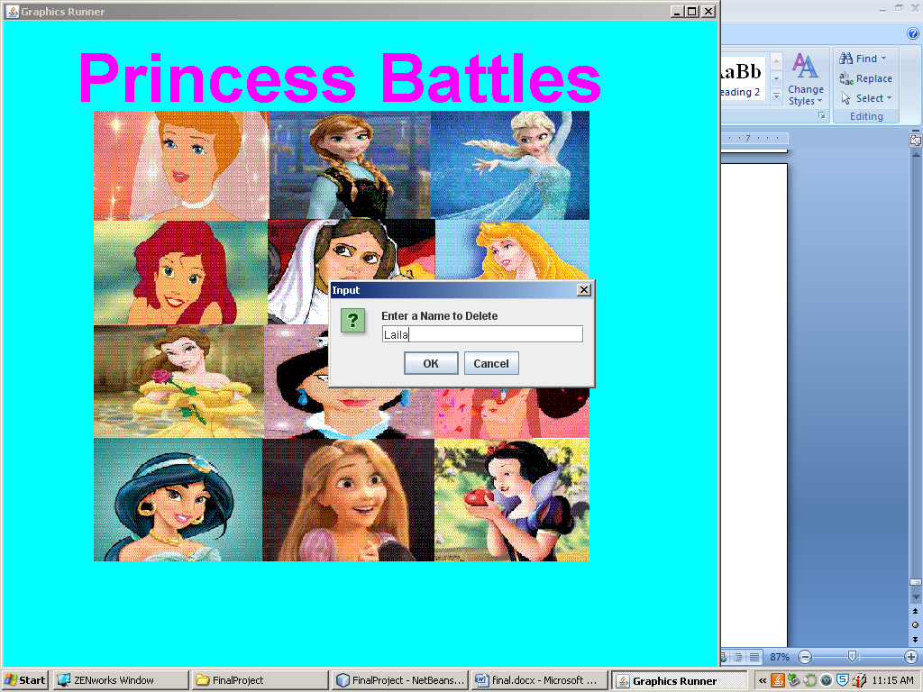

## Story Mode

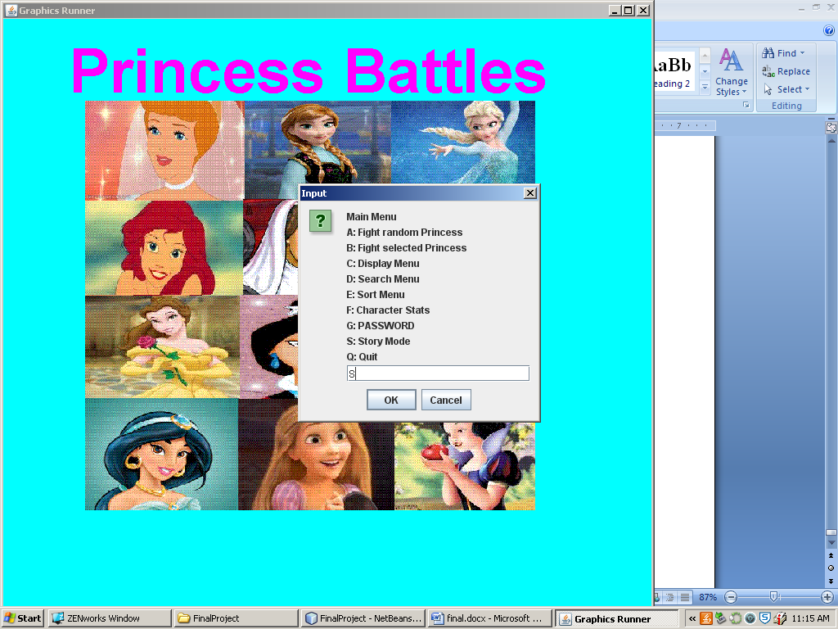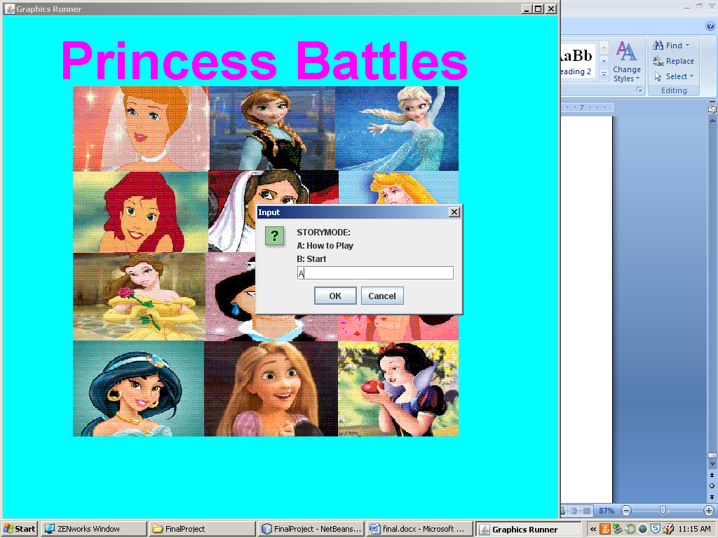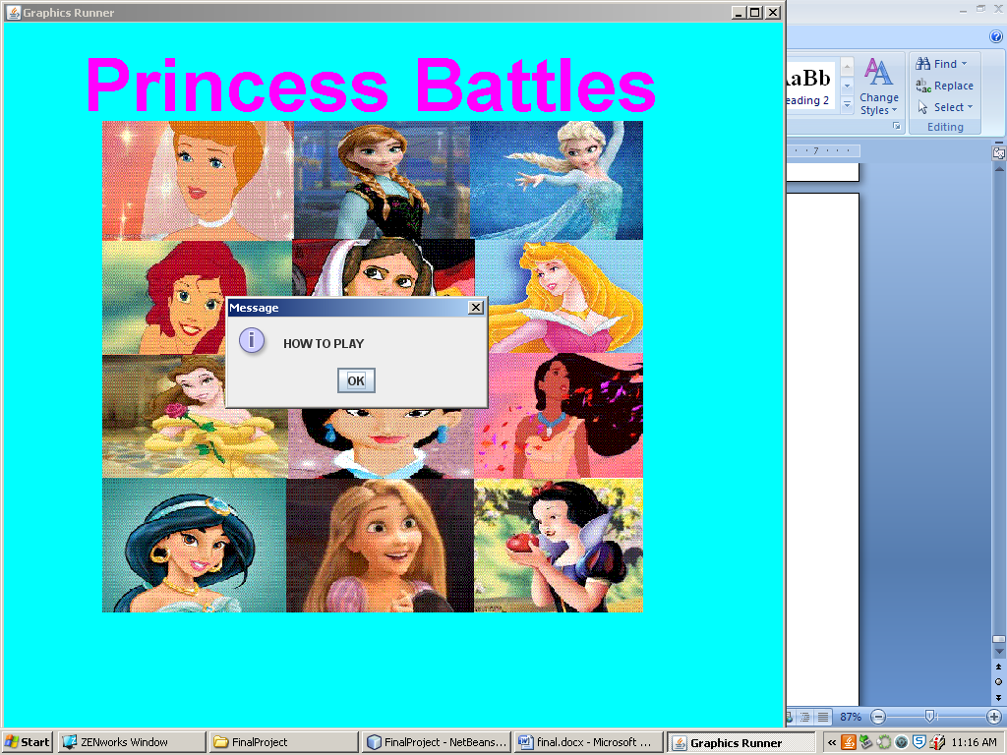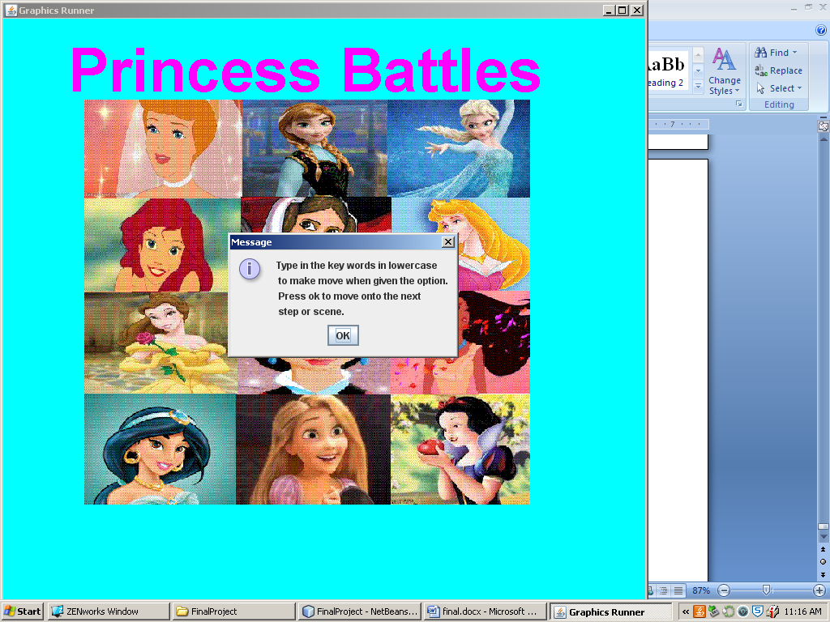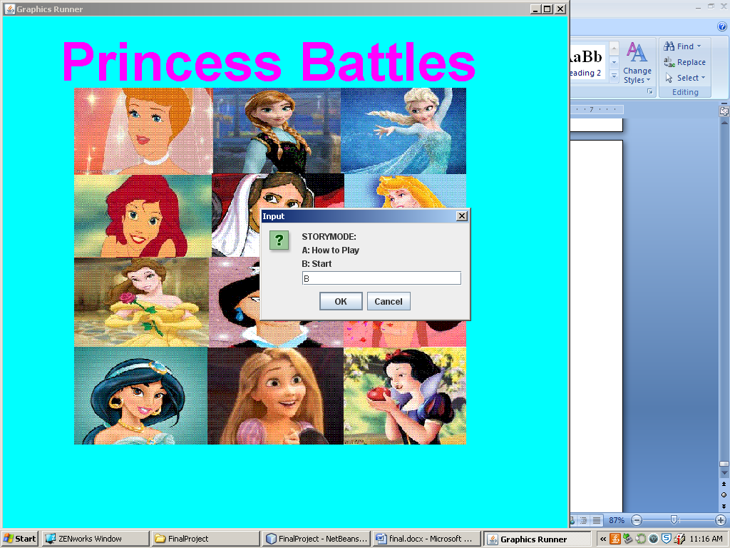

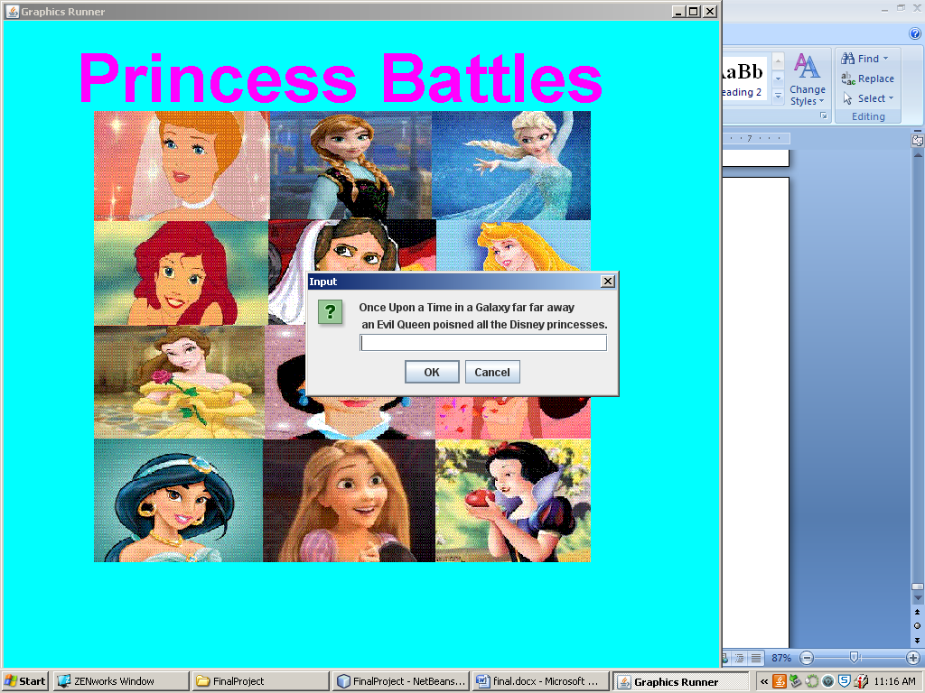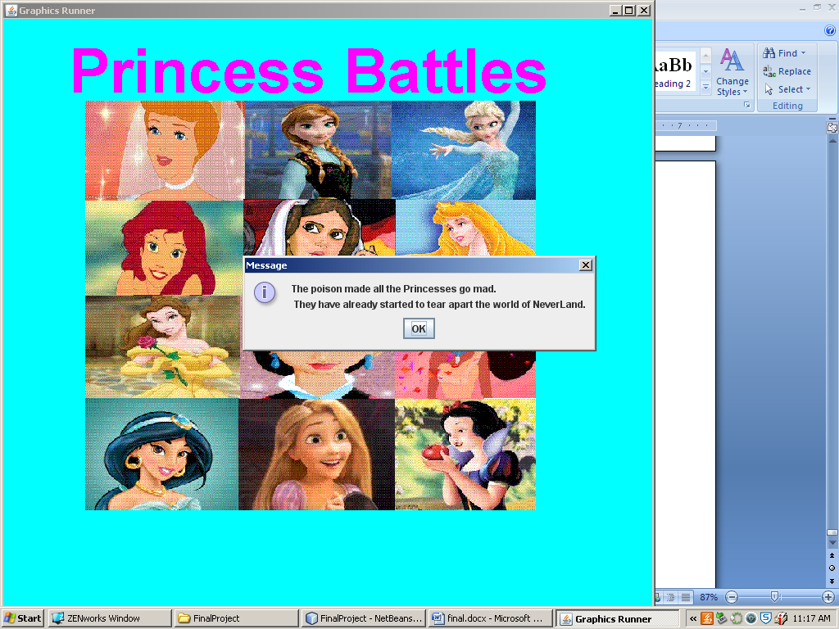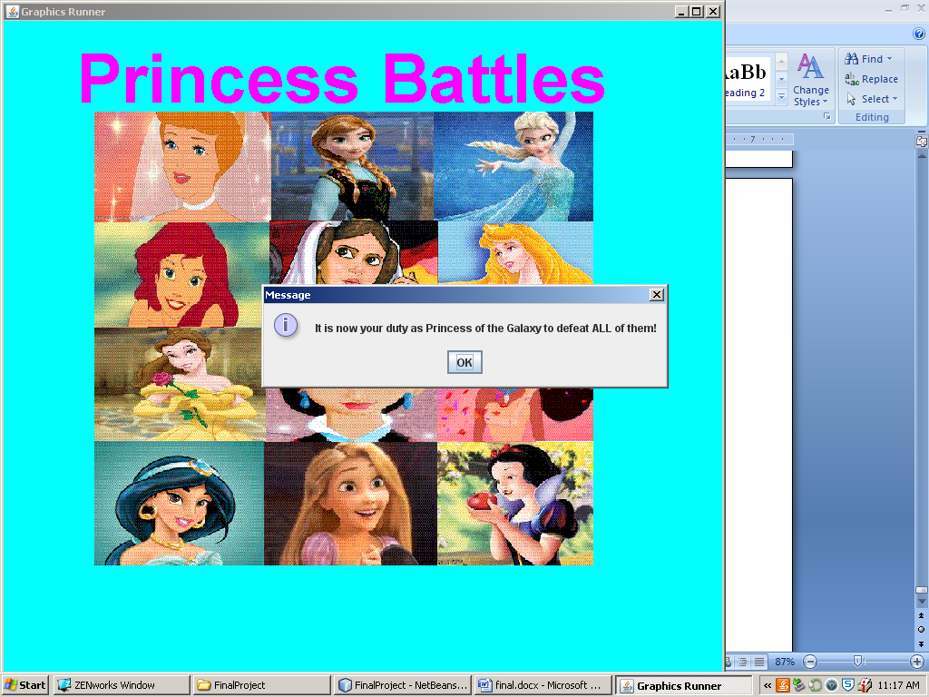

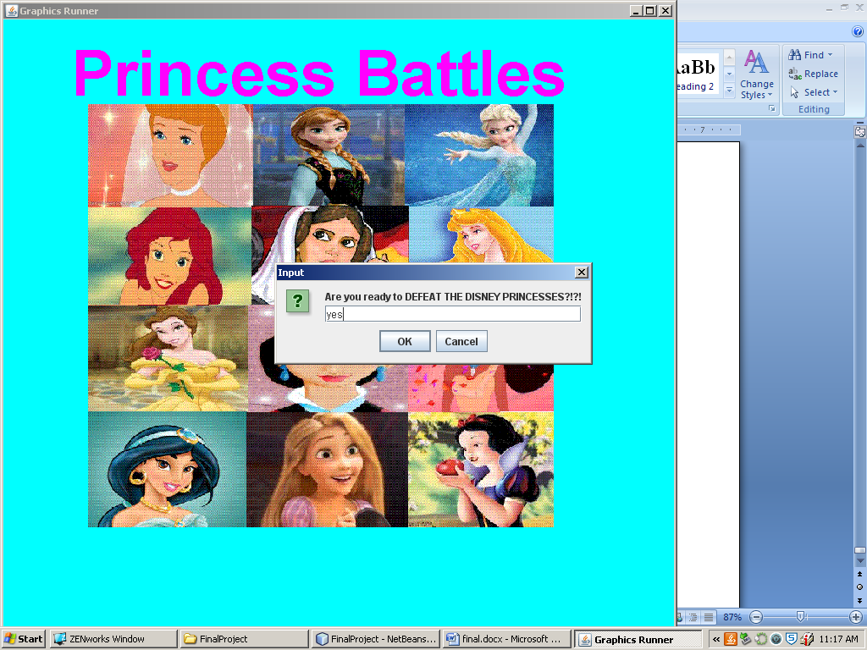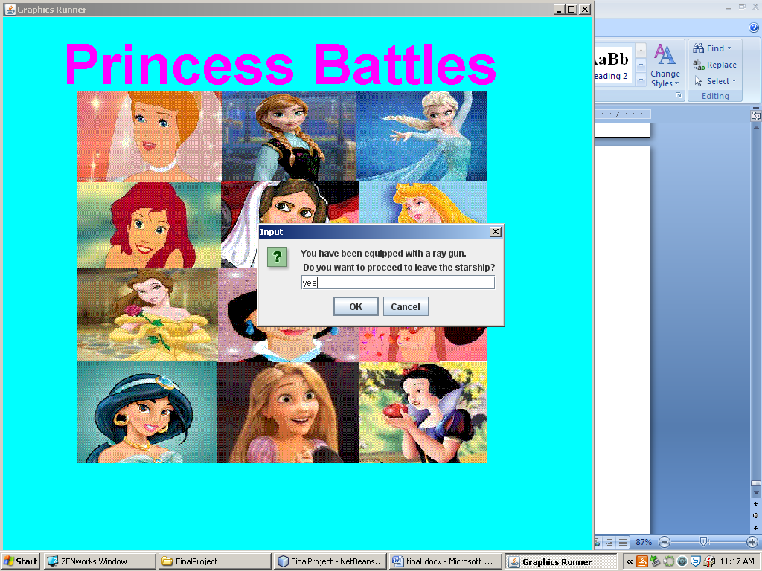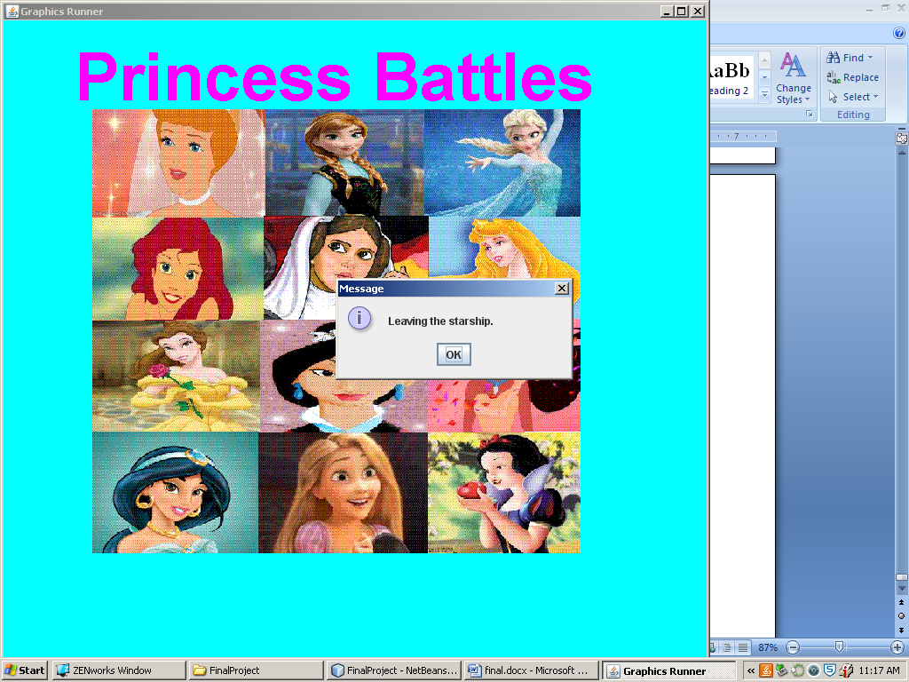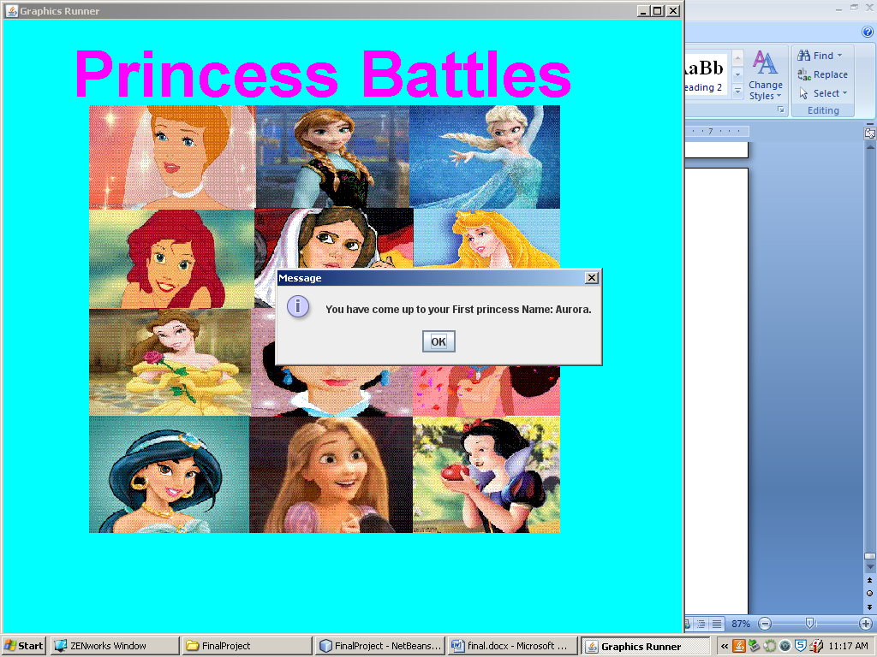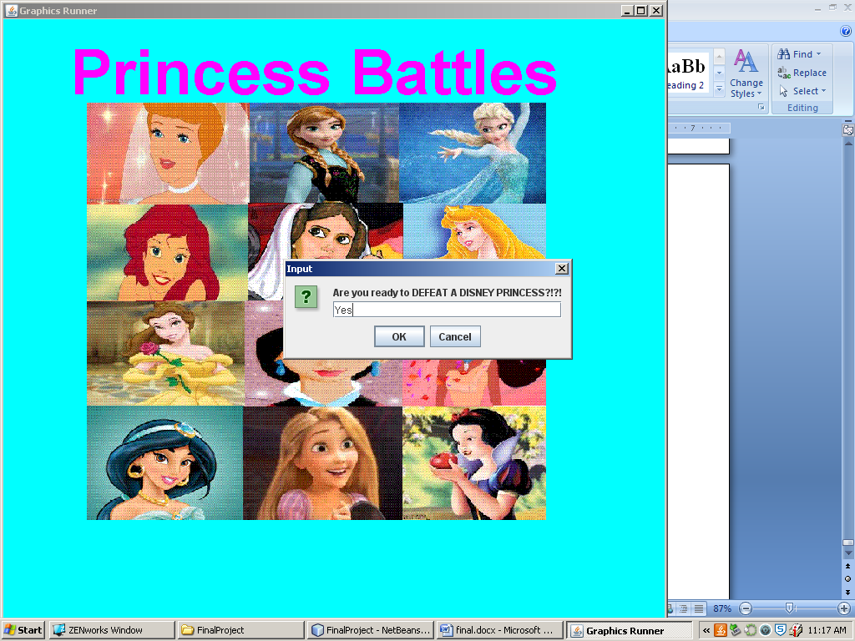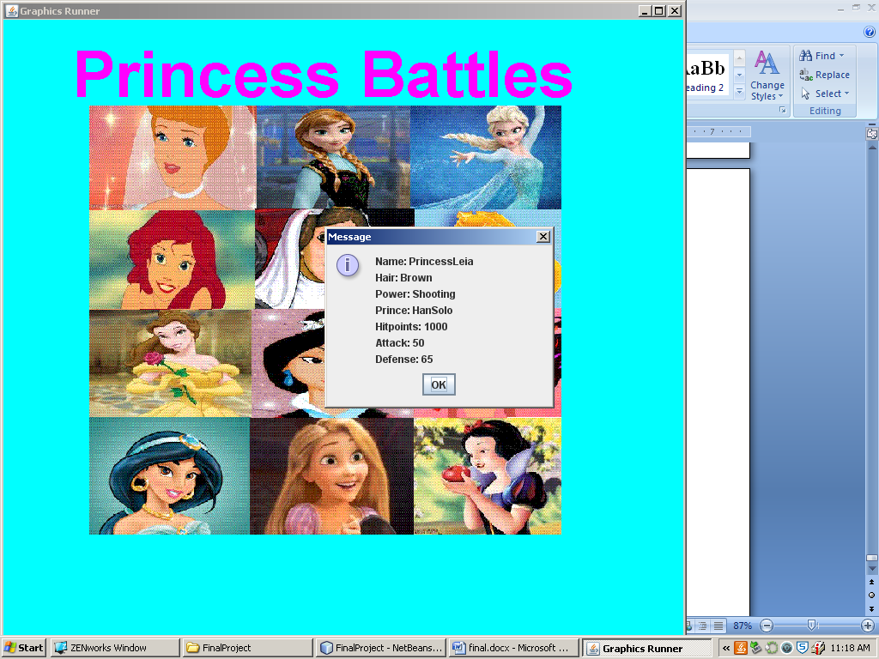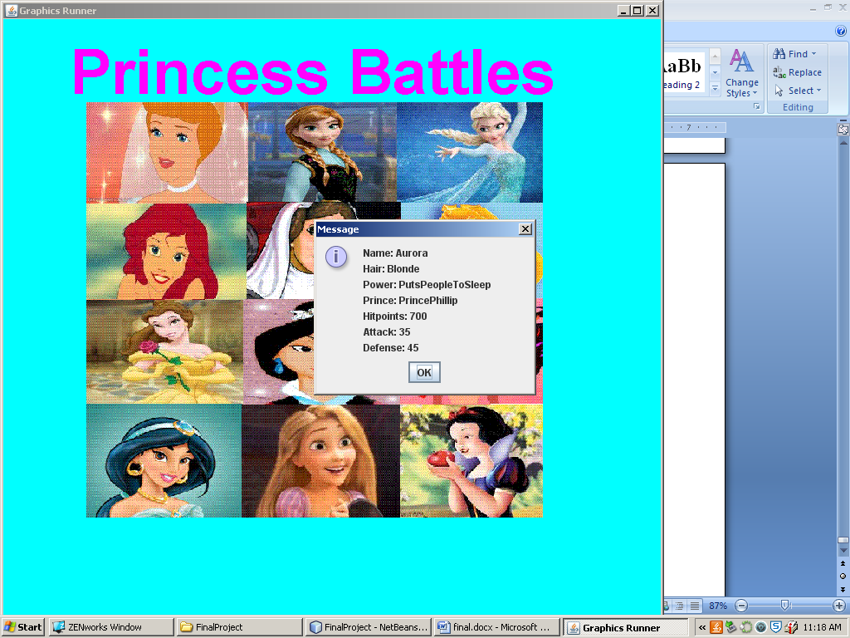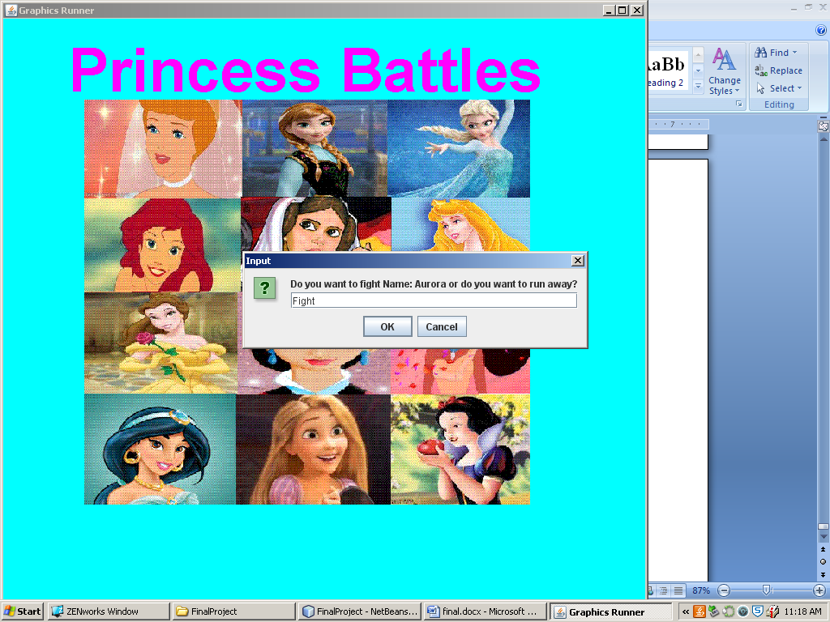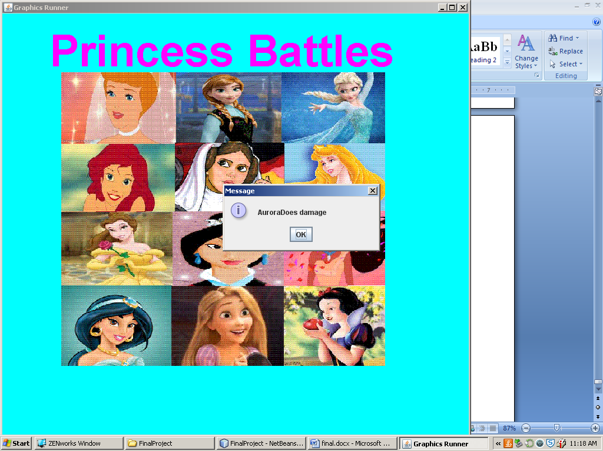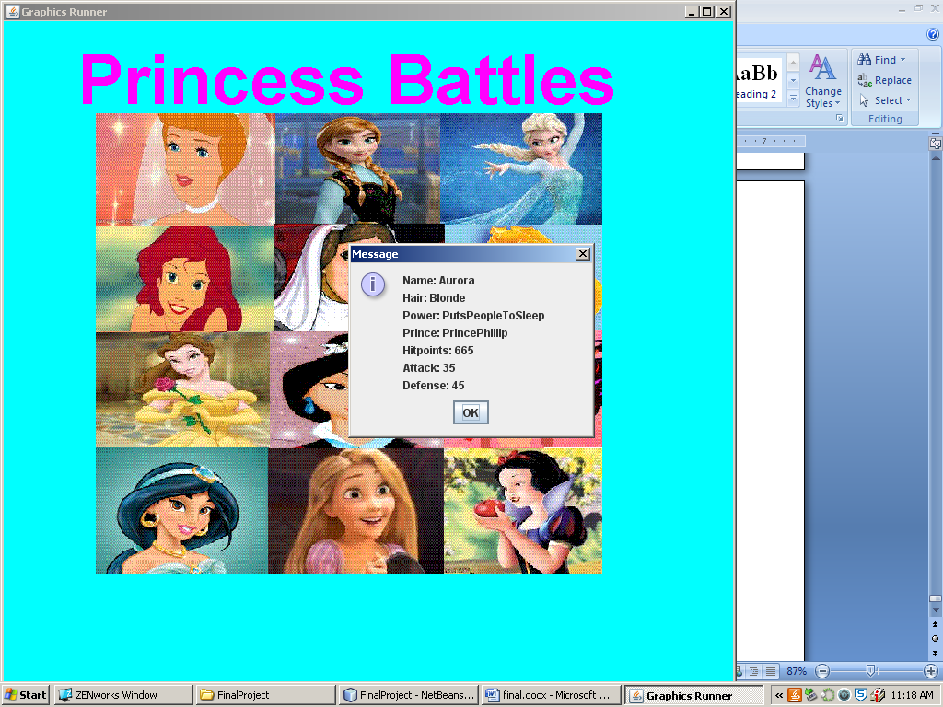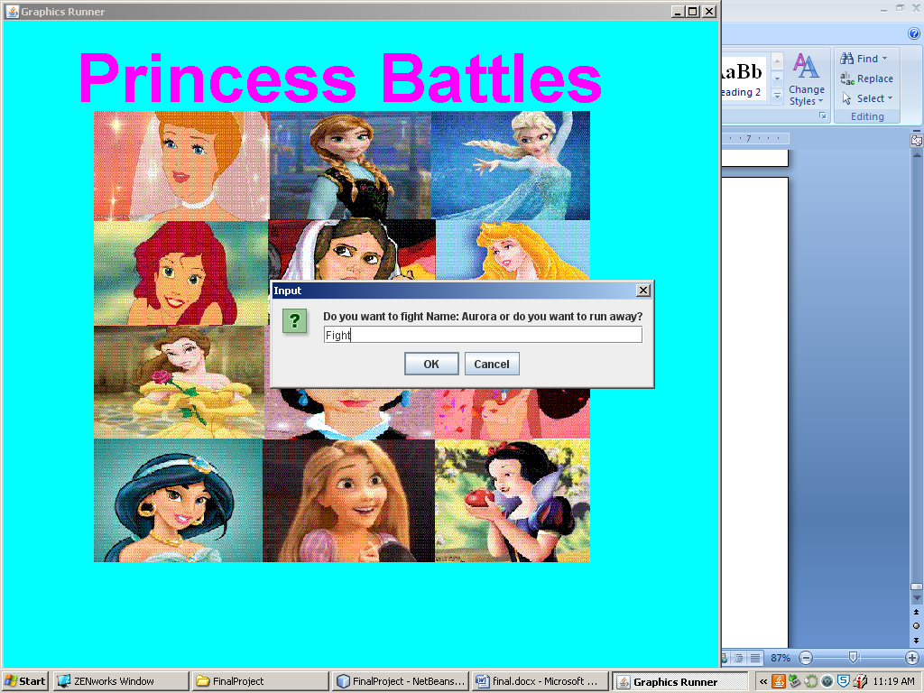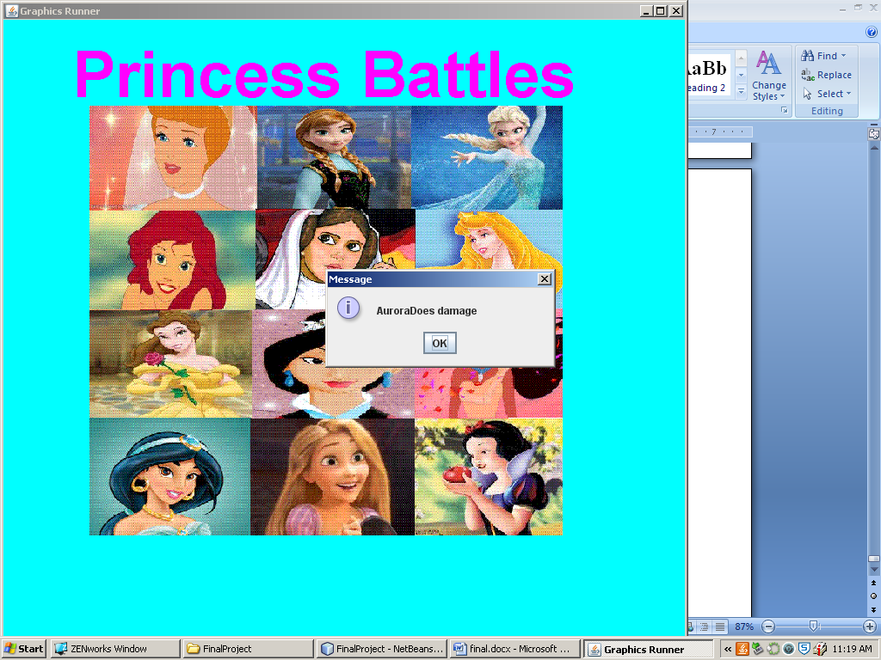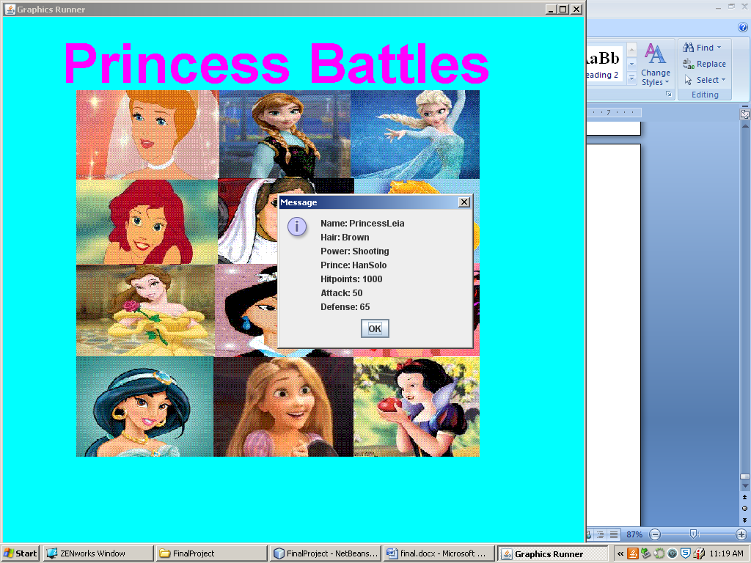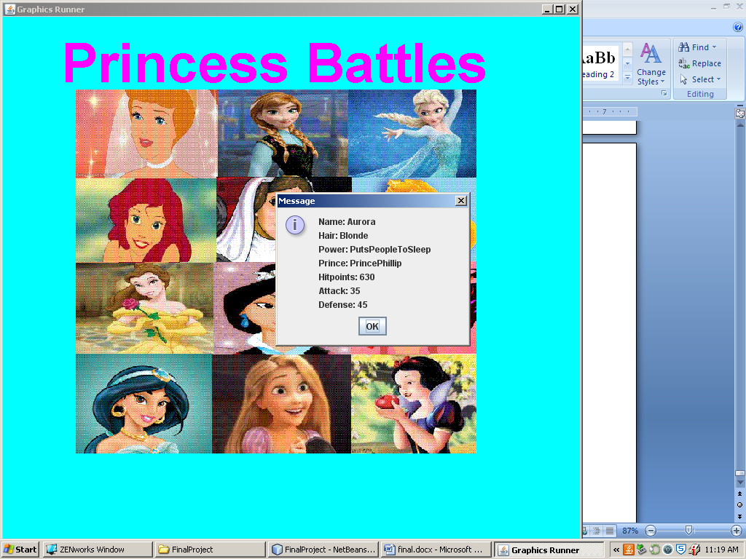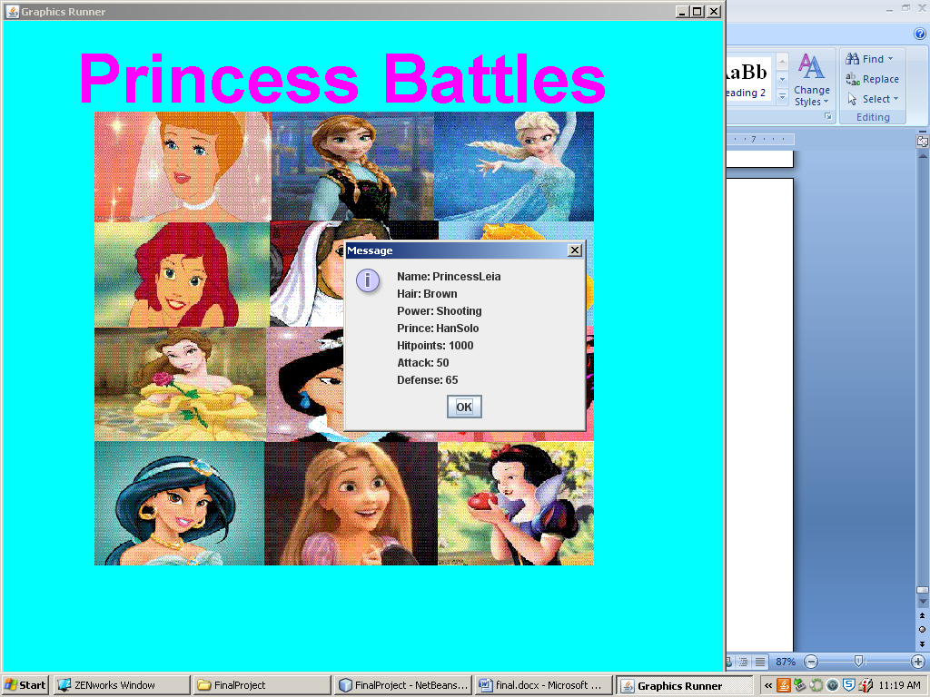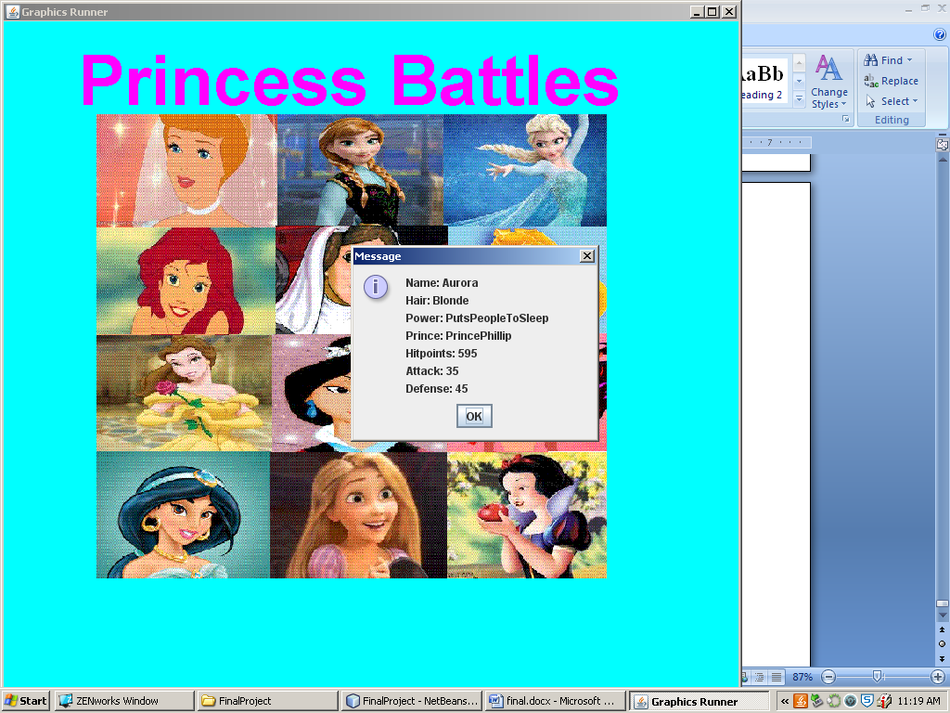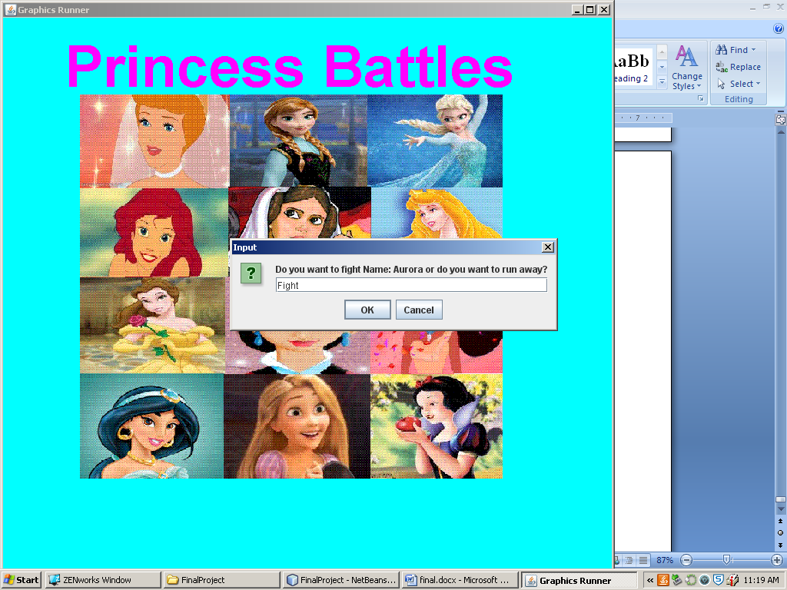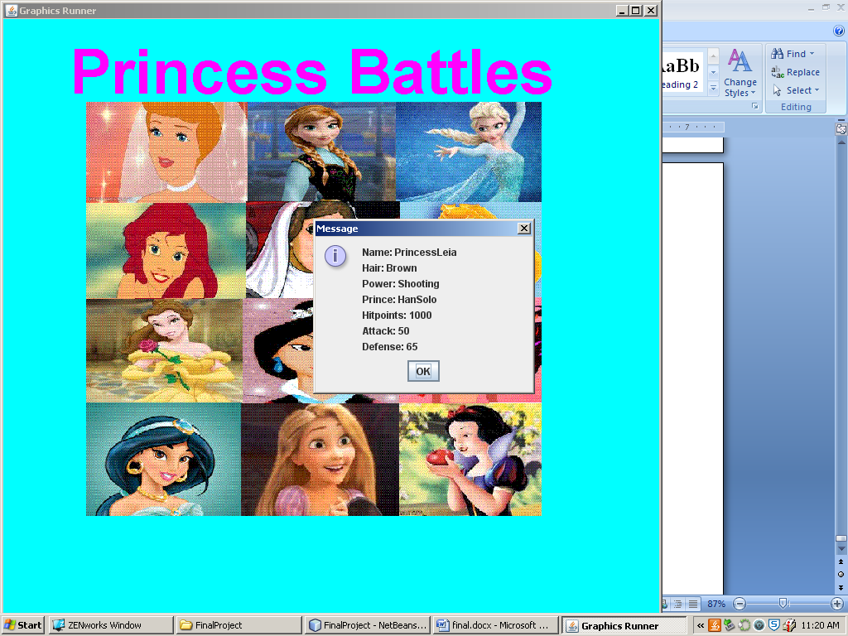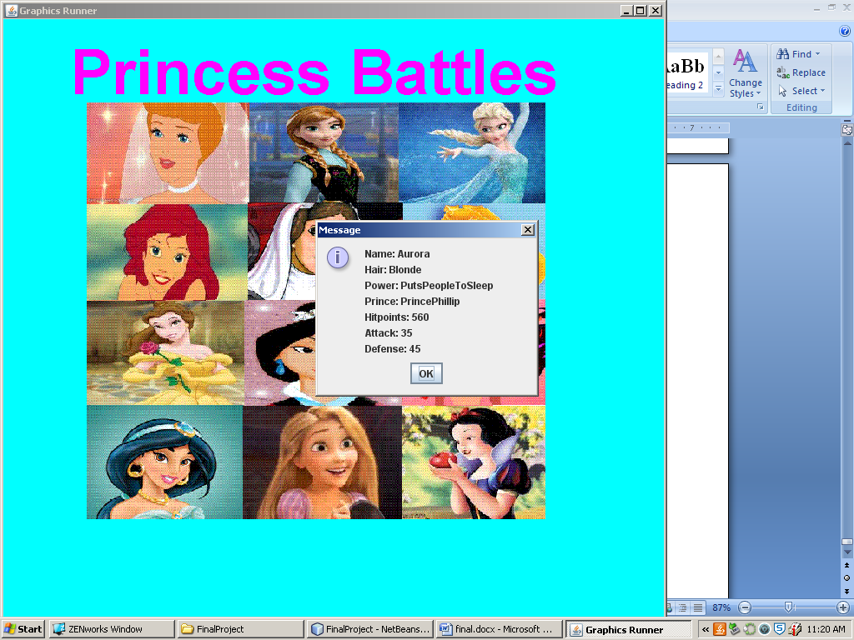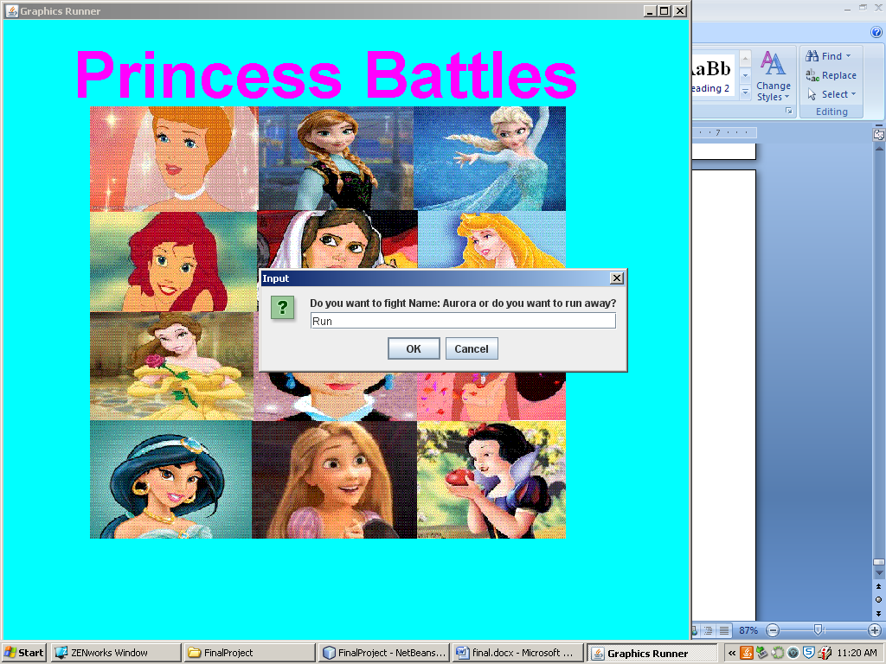

# Rubric

|  |  |  |  |  |
| --- | --- | --- | --- | --- |
| **ITEM** | **Possible Points** | Possible Bonus | Possible Minus | Points I Deserve |
| Text File | **2** |  |  | **2** |
| Object Class - monster | **5** |  |  | **5** |
| Object Class - Hero | **2** |  |  | **2** |
| Reads + auto | **5** |  |  | **5** |
| Random Seach | **2** |  |  | **2** |
| Fight | **5** | 10 |  | **11** |
| Menu's | **5** | 2 |  | **7** |
| Display's monster | **5** | 5 |  | **5** |
| Display Hero | **2** |  |  | **2** |
| Searches | **5** | 3 |  | **5** |
| Sorts | **5** |  |  | **5** |
| Saves | **5** |  |  | **5** |
| Add | **5** | 3 |  | **5** |
| Changes | **5** | 2 |  | **7** |
| Delete | **5** |  |  | **5** |
| GUI / Music | **5** | 15 |  | **5** |
| Graphics | **5** | **30** | -2 | **3** |
| Story | **10** | 20 |  | **15** |
| Good Coding Habits | **5** |  | **-20** | **5** |
| Documentation | **5** |  |  | **5** |
| Java Docs | **5** | 2 |  | **7** |
| Cover Page | **5** | 2 |  | **7** |
| Description Page | **5** |  |  | **5** |
| Submitted | **5** |  | **-30** | **5** |
| Screen Shots | **10** |  |  | **10** |
| Proper format in Word | **5** |  |  | **5** |
| Table of Contents | **5** |  |  | **5** |
| Joption Pane | **5** | 10 |  | **10** |
| MultiThreading | **0** | 10 |  | **0** |
| **Working on Project until End** | |  | **-50** |  |
|  | **138** | **94** | Points > | **160** |
|  | **145 Needed** |  | Grade > | **110** |